CLASSIFYING MATERIALS

Contents

- Introduction

- Pupils’ work at key stage 2

- Risk assessment and safety

- Storing and handling chemicals

- The particulate nature of matter

- Solids, liquids and gases

7. Changes of state

8. Elements, compounds and mixtures

9. Particles revisited: atoms, molecules and ions

- Separation techniques

- Atomic Structure

- Atomic Number and Mass Number

- Isotopes

- Relative Atomic Mass

- Chemical Bonding

- Structure, bonding and properties of materials

- Chemical formulae

- Introduction
Chemistry is usually found to be an interesting area of science by pupils in the early years of secondary education. There are many enjoyable practical activities that can be undertaken that employ apparatus, equipment and chemicals that are new to the pupils.

However, many pupils lose interest once the explanatory models used in chemistry are introduced. Explanation in chemistry soon requires use of abstract models based on ‘particles’ that cannot be seen and whose existence must, to all intents and purposes, be taken on trust. The picture is then complicated once these particles become described as atoms or molecules or ions.

This is a most important point to remember when teaching chemistry: we must remember that many pupils find difficulty in handling such abstract ideas and, hence, understanding explanations based on such ideas

- Pupils work at key stage 2
Chemistry, perhaps more so that physics or biology, requires the use of specialist equipment and ways of working. In primary schools science resources are, of course, available, but specialist facilities such as serviced laboratories are the exception. Pupils starting key stage 3 work in a secondary school are usually excited by the prospect of working in real laboratories. It is important to utilise this excitement in the pupils by making every attempt to make year 7 science exciting. DO NOT assume pupils no science/chemistry. They will have completed 6 years of science already. Access and use records of their attainment and achievements in primary school. Then build upon these.

Task 1
Read through the programmes of study for Sc3, Materials and their properties, for key
stages 1 and 2.

You will have read that pupils will have learnt about ways of grouping and classifying materials, various ways of changing materials (both physically and chemically) and ways of separating mixtures. So at key stage 3 don’t reinvent the wheel: use pupils knowledge and experience as a basis for further learning

3. Risk assessment and safety
As a science teacher it is useful to have some knowledge of the legal background to laboratory safety. The most important point/principle to bear in mind is that, as employees, teachers have an obligation to follow their employer’s rules and a general duty to care for the safety of others. Employers, on the other hand have a duty to provide safe working conditions and to inform staff of dangers arising from their work. In many cases the LEA or governors devolve specific responsibilities to a specific person, e.g. Headteacher, HoD, etc.

There are several Acts of Parliament and associated regulations relating to safety in school laboratories. Two of the key pieces of legislation are outlined below.

- The Health and Safety at Work Act (1974)

- employers must have a written H & S Policy
- employers must provide safety training
- suppliers must supply safe materials (when used properly) and provide safety information
- teachers have a duty to take reasonable care to avoid injury to themselves or others
- teachers must co-operate with employers in meeting statutory requirements
- adequate supervision of laboratory safety
- Trade Unions to have safety representatives.

I would emphasise here the importance of joining a Trade Union or professional Association. They will provide legal advice should the occasion arise.

- Control of Substance Hazardous to Health (COSHH) Regulations (1988)

- apply to substances classified as “toxic”, “very toxic” , “harmful” , “corrosive” or -“irritant”, materials with chronic or delayed effects (e.g. carcinogenic)
- do not apply to asbestos, lead and radioactive materials for which separate regulations apply
- do not apply to (very) flammable materials
- employer must assess risks to health arising from hazardous materials
- employer to reduce levels of risk as far as possible
- training and information to be provided to teachers and technicians

Risk Assessments

A Risk Assessment should look at the hazards of the substance being made or used, the scale of working, teacher demonstration of pupil investigation, age/experience/ability of pupils, precautions to be taken, location and any other relevant information.

It is the employer’s job to draw up Risk Assessments for chemicals or microorganisms. Most likely employers will devolve much of this responsibility to the Head of Science. They in turn normally use general assessments taken from existing publications, e.g. “Hazcards”, “Safeguards in the School Laboratory”. These will apply to using or making a substance in what could be regarded as a standard way. All a teacher would have to do would be to check that they are using a substance in the standard way and adopt the recommended procedures: e.g. a teacher wishing to make sulphur dioxide, say, would check the relevant General Assessment and satisfy him/herself that the proposed procedure complies with the recommendations.

There are, however, occasions when a Special Assessment will have to be made: e.g. when using a relatively unusual chemical, if working in a room where proper laboratory facilities are not available, or when introducing new ideas into the curriculum. Perhaps the most usual instance will be during pupil-centred investigations. Employers should have procedures for making Special Assessments.

Fume Cupboards

- must be used if that is what the Risk Assessment requires
- must comply with DES Design Note 29
- efficiency to be monitored at least every 14 months: this will comprise a check on airflow and, for mobile fume cupboards (filter type) testing of filter saturation.

The introduction of the COSHH Regulations initially caused a good deal of concern in schools. In fact they really just formalised existing good practice, i.e. take restrictions and precautions from Hazcards and other safety texts and put them into texts which are used daily: schemes of work, instructions for teachers and technicians, lesson plans, pupil worksheets, etc.

Fires

School laboratories are normally provided with one or more carbon dioxide (or halon) type fire extinguishers, a fire blanket and sand.

Fire blankets are used primarily for dealing with people who have burning liquid spilt on their clothes. They are also the most effective treatment for flammable liquid fires in an open container. In other words the temptation to use a fire extinguisher to fight minor fires should be resisted. A small beaker of, say, ethanol can easily be smothered. Use of a fire extinguisher on a small fire can make things worse by knocking over beakers, etc.

If fires cannot be extinguished in a minute or so then dial 999 and give priority to evacuating pupils and staff.

First Aid

“First Aid” is the term given to treatment rendered in two situations:

- where a victim needs medical treatment , action to preserve life and/or minimise the consequences of injury until qualified assistance is obtained; and
- where a person has minor injuries which must be treated but do not require qualified medical attention.

Note: caring for children who are unwell is not first aid

The legal framework for First Aid is described in a Code of Practice: First Aid at Work (1990) produced by the Health & Safety Executive.

All schools with 50+ employees must have a qualified first-aider on the premises. Most smaller schools will have a qualified first-aider as well. If not they must provide at least an “appointed person” to take charge in an emergency. It should be noted, in addition, that all field trips and school journeys should have an “appointed person”.

First Aid regulations do not require there to be a qualified first-aider among science staff. This is, however, obviously desirable. All staff will, of course, be expected to take emergency action while waiting for first aid of qualified assistance.

Task 2

I would like you to find out the appropriate emergency action to take in the following examples of laboratory accidents:

- chemical splashes in the eye
- chemical splashes on the skin
- chemicals in the mouth, perhaps swallowed
- burns
- toxic gas
- hair on fire
- clothing on fire
- electric shock
- bad cuts

Safety Policy

All schools should have a safety policy defining procedures and areas of responsibility. This should include:

- checking that a proposed activity is in accordance with the General Risk Assessment
- checking that technicians know how to carry out safely hazardous operations e.g. diluting conc. sulphuric acid.
- issuing pupils with safety rules each year
- reminding pupils about safety roles each year
- never leaving pupils unsupervised in a lab
- how labs are to be left at the end of a lesson
- duties of last person to leave at night
- emergency procedures
- what forms to be completed in the case of an accident
- how COSHH Risk Assessments are to be carried out
- how hazards in new courses are to be identified
- what procedures to adopt for risk assessment in open-ended investigations
- how pupils are to be trained in safety awareness
- what support to be given to supply teachers

Task 3

I would like you to compile a set of Safety Rules for pupils. The rules should be concise. Too much detail will not be remembered.

References
- Safety in Science Education (DfEE, 1996)

- Laboratory Handbook (CLEAPSS, 1989)

- Student Safety Sheets (CLEAPSS, 1997)

- Topics in Safety, 2nd Ed (ASE, 1988)

- Hazcards (CLEAPSS, 1989)

- Microbiology. An HMI Guide for Schools and Further Education, 2nd impression (HMSO, 1990)

- Safeguards in the School Laboratory, 9th Ed (ASE, 1988)

- COSHH: Guidance for Schools, HSC, (HMSO, 1989)

4. Storing and handling chemicals

- The storage system should be straightforward. For example

- grouping chemicals by class of material (flammable, toxic, corrosive, general chemicals of low toxicity etc.)

- storing chemicals in alphabetical order

- all containers should be clearly labelled with the name of the substance and the hazard(s) associated with it

- The amount of each substance to be stored should be considered carefully bearing in mind factors such as stability, cost, safety implications

- Stock records should be kept

- Storage facilities must be secure and include a fire-resistant store or cupboard

- Substances should not be stored above head-height

You should become familiar with the symbols on suppliers’ labels that indicate hazards (highly flammable, toxic, corrosive, oxidising, harmful, irritant).

When using chemicals with pupils it is important to keep a sense of proportion. On one extreme it is possible to limit practical work too severely by being over-cautious. On the other extreme is the teacher who pays scant regard to safety consideration. In general it has to be said that up to KS4 hazards can usually be minimised simply by using common sense. There are, of course, some materials which you may occasionally need to use which present special hazards. A few are discussed below, with suitable alternatives where possible:

- Benzene. Banned in all schools from 1/1/92

- Bromine. Should always have neutralisers on hand: anhydrous sodium carbonate for covering any spill and 1M sodium thiosulphate solution for any spillage that gets on the skin.

- Carbon tetrachloride (tetrachloromethane): use 1, 1, 1-trichloroethane (less toxic)

- Mercury: there is really no alternative to mercury as a manometric liquid of high density. However it is used infrequently in schools today.

- Methanol (formaldehyde): alternative preservatives are available for biological specimens. Limited use in A Level Chemistry as well.

- Methylbenezene (Toluene): use dimethylbenzene as it is less of a fire risk. Both chemicals have a harmful vapour so care should be taken.

- Millon’s Reagent: alternative tests are available for testing for proteins (e.g. Biuret).

- Naphthalene: for cooling curves use a long –chain alcohol, e.g. hexadecan-1-ol.

- Phosphorus (White): must always be stored completely under water. It will adhere to the skin and cause serious burns (Ref. R T Watson)

- Potassium, sodium, and lithium: all are soft and can be cut with a knife and tweezers. They are stored under oil. If adding to water remove surface oil with a filter paper, use a very small piece and ensure bare, shiny metal is exposed. DO NOT be egged on by pupils to use larger pieces of the metal(s)

- Trichloromethane (Chloroform): use dichloromethane.

5. The particulate nature of matter
As discussed in the introduction, a major hurdle that confronts learners is to understand chemical (and physical) phenomena in terms of an explanatory model based on ‘particles’. A limited amount of science can be done at a purely descriptive level, but the notion of particles is embedded in the programme of study by key stage 3. Remember, however, that this explanatory model is largely taken on trust by pupils. There is little direct evidence that you can use to convince them of the existence of these ‘particles’. However, let us consider some of the ways in which a teacher can introduce the idea of particles as an explanatory model:
I am going to describe some experiments and demonstrations that can be carried out that indirectly give evidence of the particulate nature of matter. The challenge as a teacher is to make this evidence credible to the pupil. It is necessary to convey:

- all matter is made up of particles.
- the difference between solids, liquids and gases is in the distribution of these particles: particles are close together in liquids and solids, far apart in gases; free to move around in liquids and gases, restricted in solids.
- particles are in motion, the particles move fastest in gases, slowest in solids.

Brownian Motion

Although it is not possible to ‘see’ individual particles, we do have indirect evidence for their random motions. Brown observed the erratic motion of pollen grains in water, this motion is due to the bombardment of the grains by water molecules. Smoke particles can be used to observe Brownian motion using an apparatus designed to fit on a microscope stage.

smouldering straw
Figure 1
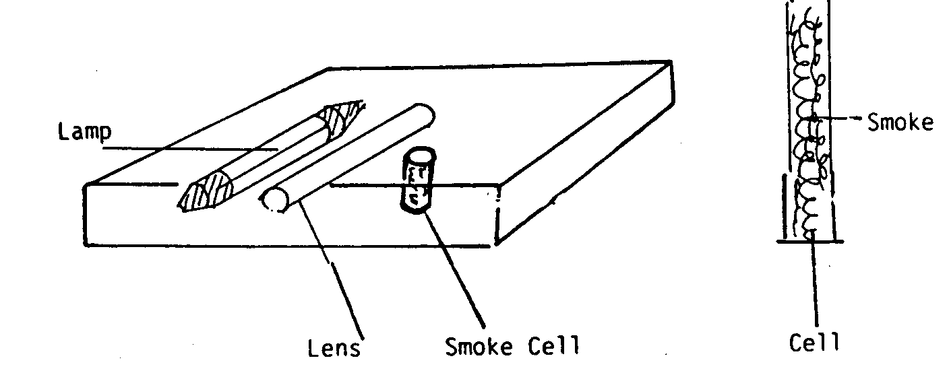

The lamp is connected to a separate 12v supply so that the microscope’s own supply is not required. Great care is necessary when focusing to prevent damage to the lenses or cells. (An objective lens of about 10x is sufficient to view the particles.)

After removing the cell from the microscope the drinking straw is lit and held vertically so that smoke flows down into the smoke cell held below. There are obvious risks in this part of the experiment and it is essential that it has been ‘run through’ in advance of the lesson. The smoke cells may be ‘filled’ with smoke by the teacher. The cell is then repositioned on the microscope stage and the lamp switched on to observe the specks of smoke. These specks, should be moving in an erratic manner due to collisions with air molecules.

It must be emphasised to learners that these bright specks are not particles.

Diffusion of Gases
Diffusion gives us more evidence for the motion of particles. For example:

Figure 2

Nitrogen cover slip
dioxide
nitric acid (brown gas)
_{oooo}
copper

A B C
The preparation of the brown gas takes place before the lesson, it is prepared in a fume cupboard and the entire experiment is best performed in the fume cupboard.

At stage C the cover slip is removed and the brown gas begins to diffuse upwards into C. The gas is more dense than air so that it must start in the lower gas jar to prevent simple mechanical mixing.

There is diffusion, i.e. spreading of one gas into another. The diffusion is slow although we know that particles have high speeds – hundreds of metres per second. This slow process is due to the large number of collisions (that a diffusing particle has) with other particles. At each collision the particle is knocked off course.

This kind of experiment can also be performed with bromine in specially designed apparatus so that the vessel in which the diffusion can be observed can be either evacuated or air filled. It must be emphasised that bromine is a very dangerous substance and special precautions are required in its use and storage, see for example, the HAZCARD for Bromine.

An easier demonstration (but which cannot be 'seen' in the same way) involves opening a bottle of scent. Get pupils nearby to raise their hands once they can detect the perfume. Then get them to think about how the scent moved from the scent bottle to their noses.

Diffusion of Liquids
Blue copper sulphate solution can be carefully poured down a funnel so that it forms a layer under a layer of water.
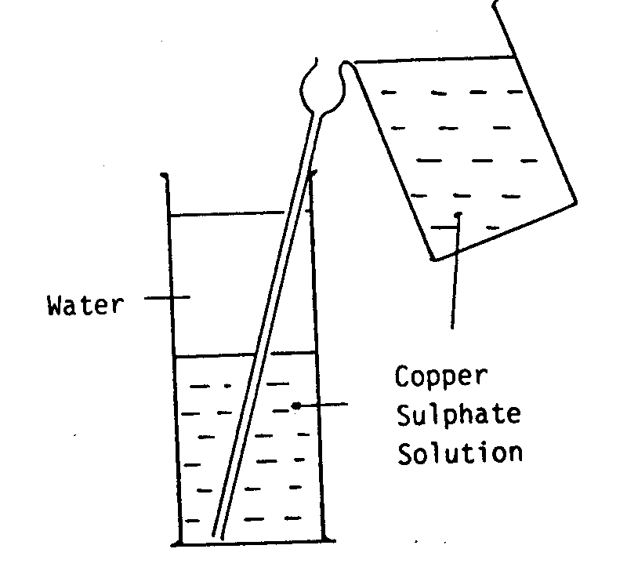
Figure 3
The process is slower and needs several days undisturbed to show diffusion.

In order to explain diffusion in terms of a particulate model it is useful to use a tray of expanded polystyrene spheres. Show how in a gas the particles are far apart while in a liquid they are close together. By using different sized or coloured spheres you can demonstrate how, by agitating the tray, the two types of sphere intermingle: rapidly in the “gas” and slowly in the “liquid”.

Crystalline structure of sulphur

Heat 2cm of sulphur powder in a test tube. As the sulphur melts it will darken. When the sulphur has just all melted pour it rapidly into a dry folded filter paper resting in a clamp stand. Crystals of monoclinic sulphur will appear as long needles as the sulphur cools. Don’t overheat the sulphur, as it will become too viscous to pour easily.

By using the tray of polystyrene spheres show how particles in a solid form regular arrangements of rows of particles. This can account for crystals having flat sides and sharp edges.

There are other models that can be employed in place of polystyrene spheres when explaining phenomena in terms of the particulate nature of matter:

Spring Models for a Solid

Figure 4
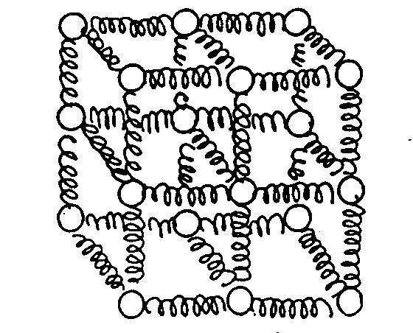
This model may be shaken gently to mimic the lattice vibrations of a solid. If the vibration is increased some ‘particles’ gain sufficient energy to break out of the regular array and a ‘liquid’ begins to form.

Marbles in a Tray

Figure 5
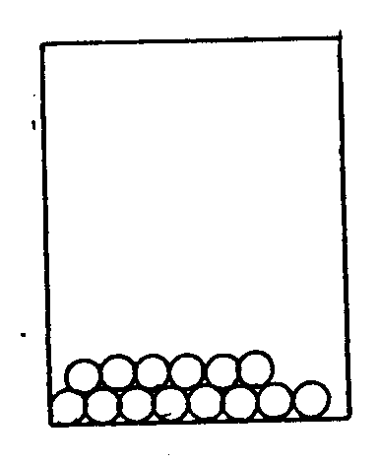
If we pack marbles into a sloping tray they will roll to one end to form a static structure – solid. A small amount of shaking causes the loss of the regular structure to give a dense system in which the particles can move around, as in liquid.

If most of the marbles are removed so that their spacing increases we have a model for a gas. The marbles can be made to move around, like gas particles, colliding with the sides of the tray. If a marble is followed its motion cn be sketched.

A large sphere, or simply more massive marble, can be placed in the tray and its motion observed as the tray is shaken. This motion is like the motion of a smoke speck in the Brownian Motion experiment.

Three Dimensional Model of a Gas
Figure 6
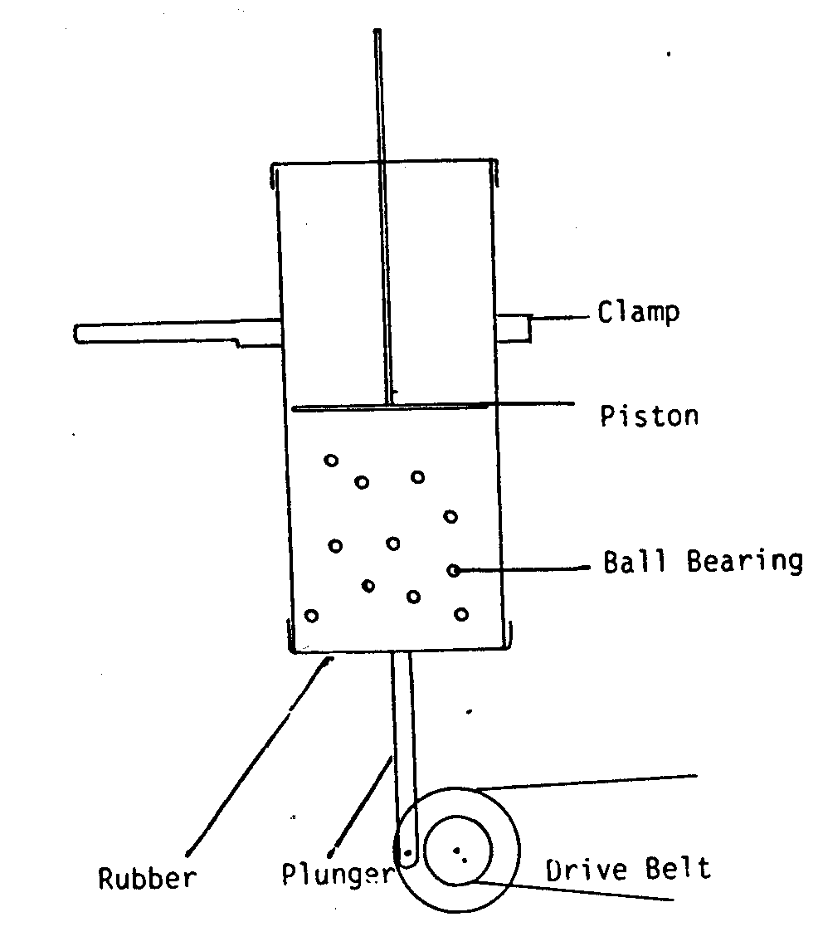
The eccentric drives a plunger causing it to vibrate a rubber diaphragm, which is across the lower end of a perspex tube. Small ball bearings in the tube are kept in motion by the vibrating diaphragm. Their behaviour is similar to that of gas particles and when a small cardboard piston is placed in the tube and ball bearings will collide with it and exert a pressure. There are of course important differences: an energy input is required in the model, the speeds are very low in the model, the walls and base should behave in a similar way. Gravity however acts in both cases.

Task 4
A bright 13 Year-old pupil asks you a number of questions:

- Why does a coloured crystal spread slowly through water without stirring?

- Why does a kettle lid lift up when the water boils?

- Why do metals expand when heated?

- Why does a cube of ice change to the shape of its container when it melts?

Assume these answers are posed during a science lesson. You need to provide a concise response that satisfies the pupil(s) inquiry and that is at a level appropriate to the age-range of the class.

Write down a transcript of how you would respond to each question. It is a good idea to try out your explanations on a friend or relative.

So far we have been using the term “particle” exclusively. This, of course, has the advantage of being an all-embracing term. At some stage, however, it is necessary to start talking about atoms and molecules and, at a later stage, ions. This will come when elements and compounds are introduced.

Let us assume that pupils now have some notion of the existence of particles (molecules, atoms) and that these particles cannot be observed directly because they are very small. The logical question that follows is .... how small? The experiment following describes how this can be answered. Please note, however, that the oil film experiment relies on some fairly difficult mathematics and should not be attempted with less able sets.

The Oil Film Experiment
This experiment allows us to estimate the size of an oil molecule. A drop of oil of measured size and therefore known volume is placed on the clean surface of a tray of water. The drop forms an oil patch that rapidly spreads to its final size. By measuring the size of the patch and calculating the area the thickness can be determined.

We assume that the oil drop and the oil patch have the same volume. It is also assumed that the patch spreads until it is one molecule thick.

In the preparation of this apparatus cleanliness is of paramount importance. Any grease, e.g. from finger marks, will contaminate the containers so that the oil film does not reach its correct size. All the containers i.e. tray and jugs or beaker must be thoroughly rinsed before use. The tray is filled to overflowing so that a meniscus forms causing the water level to be slightly above the container sides. Two waxed booms are used to clean any remaining contamination from the surface. The booms are placed across the centre of the tray as shown. They should then be carefully drawn across the tray so that they take any
contamination with them to the ends of the tray. A light powder (Lycopodium) is sprinkled across the water surface so that it can be used as an indicator of oil patch size.

The oil drop should by now have been produced and measured. It is formed on a piece of bent wire and its diameter measured with a simple magnifying glass and scale. The drop is placed in the centre of the tray and immediately a patch some 20mm across forms, the diameter of which should be quickly measured.

In many cases nothing remarkable happens when the drop is placed on the surface this failure is likely to be due to contamination. It is then necessary to start again by cleaning the tray and refilling.

If the volume of the drop is equal to the volume of the patch. We can write:

volume of drop = volume of patch

and 4πr³_{d} = πr²_{p}t
3

where r_{d} = radius of drop
r_{p} = radius of patch
t = thickness of patch

then t = 4r_{d}³
_____
3r_{p}²

This is not an easy calculation and yet this experiment was used in an early part of the Nuffield O level Physics course. To simplify calculation it has been suggested that the drop could have approximately the same volume as a cube of side r_{d} and the patch could be taken to be square.

These two approximations give: r_{d}³ = r_{p}²t t = r_{d}³

r_{p}²

two main difficulties are clear
- The mathematical skills required
- The concept of volume is essential for an understanding of the method.

Example

An oil drop of diameter 1.0mm is placed on the surface of the water so that it spreads to give a patch of diameter 250mm.

Calculate the thickness of the patch:

radius of drop = 0.50mm
radius of patch = 125mm
volume of drop = volume of patch

4π(0.50)³ = π(125)²t
3

t = 4 x (0.50)³ = 1.5 x 10⁻⁵ mm
3 x (125)²

The Oil Film experiment requires some fairly sophisticated mathematics in the calculation. It cannot really be successfully tackled unless you have a fairly able group of year 10/11 pupils.

Task 5

In an experiment to estimate the size of a molecule of olive oil, a drop of the oil, of volume 0.12mm³, was placed on a clean water surface. The oil spread into a patch of area 6000mm². Estimate the size of a molecule of olive oil. What assumptions did you make?
I would emphasise here that it is never a question of pupils either knowing or not knowing about atoms/molecules/ions, it is a question of the degree and depth of their understanding. In particular their ability to apply the model when explaining what they see.

Task 6
Refer to the Level Description in the National Curriculum. Find Sc3, and look for references to the properties of materials in terms of the atomic/molecular model.

In GCSE examinations Grade C corresponds to about Level 7. A minority of pupils attain a Grade C or above in GCSE Science.

In the light of the above, to what extent is the theory underpinning Chemistry accessible to all pupils?

- Solids, liquids and gases
Solids are normally rigid with a specific shape of their own. They are usually dense.

Liquids take up the shape of the bottom of the container that they are in and have a flat surface under normal conditions. They are fluid (ie they flow) and are normally dense. They may be very runny (low viscosity) or quite sticky (high viscosity).

Gases take up the shape of the whole of the container that they are in. They are fluid, usually colourless and have a low density. The most common coloured gases are bromine vapour (brown), nitrogen dioxide (brown) and chlorine (pale yellow/green).

A common misconception is ‘gases are light, solids are heavy and liquids come in between’. Certainly gases have a very low density. However the density of liquids and solids is comparable. Get pupils to pick up a bucket of water…this normally convinces them that liquids, like solids are normally dense.

You can begin to use models to explain the differences between solids, liquids and gases. Marbles or polystyrene spheres can be put in a try to model the idea of ‘particles’ and that particles are arranged differently in solids, liquids and gases.

Fig. 7

O Gas: particles can move around freely (gases flow) and
O are far apart (have a low density)
O

Figure 8
If we pack marbles into a sloping tray they will roll to one end to form a static structure – solid. A small amount of shaking causes the loss of the regular structure to give a dense system in which the particles can move around, as in liquid.

- Changes of State

Pupils may have real difficulty believing that materials can exist in any of the three states of matter. They will, of course, be familiar with water existing as a solid (ice), liquid (‘water’) and a gas (‘steam’)* and that heating and cooling can be used to bring about changes of state of water. However there are few other materials which are readily available to illustrate the material existing in two (or three) different states. A complication is that many materials will change chemically when heated, perhaps by burning or decomposition.

(* steam is not a gas or vapour . Water vapour is colourless and invisible. Steam is formed as water vapour cools resulting in the formation of tiny droplets of water suspended in the air)

Let us recap the inter-relationship of the states of matter:
melting boiling
SOLID LIQUID GAS
freezing/ condensing
solidifying

Changes of state occur at specific temperatures (at normal atmospheric pressure). Changes of state do not normally occur quickly. A popular experiment to carry out as a class practical is to get pupils to construct cooling curves:

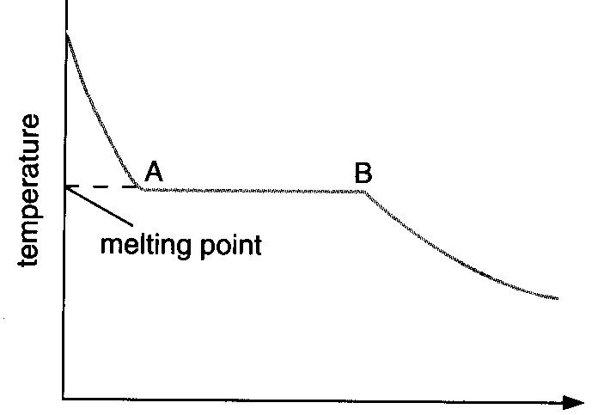
Fig.9
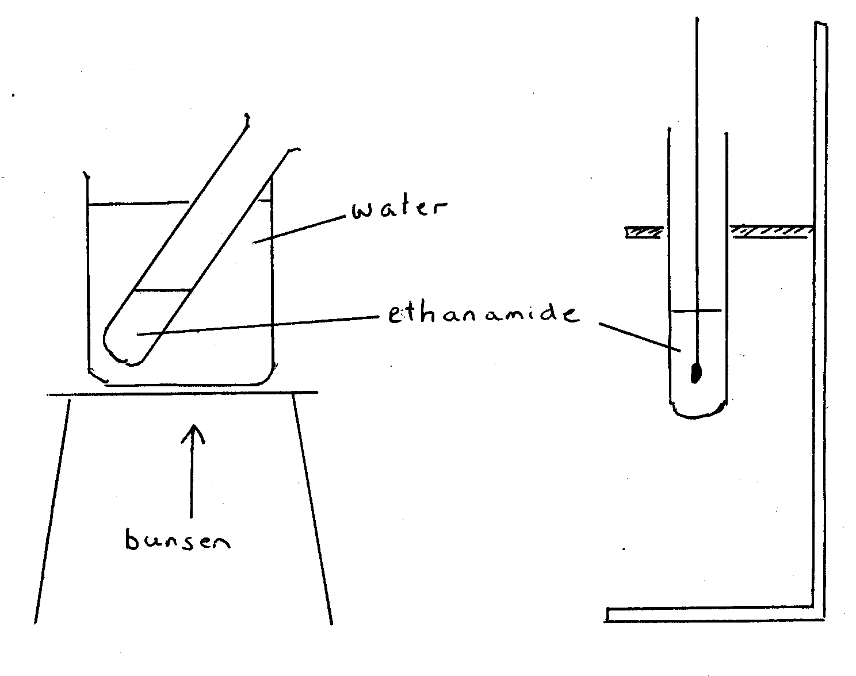
time

A few substances appear to pass straight from a solid form to a gaseous form.

Fig.10

purple iodine vapour rising

Note: this demonstration should be
carried out is a fume cupboard
black iodine crystals

If a few iodine crystals are gently heated on a large watch glass, they appear to change to purple iodine vapour which then condenses back into tiny iodine crystals on the cool surface of the inverted funnel. This process, sometimes called sublimation occurs when the melting point and boiling point of the material are very close together.

Let us think now about how changes of state can be explained using particle theory:

A solid consists of tightly packed particles that are held together by forces of attraction. These forces are strong enough to align the particles in a particular ways, thus giving the solid an overall shape. The particles cannot move freely but they can vibrate about their fixed position in space. As the solid is heated and its temperature rises the vibration of the particles increases, but the forces of attraction between adjacent particles remain sufficient to keep each particle in its own particles position within the solid structure.

Eventually the vibration of the particles becomes so large that they are able to break free from their fixed positions in space and move about freely within the material: the substance has melted. However the forces of attraction between particles is such that the particles remain close together (liquids are normally dense).

Within liquids particles are moving around in all directions. Some particles are more energetic than others; some are moving more quickly and some more slowly, but as the liquid is heated the average speed of the particles increases. Energetic particles near the surface may, if moving upwards, have sufficient energy to leave the surface of the liquid and go into the air. Such particles may fall back into the liquid again or they may escape completely from the liquid (particularly if they get blown away by a breeze or draught). This is evaporation: this can occur at any temperature but occurs more readily at higher temperatures when there are more faster moving particles in the solution.

Boiling, on the other hand, occurs at a specific temperature, the boiling point. While evaporation occurs at the surface of a liquid, boiling takes place within the body of the liquid. Thus the bubbles seen when water boils can form anywhere within the water.

Task 7

When you heat up a saucepan of water in order to boil an egg you will see bubbles forming around the sides of the saucepan once the water reaches about 40-50ºC. What are these bubbles made of?

Once the water is boiling you will see larger bubbles forming within the body of the water and their will be some churning of the water as these bubbles rise up to the surface. What are these bubbles made of?

Tap water contains dissolved air. In hot water the solubility of air is less than in cold water. As tap water is heated the dissolved air forms bubbles and slowly escapes.

When water boils there is a change of state: water changes from the liquid to the vapour state. Bubbles in boiling water are made of water vapour. In water boiling at 100ºC the faster moving particles change from liquid to vapour state first. Heat from a sources such as a bunsen burner then provides additional energy to the slower particles which then in turn change to the vapour state.

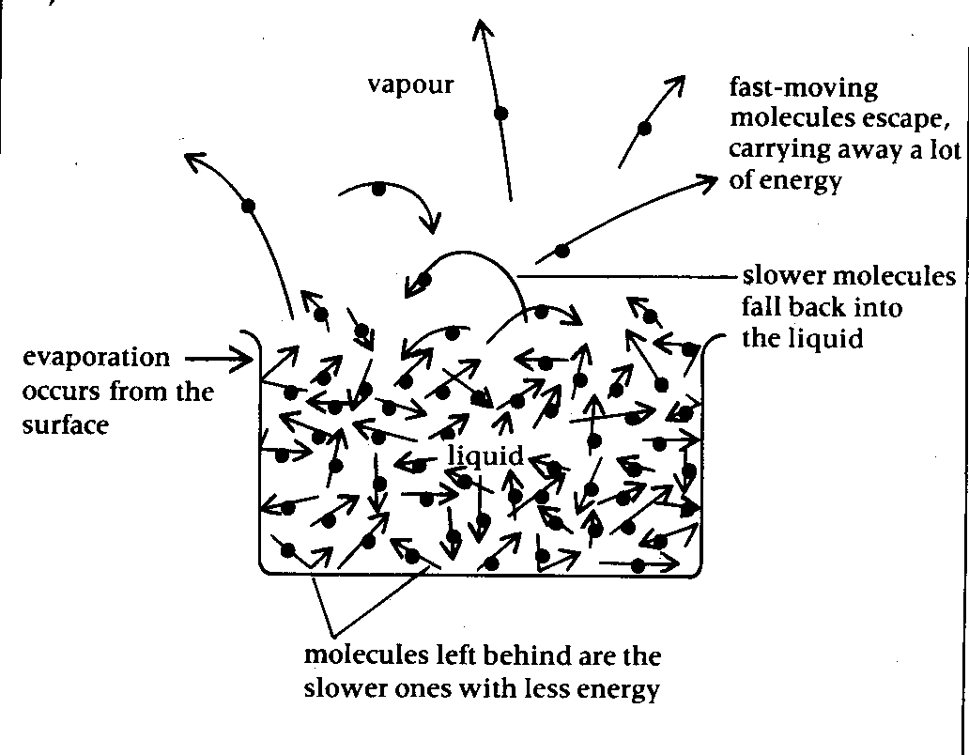
Fig.11 Evaporation
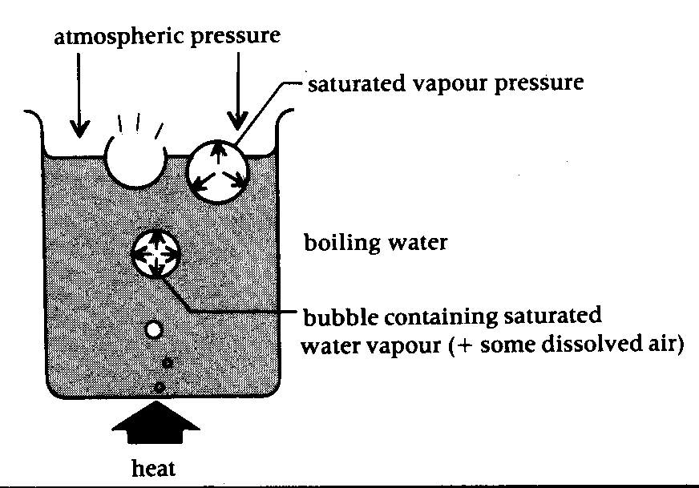
Fig 12 Boiling
Changes of state are not spontaneous: they occur over a period of time during which energy is either taken in (melting, boiling) or given out to the surroundings (freezing, condensing) while the temperature remains constant. This heat exchanged with the surroundings is called latent heat and is the energy change needed for a change of state to occur.

- Elements, Mixtures and Compounds
An element is a material that cannot be broken down into simpler constituent substances. For example, a piece of gold (an element) cannot be broken down into simpler substances. This is because all the constituent atoms are identical: they are gold atoms. Similarly iron is made up entirely of iron atoms. All elements are made up of identical atoms, each unique to that particular element.

Pupils are often fascinated by the derivation of the names of elements. One activity you can try is to give the pupils a list of the 100 or so elements and get them to try and identify which have been named after people or places. You can explain why some elements have symbols derived from Latin names and that this might mean that the Romans knew these materials (lead, copper, tin, iron etc). Get pupils to learn 20 symbols for homework…and test them on this the next lesson!

A compound is a substance that cannot readily be separated into simpler substances by physical means. It is made up of identical particles (such a molecules). Water is an example of a compound. Pure water is made up entirely of water molecules that are identical. However the water molecules can be broken up into oxygen and hydrogen gases (elements) by means of electrolysis.

A mixture can usually be fairly readily separated. A mixture could be:
- An element mixed with another element or elements
- An element mixed with a compound or compounds
- A compound mixed with another compound

To simplify matter the examples chosen to use with pupils should normally have only two constituent materials.

Let us consider some examples of mixtures:

Brass is a mixture of zinc and copper
Brine is a mixture of ‘salt’ and water

A common experiment to illustrate the idea of elements, compounds and mixtures is to use iron filings and sulphur to make iron (II) sulphide. Iron and sulphur can be discussed as elements consisting of either iron or sulphur atoms. A spatula full of iron can be mixed with a spatula full of sulphur to produce a mixture of the two elements. You can then ask the class to suggest a way in which the mixture could be separated. Suggestions are likely to include:
- Using a magnet to ‘pull’ the iron filings away from the sulphur
- Adding water and shaking: the iron tends to sink and the sulphur tends to float.
In fact neither methods is completely satisfactory as the two materials tend to stick to each other.

A small amount of the mixture can then be heated in a test tube held in a hot bunsen flame. After a little while a red glow spreads through the mixture as the iron and sulphur start to react. At this point the test tube can be removed from the bunsen flame. The heat of the reaction will allow the reaction to complete.

N.B. - most people do not heat the test tube strongly enough
- check HAZCARD: sulphur dioxide can be produced

So far we have not explained the differences between elements, mixtures and compounds in terms of simple particle theory. This is because we now need to refine the notion of particles and begin to think in terms of types of particle in order to satisfactory explain how elements, mixtures and compounds differ, Let us now consider this further.

9. Particles revisited: atoms, molecules and ions
To date we have largely been using the notion of ‘particles’ to explain the behaviour of matter. You will be aware of other terms that are used when refining the description of such particles. Thus we may talk of ‘atoms’ or ‘molecules’ or ‘ions’.

Let us go through the meaning of each of these terms:
Particle is a generic term. Thus we can say (correctly) that all matter is made up of particles. The existence of particles can help explain a range of physical phenomena:
Differences between states of matter
Changes of state
Expansion and contraction of materials
Pressure of gases
Diffusion

However the term ‘particle’ is insufficient for explaining much of chemistry. Chemistry, being the science of materials needs an explanatory framework explaining how and why materials differ from each other and how different material react with each other. Some questions which cannot be answered satisfactorily using the term particle would include:
Why do some substances conduct electricity while others do not?
Why does sodium react with water while copper does not?
Why is iron an element while iron (II) sulphide is not?

In chemistry we must first refine the notion of ‘particle’ by introducing the terms ‘atom’, ‘molecule’ and ‘ion’ at appropriate junctures. Having done this we need to move on to examining the sub-atomic structures of such particles. Let us consider next the different types of particle

Atoms are the smallest part of an element. Thus, if we were able to divide a piece of iron (an element) successively into smaller and smaller pieces, the smallest particle we would end up with which is still a piece of iron would be an atom of iron.

Molecules are normally small clusters of atoms bonded together to form the smallest piece of a chemical substance. Thus the smallest particle of water possible is a molecule consisting of two hydrogen atoms and one oxygen atom joined together.

Fig 13

Water (H₂O)

Water is a compound of oxygen and hydrogen, with two hydrogen atoms bonded to a central, larger oxygen atom. Other examples of molecules of compounds include:

Fig 14

ammonia (NH₃) methane (CH₄)

The reason why compounds are difficult to break up into constituent atoms is because the constituent atoms are bonded together strongly. It needs a great deal of energy in order to break these bonds.

Most elements are also made up of molecules rather than individual atoms. The majority of common gaseous elements are made up of diatomic molecules consisting of two identical atoms bonded together. For example:

Fig.15

gaseous oxygen (O₂)

Sulphur, on the other hand is made up of molecules consisting of eight sulphur atoms (S₈). Some elements and molecules are made up of macromolecules rather than the simple discrete molecules we have considered to date. Let us consider some examples:
- diamond and graphite are both pure forms of the element carbon ('allotropes' of carbon). The structure of each substance consists of an extended 3-dimensional array of carbon atoms. The differences between diamond and graphite can be explained by the different ways in which the carbon atoms are arranged. Most schools will have molecular model kits than can be used to represent atoms, molecules and bonds. 'Ball and stick' modelling kits are particularly useful. Using these we can represent diamond and graphite thus:

Fig. 16
diamond graphite

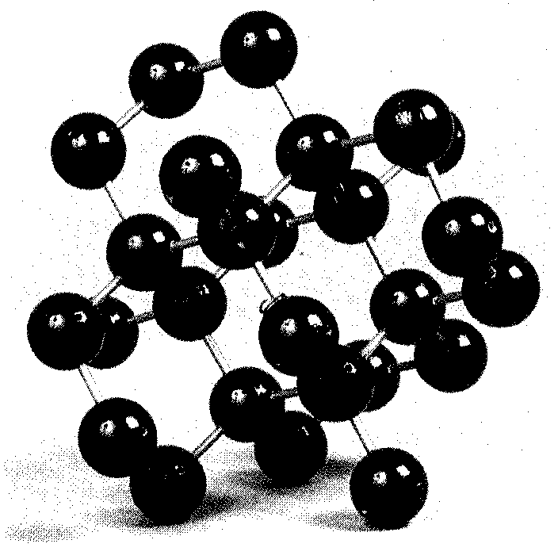
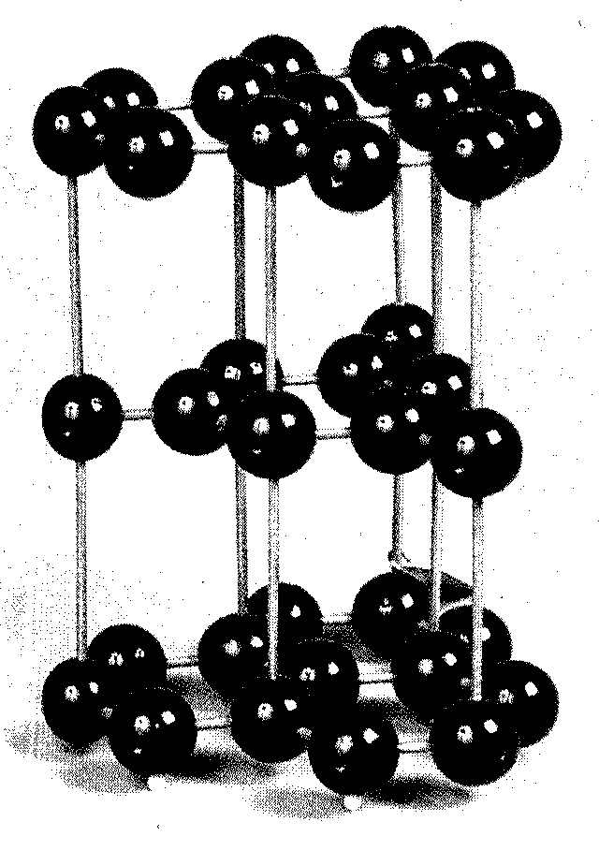
You should note that in each case only part of the macromolecule is shown.

Ions are electrically charged particles. Ions can be negatively or positively charged. Materials made up of ions have an overall charge of zero as they contain both positively charged and negatively charged particles with the number of charges cancelling out. Many common crystalline chemicals are made up of ions. Sodium chloride ('salt') is one example:

Fig. 17

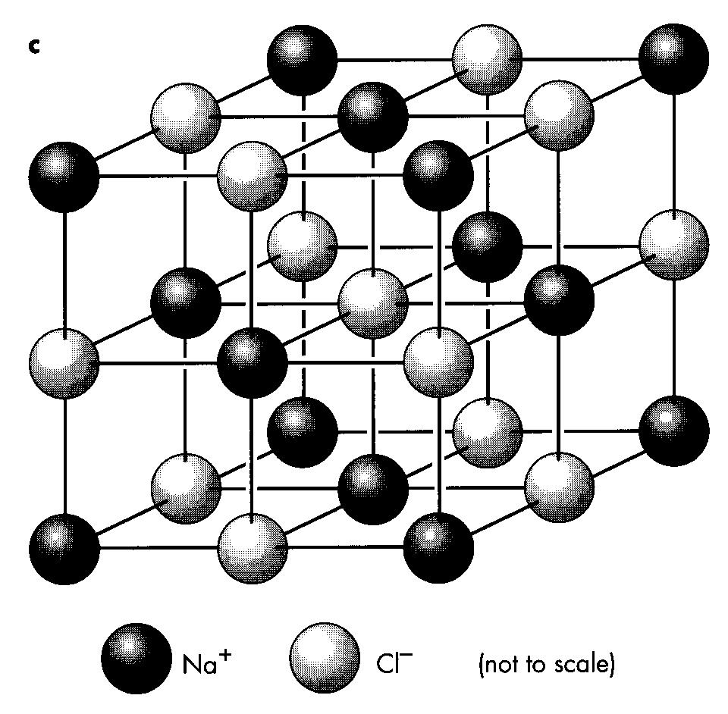
The figure represents a small part of a crystal of sodium chloride. The particles in the crystal are charged ions rather than atoms. Sodium ions (Na⁺) are positively charged particles with one electron less than a sodium atom, while choride ions are negatively charged particles with one electron more than a chlorine atom. The ions are bonded together into a crystal lattice. The bonds are electrostatic in nature. Within the lattice ions will interact in a number of ways:
Postive ions will attract negative ions
Postive ions will repel other positive ions
Negative ions will repel other negative ions

Overall the forces of attraction exceed the forces of repulsion thus holding the ions in place within the crystal lattice.

Within sodium chloride, or any other substance made of ions for that matter there is no overall charge. In the case of sodium chloride this occurs because there are equal numbers of positively charged sodium ions and negatively charged chloride ions.

10. Separation techniques
There are a variety of physical methods that can be used to separate mixtures of substances. We have already suggested two of these when thinking about the separation of iron and sulphur. Let us consider some additional ways of separating mixtures:
Filtration

You will be surprised to learn that pupils do not find this skill self-evident. Indeed, even after acquiring it many pupils quickly forget how to fold a filter paper or do not realise the importance of not over-filling the filter funnel. Thus, while the technique of filtration is included in the PoS for KS3 you may need to refresh pupils’ memories.

A good experiment to use (which also brings in changes of state and the concepts of soluble/insoluble) is the separation of pure salt from rock salt by:

- Grinding up a few crystals of rock salt with a mortar and pestle.

- Mixing the small crystals with distilled water and stirring to dissolve the pure salt.

- Filtering the mixture to separate the residue from the salt water.

- Boiling off most of the water from the solution in an evaporating basin. Allow the salt to crystallise.

This may seem a trivial experiment to you. However it is important to stress to you at this stage that one lesson that all trainee teachers must learn is that learning science is neither easy nor straightforward for the majority of children. It is a common mistake to both overestimate children’s background knowledge and to overestimate their ability to acquire and retain new knowledge. On the other hand you need to be aware of the range of experience of science they have encountered in primary school, as well as the range of ability and attainment found in a class of pupils. The key to successful teaching is to address pupils in language that they can understand and provide explanations to them that are clear and at a level that is appropriate to their age and ability.

At this stage it might be appropriate to extend children’s knowledge by showing that filtration can be used with solutions using a solvent other than water. A useful preliminary exercise is to ask pupils if they know of any liquids that don’t contain water. You will find a very limited range of answers.

Distillation

Separating water from “sea water” is a good method of illustrating this and can be discussed in conjunction with desalination. Use of a Liebig Condenser will certainly aid condensation of steam but it must be remembered that the mechanics and structure of the Liebig Condenser needs good explanation: some pupils will believe that the water dripping from the end of the condenser comes from the tap connected to the hose.

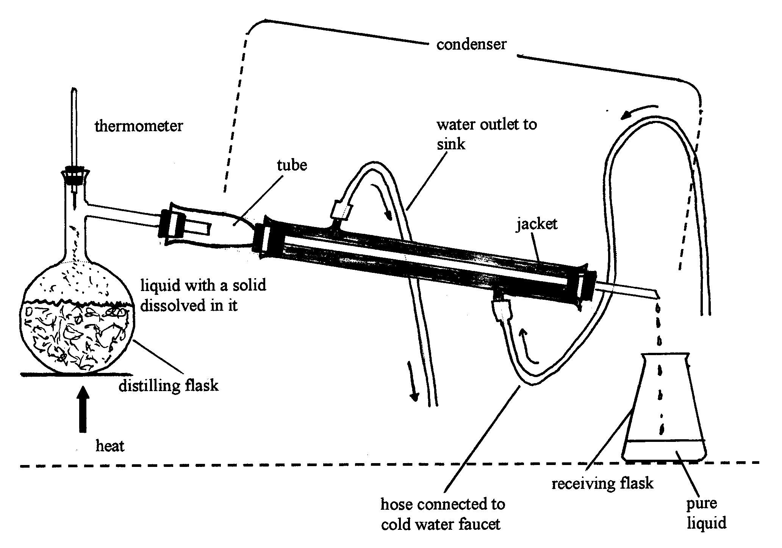
Figure 17
Using copper II sulphate solution can be more eye-catching to the pupil as the colourless water emerges from the blue solution.

Fractional Distillation

As a method of separating two liquids methylated spirits can be separated from water using a fractionating column (of which there are a number of varieties on the market). This would be carried out as a demonstration. Remember to heat the mixture slowly to effect a good separation. (It should be born in mind as well that operating a still has legal implications!) A very simple explanation of this phenomenon should be given at this stage in terms of differences in boiling point.

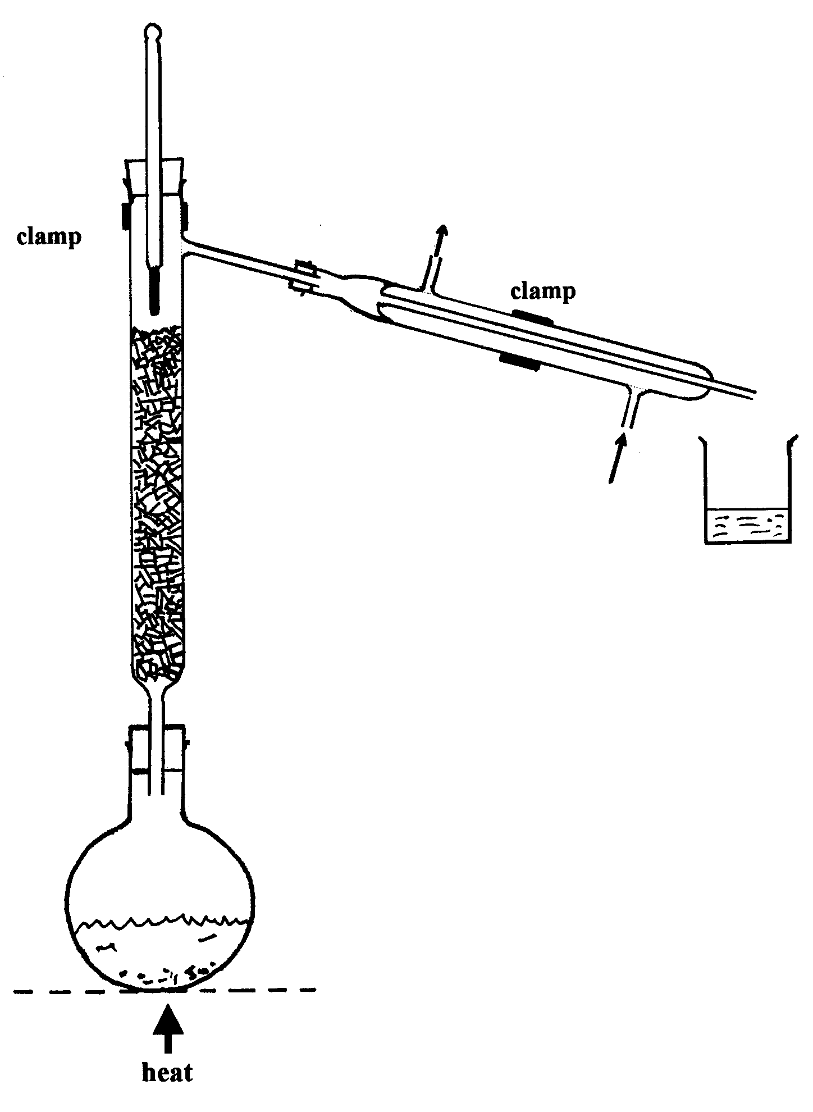
Figure 18
Figure 19

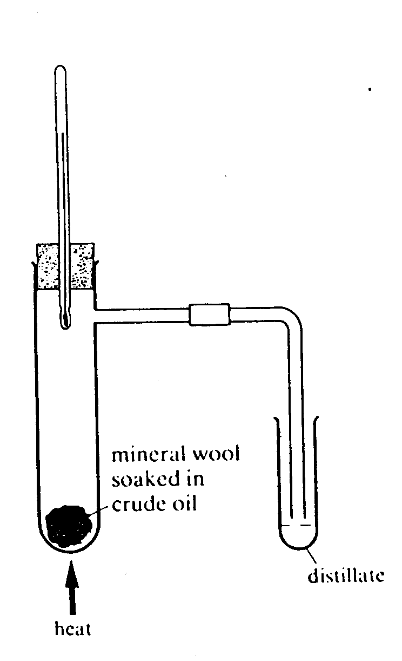
A very nice class experiment involves the fractional distillation if “crude oil” (a synthetic mixture containing no carcinogens can be made up). Once again the key to good separation involves gentle heating. (You will find that pupils will use excessive amounts of chemicals and heat substances too strongly).

Four of five fractions can easily be obtained and compared for colour, viscosity and combustibility. This lesson can make a very important contribution to an elementary discussion of the petroleum industry, perhaps with a Unit/Module/Topic on Fuels.

Chromatography

At an elementary level we are talking about separating a mixture of coloured pigments using paper chromatography. This can be achieved in a number of ways:

- “Drop” chromatography. Here a filter paper has two cuts made in it so a segment can be made to hang down. A drop of the mixture to be separated is placed at the centre of the filter paper. The hanging piece of filter paper is allowed to dip into a beaker of water. Coloured rings are seen to separate out. This method is good when water is an appropriate solvent.

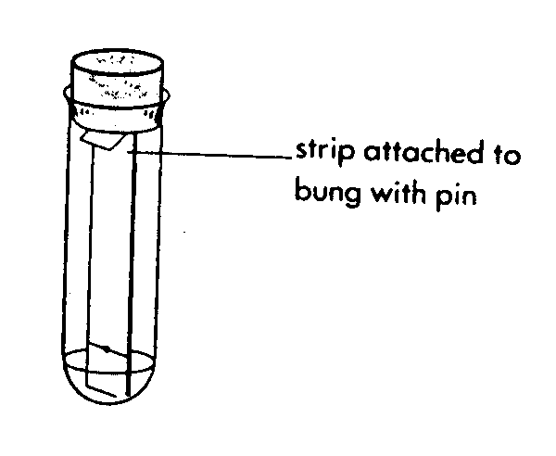
Figure 20

- “Filter strip” chromatography. In this case a strip of filter paper is cut to fit into a boiling tube. The paper can be clipped into a slit made in a cork and marked with a spot of the coloured mixture as shown. Solvent is added to the bottom of the boiling tube and the paper suspended in it.

Felt tip pen inks can be used as the coloured mixture. Dark inks work best usually. Use an appropriate solvent.

Separation of the pigments in plant extract from leaves works well too, especially in summer. In this case the leaves must be ground up in a mortar and pestle with sand and a little ethanol of acetone (propanone) to obtain the extract. Ethanol or acetone would be used as the solvent in the boiling tube.

- Atomic Structure
Atoms of elements cannot easily be broken down into sub-atomic particles (protons, electrons, neutrons etc). The story of how late nineteenth century and twentieth century physics led to the discovery of sub-atomic particles is a fascinating one. However it is largely beyond the remit of key stage 3 science pupils. However it should be remembered that this is a very recent story, starting with Thompson's discovery of the electron in 1897 and the whole story has yet to be told. The elusive 'Higg's Bosun' sub-atomic particle has been postulated theoretically but as yet there is no empirical evidence of its existence. Watch this space!

At GCSE level the 'Bohr model' of the atom is called for. With this model each atom has a central nucleus containing positively charged protons and uncharged neutrons. Orbiting the nucleus are the much smaller negatively charged electrons. In summary

sub-atomic particle | electrical charge | relative mass | where found
proton | +1 | 1 | nucleus
electron | -1 | 1/1840 | orbits nucleus
neutron | 0 | 1 | nucleus
Atoms of different elements differ in their numbers of protons, electrons and neutrons.

Let us consider the three smallest and simplest atoms:

Fig. 21
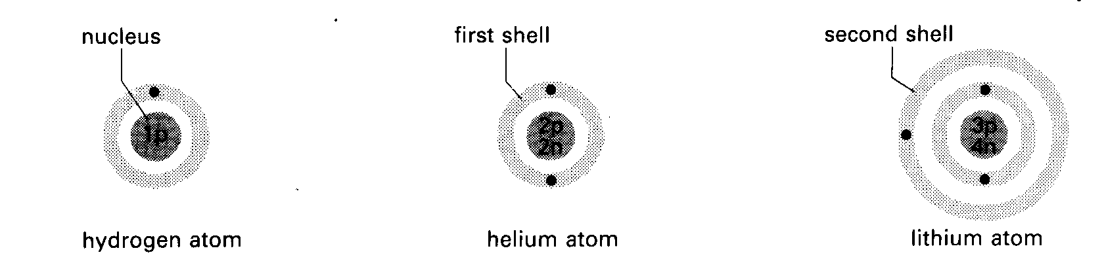
In the case of hydrogen the nucleus contains just one proton (1p) around which one electron orbits.

In a helium atom the nucleus contains two protons and two neutrons. Two electrons orbit the nucleus in the 'first shell'.

In a lithium atom the nucleus contains three protons and four neutrons. Three electrons orbit the nucleus: two in the first shell and one in the second shell

Note:
- The number of protons and the number of electrons in an atom is identical, thus rendering atoms electrically neutral overall.
- Electrons are found in regions of space called 'shells'. The first shell can hold a maximum of two electrons; the second shell up to eight electrons, the third shell up to eighteen electrons
- As atoms get larger the numbers of protons, neutrons and electrons in the atom increasing the mass of successive atoms
- The Bohr model is a useful representation of the structure of atoms. Beyond GCSE and going on to degree courses increasingly sophisticated models become needed to explain more fully the properties of matter. For example the magnetic properties of iron are not explicable using the Bohr model of an atom.
- Remember: atoms are 3-dimensional. Normally they are represented by a 2-d model.

- Atomic Number and Mass Number
The atomic number of an element is defined as the number of protons in the nucleus of the atom ( = number of electrons orbiting the nucleus)

The mass number of an atom of an element is the number of particles in the nucleus of that element (i.e. number of protons + number of neutrons)

Often atoms are represented showing the chemical symbol of the element, the atomic number and the mass number. For example, let us consider representations of the three atoms shown in Fig. above.

1 4 7 mass number
H He Li
1 2 3 atomic number

Simply by knowing the atomic number and mass number of an atom it is possible to draw Bohr models of the atom. See how you get on with the Task below:

Task 8

Draw Bohr models of:

12 16 23
C O Na
6 8 11

There are two points of confusion that often arise:
- Sometimes the mass number and atomic number are reversed so we would get, for example: 6
C
12
However, it should be remembered that the atomic number is the numerically smaller of the two.
- Sometimes elements are represented using the atomic number and the relative atomic mass, rather than the mass number. While the mass number and relative atomic mass are numerically similar, they have different meanings (see below)

- Isotopes
In samples of most elements all atoms are not identical. While all the atoms in, say, oxygen, are oxygen atoms (they all have an atomic number of 8), a few have a slightly higher mass than the great majority of atoms. This is because naturally occuring oxygen atoms are of three different types:

16 17 18
O O O
8 8 8

The only difference between the three types of atom lies in the number of neutrons in the nucleus. The great majority of oxygen atoms have 8 neutrons in the nucleus while a much smaller proportion of oxygen atoms have either 9 or 10 neutrons in the nucleus.

Consider next two isotopes of the element carbon:

Fig.22
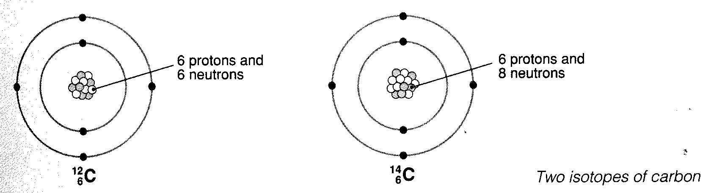
Isotopes are atoms of the same element containing different numbers of neutrons in the nucleus and, hence, different mass numbers. Often (as with oxygen and carbon) one of the isotopes is much more common that the others.

- Relative Atomic Mass
This quantity is defined as the average mass of an atom of an element using a scale where an atom of Carbon-12 is defined as having a mass of 12.0000 atomic mass units.

Consider the element chlorine. In chlorine gas two isotopes are found:
- 37
Cl Cl
- 17
Cl-35 has a relative isotopic mass of 35 (= mass number)
Cl-37 has a relative isotopic mass of 37 (= mass number)

However in chlorine 75% of the atoms are of the isotope Cl-35 and 25% of the atoms are of the isotope Cl-37. To find an average mass of a chlorine atom we must calculate a weighted average that takes into consideration the relative proportions of the two isotopes of chlorine.

Thus:
The mass of 100 chlorine atoms = (75 x 35) + (25 x 37) atomic mass units

The average mass of a Cl atom = (75 x 35) + (25 x 37) atomic mass units
100

= 35.5

This is the figure given the relative atomic mass of chlorine. You will usually find this figure in Periodic Table charts.

- Chemical Bonding
We have used the term 'bonding' in a number of contexts already. In this section we will look more closely at why bonding occurs between various atoms/ions and at the different types of chemical bond.

It is known that certain chemical elements are particularly inert; that is to say they do not undertake chemical reactions. These elements are termed inert gases. They include neon, argon and krypton. Chemists explain their lack of chemical reactivity by referring to the way in which electrons are arranged around the nucleus of each atom.
Let us consider an atom of the element neon for example. Neon has an atomic number of ten: therefore it will have ten electrons orbiting the nucleus. We know that the electron shell nearest the nucleus can hold only two electrons. The second shell can hold a maximum of eight electrons. We can say that the electrons in a neon atom are arranged thus:
Ne = 2.8

Thus an atom of the element neon has two full shells of electrons. Such an arrangement of electrons we believe confers stability and lack of reactivity to the element neon. Other inert gases have similar stable arrangements of electrons:

He = 2.
Ne = 2.8
Ar = 2.8.8

Other atoms do not have stable arrangements of electrons but could, by exchanging or sharing electrons with other atoms, achieve these stable arrangements. Let us consider how this can occur.

Ionic bonding
At GCSE level ionic bonding is described in terms of electron transfer from one atom (normally a metal) to another atom (non-metal). This occurs so that the respective electron arrangements can become stable. A stable electron arrangement is one that corresponds to those of inert (noble, rare) gases. This can be illustrated easily by looking at the interaction between an Na atom and Cl atom using the Bohr Model of the atom:

Figure 23
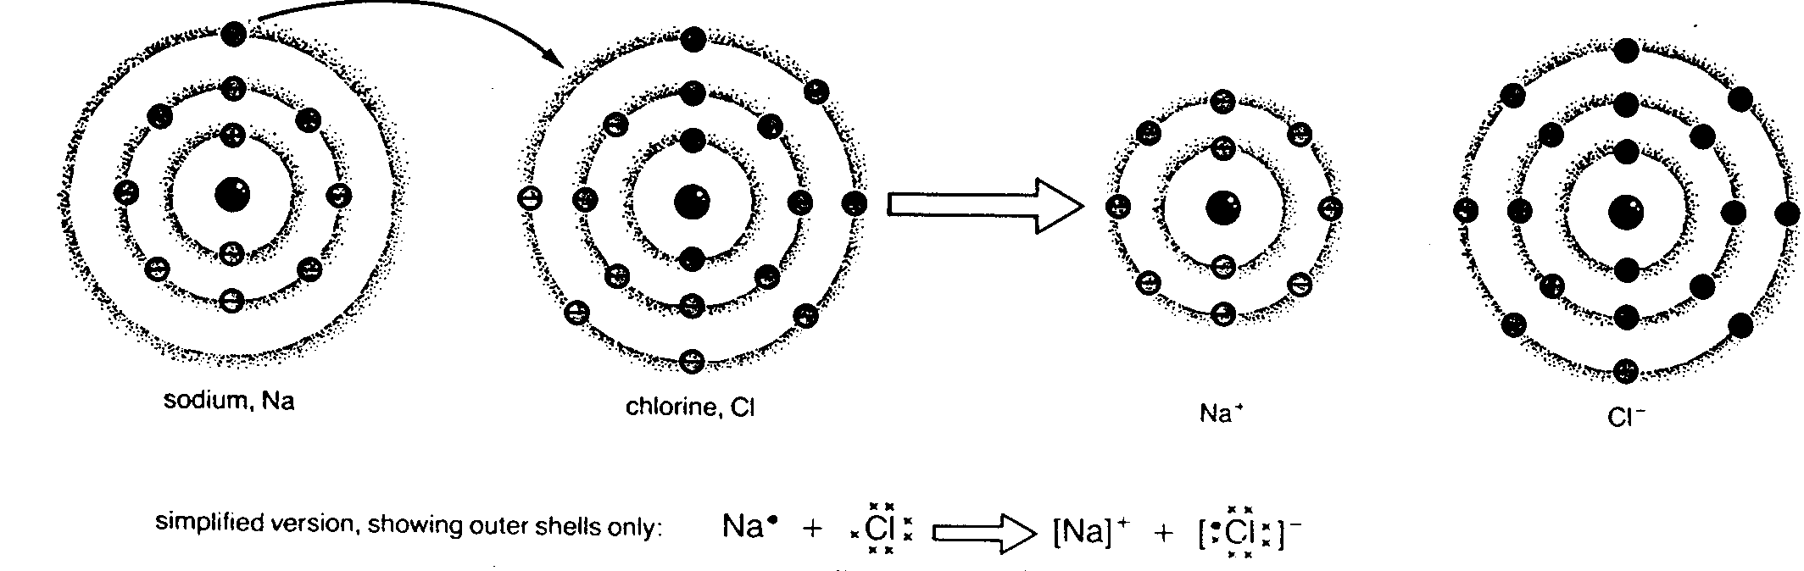

The electrons in a sodium atom, Na, are arranged:
Na = 2.8.1
The electrons in a chlorine atom, Cl, are arranged:
Cl = 2.8.7

If an electron is transferred from a sodium atom to a chlorine atom as shown above ions are formed which have their electrons arranged in the same way as an inert gas:

Na⁺ = 2.8 Cl⁻ = 2.8.8

Task 9

Show diagrammatically how a magnesium atom (Atomic number = 12) and an oxygen atom (Atomic number = 8) can exchange electrons to form magnesium oxide so that the magnesium ion (Mg⁺⁺) and oxide ion (O⁻⁻) have stable electron arrangements.

Covalent Bonding
In the case of covalent bonding stable arrangements of electrons can be achieved by atoms sharing outer electrons with neighbouring atoms. Consider, for example,

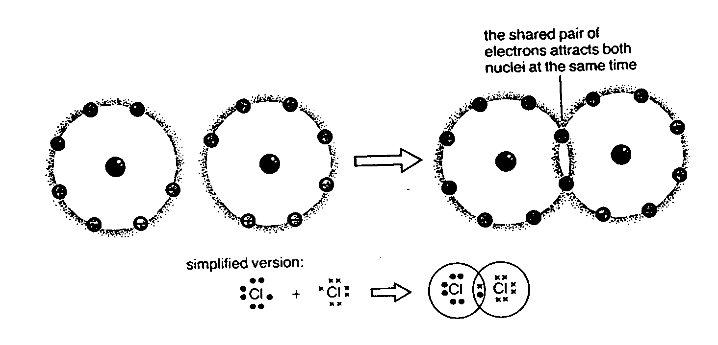
Figure 24
(Note: for the sake of simplicity only electrons in the outermost shell are shown)

This figure shows how two atoms of chlorine (Cl = 2.8.7) can, by sharing one electron from each atom, achieve stable electron arrangement (2.8.8).

Covalent bonding normally is found when atoms of non-metallic elements are bonded together.

Task 10

Show diagrammatically how two atoms of oxygen (O = 2.6) can bond covalently to form an oxygen molecule (O₂) such that each atom achieves a stable electron configuration (2.8) through sharing electrons

Hint: 2 electrons from each atom will need to be shared with the adjacent atom

Metallic bonding
A metal lattice can be thought of as containing positive metal ions held together by a “glue” of mobile electrons. These mobile electrons are delocalised and originate from the loosely bound outermost electrons of the metals.

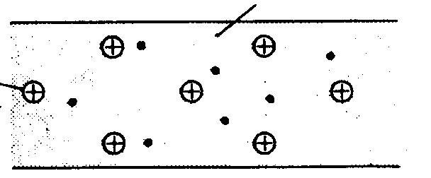
Figure 25
'sea' of electrons
Positive metal ion

16. Structure, bonding and properties of materials
In this section we will look at how structures of different materials are related to the types of chemical bond found in them. We will go on to look at how the properties of materials are related to their structure and bonding.

The structures of materials can be classified thus:

MATERIALS

GIANT STRUCTURES SIMPLE MOLECULAR STRUCTURES

METALS GIANT IONIC GIANT COVALENT
STRUCTURES STRUCTURES

This classification is not inclusive but is a helpful way of considering common materials encountered at key stages 3 and 4.

Giant structures consist of a 3-dimensional array of many millions of particles (atoms, ions) linked together in a crystal lattice. Giant structures are normally solids at room termperature with high melting points and boiling point. The particles within the giant structure are normally held in place by strong bonds (see Figs 16, 17 for example) On the other hand, simple molecular structures are normally liquids or gases at room temperature. The discrete molecules of which the material is made up attract each other by weak forces of attraction (see Fig. 15 for example)

Metals are Giant Structures consisting of an array of positive metal ions held together in a crystal lattice by a ‘glue’ of negatively charged electrons. As these ‘free’ electrons are not bound to any one particular ion within the crystal lattice they are able to migrate through the crystal lattice. These free electrons give rise to the high electrical and thermal conductivity of metals.

When a length of metal has a potential difference applied across it, the free electrons (which had been moving randomly) accelerate toward the positive potential. However in doing so they collide with nuclei and are slowed down, transferring much of their energy to the nuclei, which in turn vibrate (warm up). The electrons attain a drift velocity in the direction of the positive potential i.e. an electric current flows which causes a heating effect in the metal.
Thermal conduction takes place by two mechanisms, one involving the ions, the other involving the free electrons. Ions at a higher temperature vibrate more vigorously about their equilibrium positions in the metal lattice. Some of this vibratory energy is passed on to their “colder” neighbours causing them to vibrate more energetically as well. This process, however, is generally slow because the metal ions, compared with electrons, are massive and the increases in vibratory motion are therefore fairly small. (This is the main conduction mechanism in insulators).

The second mechanism involves free electrons. As they are much smaller (and more mobile) compared with ions, they are able to pass on energy quickly to cooler parts of the metal. This is the major mechanism of heat flow in metals.

Convincing pupils that metals are crystalline is not an easy task. There are, however, a number of simple experiments illustrating the crystalline nature of metals:

(i) Examine a zinc bucket. You should be able to identify regions on the surface where the crystalline structure of the metal is clear.

(ii) Crystals of lead can be grown by placing a strip of zinc foil in a test tub containing lead ethanoate (acetate) solution (0.1 to 0.5 Molar). Leave the crystals to grow over a period of several hours, although you will get quite an array of crystals within minutes.

(iii) Silver crystals can be grown on a length of copper wire, would into a helix placed in a solution of silver nitrate (0.1M) in a test tube. Crystals develop within minutes.

Most crystals are dense. This suggests that the metallic ions in the crystal lattice are closely packed. This packing occurs in a number of ways that can be simulated using polystyrene spheres. Metals are normally bendable and malleable (unlike other Giant Structures). This is because the metallic bonds are non-directional so that individual ions in the lattice are able to move relative to each other fairly easily.

Giant Ionic Structures, such as sodium chloride (Fig. 16) consist of a 3-dimensional array of ions held together in a rigid crystal lattice. They are normally brittle and can be cleaved: for example a large crystal of rock salt can be split using a hammer and chisel into smaller crystals:

Fig. 26

Cleaving will occur only if the chisel is aligned parallel to the sides of the crystal so that splitting will occur between parallel planes of ions in the crystal lattice.

The crystal is held together by the overall forces of attraction between positive ions (normally metal ions) and the negatively charged non-metal ions. These strong bonds account for the hardness of Giant Ionic Structures as well as their high melting and boiling points.

Giant ionic structures are poor conductors of heat and electricity. HOWEVER they are usually soluble in water. The now ‘free’ ions can carry charge (conduct electricity). Thus positively charged ions can be attracted to and move towards a cathode (negatively charged electrode) while negatively charged ion can migrate towards an anode (positively charged electrode)

Fig.27 cell
bulb lights

Salt water (sodium chloride solution)

Similarly molten sodium chloride can conduct electricity: the ions in the melt are not held in a crystal lattice and can migrate towards electrodes.

Giant covalent structures are normally hard, brittle, and have high melting points and boiling points indicative of the strong covalent bonds holding the atoms together. Giant covalent structures might be of elements such as carbon (graphite, diamond) or compounds such as silica (SiO₂). Normally they are poor conductors of heat and electricity. They are invariably insoluble in solvents.

Simple Molecular Substances are normally liquids or gases at room temperature (low melting points and boiling points). While the covalent bonding within individual molecules is very strong, the forces of attraction between adjacent molecules are weak. Iodine is an example of a simple molecular structure. The black crystals of iodine contain I₂ molecules held together by weak forces of intermolecular attraction. Very gentle warming is sufficient to turn the iodine crystals into a purple vapour (see Fig. 10).

A common misconception among pupils is that ionic bonds are strong while covalent bonds are weak: remind them that the low melting points of simple molecular materials is a result of weak forces of attraction between molecules: the covalent bonds holding molecules together are very strong.

Simple molecular substances are usually insoluble in water but soluble in organic non-polar solvents such as propanone (acetone).

___________________________________________________________________________________

Task 11

Complete the following table:
substance | structure | melting point (high/low) | solubility in water | hardness | electrical conductivity
Sodium chloride
Silica
ammonia | simple molecular
 |  | high | insoluble | hard | high

_____________________________________________________________________

17. Chemical Formulae
Chemical formulae represent the composition of a chemical compound. This is most easily understood with simple molecules. Water, for example, consists of water molecules made up of two hydrogen atoms bonded to a central oxygen molecule (see Fig. 13). It is easy to see why the formula of water is given as H₂O.

In Giant Structures, on the other hand, there are no discrete molecules. For Giant Structures, the chemical formula represents the ratio of particles in the crystal lattice. Thus sodium chloride is assigned a formula of NaCl as the number of Na⁺ ions and Cl⁻ ions is in a ratio of 1:1 within the crystal lattice. In silica (SiO₂) the number of silicon atoms and oxygen atoms is in a ratio of 1:2.

