PATTERNS OF BEHAVIOUR

- Introduction

- The Periodic Table
Development of the Periodic Table
Uses of the Periodic Table
Reactive Metals and Transition Metals
Reactive Metals
Transition Metals
Semi-metals
The Halogens
The Inert gases
The Periodic Table and Atomic Structure

- The Reactivity Series of Metals
Corrosion of metals
Reaction of metals with water
Reaction of metals with acids
Displacement of metals

4. Acids and Bases

- Chemical Reactions
Combustion
Thermal decomposition
Oxidation/reduction
Salt formation
Neutralisation

- Rates of reaction
Temperature
Concentration
Particle size
Catalysts

- Chemical Energetics
Exothermic reactions
Endothermic reactions
Where does the energy come from?

- What makes chemical reactions take place?

- Introduction
The unifying concept in this unit is that of 'chemical reactions' and how and why they occur. At key stage 2 pupils will have encountered certain chemical changes resulting in the formation of new materials. In particular they should know that burning is a non-reversible process that leads to the formation of new substances. However the scope for studying chemistry in primary schools is usually limited by lack of the sort of specialist facilities needed to investigate chemical reactions. Thus the bunsen burner is usually a new experience for year 7 pupils entering secondary school.

- The Periodic Table
The Periodic Table is not discussed formally in the National Curriculum until key stage 4. However, the idea of an element and how it differs from a compound is in the key stage 3 programme of study. Thus pupils at key stage 3 need to be made aware of a range of elements and it is not uncommon for simple ideas of periodicity to be introduced at this time, for example in relation to the reactivity series of metals. Many school laboratories will have a Periodic Table chart and reference will be made to this when discussing elements.

The Periodic Table has two major influences on Chemists. The first was its influence on science during its making. The second is the order which it brings to our knowledge of Chemistry. When Boyle introduced the idea of a chemical element in 1660 only a few were known. Chemists started searching for a pattern which would bring the elements into some sort of order. As the pattern began to form certain substances seem to be needed to complete it. They were looked for and new elements were discovered. It took 200 years to arrive at a pattern, which looked anything like our present Periodic Table.

Development of the the Periodic Table

France 1789: Lavoisier’s Groups
In 1798 Lavoisier published one of the most influential books on chemistry ever written, and in it he gave a list of simple substances that could not be broken down by any process of analysis. He divided this list into several groups, based on similar chemical behaviour of the elements in each group. We now know that many of the substances in these groups are compounds containing combinations of elements which are very difficult to decompose into their constituent elements.

Germany 1817: Dobereiner's Triads
After this original idea of relationship between elements had been established, Dobereiner realised that three recently isolated elements; calcium, strontium and barium all had properties that were strikingly similar. He thought that they might be chemically related and also noticed that the 'atomic weight' of strontium (88) was midway between those of calcium (40) and barium (137). He called this group a triad and later noticed that other elements also formed triads; chlorine, bromine, iodine and lithium, sodium, potassium. Dobereiner thought that he had discovered the key to the jig-saw: that the elements in nature fitted together in threes, but unfortunately his discovery was restricted to only a few elements. However this observation that the link up between elements depended on their atomic weight provided a clue to much of the later work.

Britain 1863: Newland’s Octaves
It was not until 1857 after intensive work by scientists, that an accurate method was found for determining the atomic weights of elements. Six years later Newlands found that when the elements were arranged in order of their atomic weights, the first, eighth and fifteenth elements were similar as were the second, ninth and sixteenth. He connected this repetition with the eighth note in an octave of music and said that the properties reoccurred periodically. Unfortunately this periodic relationship only held good for the first sixteen elements which made scientists rather reluctant to accept it.

Germany 1864 Meyer’s Curves
Meyer, whilst grappling with the same problem as Newlands, worked out the volume that one gram atom of an element would occupy if it was a solid. This he called the atomic volume of the element. He plotted atomic volumes against atomic weights.
He found that lithium, sodium and potassium together with rubidium and caesium lie on the highest points of the curve. From this curve it is possible to arrive at the periodic arrangement of the elements.

Russia 1869 Mendeleev’s Table
Mendeleev arranged the elements according to their atomic weights, much as Newlands had done but with two important differences: he left gaps for elements which he said had not yet been discovered and he listed separately some odd elements whose properties did not fit in with those of the main groups. This regrouping helped to remove any obstacles and, apart from the fact that it contained only about sixty elements, it is in principle much the same as that which we use today. Perhaps the most important feature of Mendeleev’s work was that he left gaps and then predicted what type of element would fill the gap. The later confirmation of his predictions was the strongest possible proof that his ideas were correct. Nevertheless there were still problems in this arrangement, some of the elements appeared to be in the wrong order.

Britain 1913: Moseley, Atomic Numbers
Up until 1900 the only definite idea people had about atoms was that of their weights. But during the first years of the century it was discovered that each atom had a central nucleus of positive charge. Using X rays Moseley found that the amount of positive charge carried by an atomic nucleus was a definite and different amount for each element. The amount of positive charge was called the atomic number of the element. Moseley found that if elements were arranged in order of atomic number they fell into nearly the same pattern as they did when arranged according to atomic weight. The difference was that several irregularities in Mendeleev’s Table were cleared up. With the discovery of elements for all the gaps in the table we believe that all the natural elements have been discovered; the jig-saw was completed. However, elements are still being made artificially in the laboratory so that the Periodic table is still being extended.

Fig.1
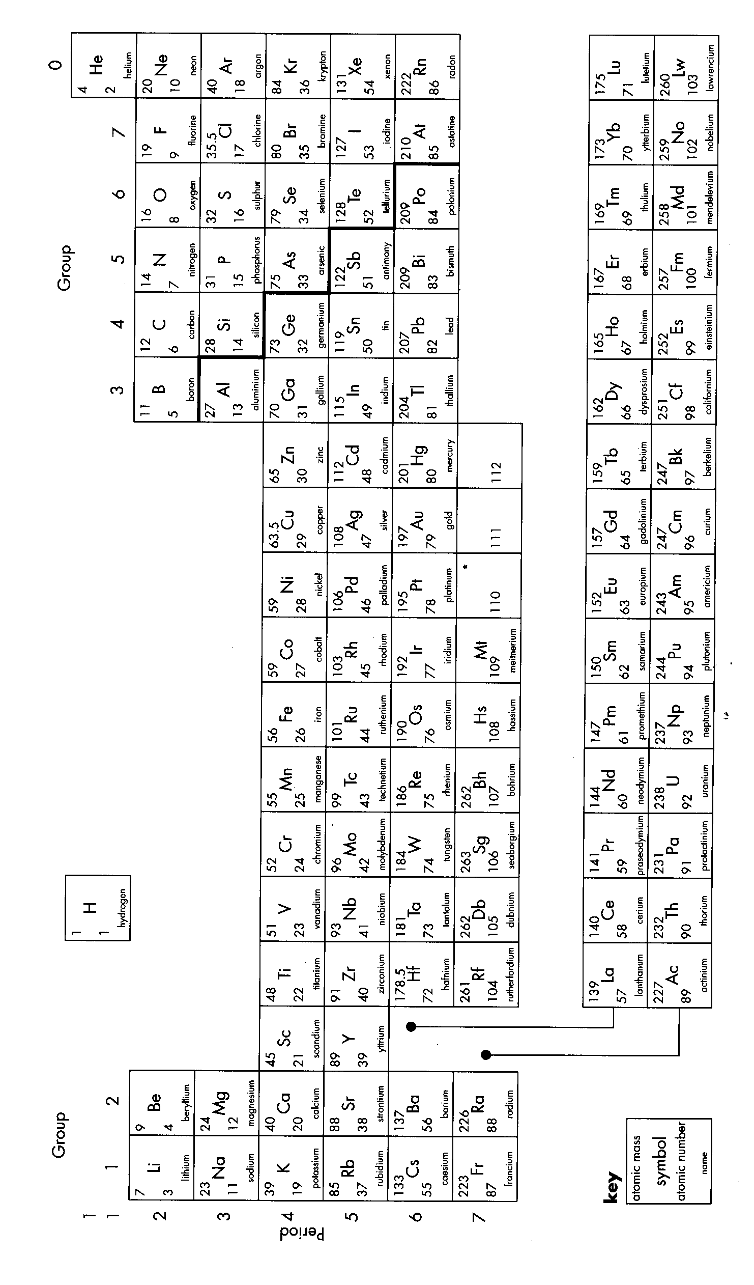
Note: Vertical columns are called 'groups' while horizontal rows are called 'Periods'.
For example, sodium (Na) is in Group 1, Period 3.

Uses of the Periodic Table
The Periodic Table occurs in every Chemistry or Science syllabus taught in schools. It really unifies and brings together most of the ideas taught in school chemistry.
At Key Stage 3/4 it is used to create the distinction between metals and non-metals using such properties as:
Appearance
Conductivity of Electricity
Reactivity with water and acids
Acidity of oxides formed on burning.

It is also used to relate similarities between elements in Groups;
Relating similarities in electronic structure to properties.
Comparing the Alkali metals and alkaline earth metals.
Looking at the less reactive metals in the Transition Series.
Looking at a group of Non metals usually the Halogens.
Considering a group of unreactive elements – the Rare Gases.

The division into Metals and non Metals is not exactly clear but it is a broad distinction which is represented on the Periodic Table by a zigzag line.

Reactive Metals and Transition Metals
The Periodic Table helps us to organise our knowledge and this makes the factual information easier to remember. It does this in a series of ways, gradually getting more and more specific. We have considered briefly the distinction between Metals and Non Metals. Most of the 100+ elements are metals. Clearly we need to subdivide these. The main groupings of interest at key stages 3 and 4 are the Alkali Metals (Group I), the Alkaline Earth Metals (Group II) and the Transition Metals.

Reactive Metals
The elements in Groups I & II are the most reactive metals known so many of their chemical reactions are too dangerous for pupils. In general they get more reactive as you descend the Groups and horizontally Group I are more reactive than Group II.

Reaction with water
This reaction is often used to show the vertical and horizontal trends in reactivity for the reactive metals but many are extremely dangerous. Only lithium, sodium, potassium, magnesium and calcium are used in schools and usually these are done as demonstrations. You need to refer to the relevant HAZCARD when planning work.
The reactions can be summarised thus:

Reactive Metal | Reaction with cold water
Lithium | Fizzes slowly to give hydrogen and an alkali Lithium hydroxide
Sodium | Fizzes quickly, melting producing hydrogen and steam and a soluble alkali sodium hydroxide
Potassium | Reacts violently, melting and giving hydrogen which ignites (lilac flame) produces a soluble alkali potassium hydroxide
Magnesium | Very slow reaction only noticeable by bubbles on surface of metal
Calcium | Rapid reaction producing hydrogen, heat and white precipitate of Ca(OH)₂

Task 1

In view of what you have read so far concerning reactivity trends in the Periodic Table:
- Why does potassium produce a lilac flame in cold water, whereas sodium and lithium produce no flame?
- Why does lithium react more energetically than magnesium?

You should certainly demonstrate the action of lithium sodium and potassium with water. This is usually a memorable experience for pupils. The three metals are stored under a layer of oil to prevent contact with the air. You should carefully remove a small piece of lithium from its container with tweezers. The oil should now be removed with tissues. If necessary cut the piece of lithium with a small knife. Add the lithium to a trough of cold water and get pupils to write down all they observe. Their list should include most of the following observations:
- It fizzes
- It melts
- It floats
- It moves around on the surface of the water
- It eventually all disappears/dissolves
- Small bubbles of gas form around the lithium

Repeat with small pieces of sodium and lithium. Get pupils to notice the obvious trend in reactivity. DO NOT be egged on by the class to use a larger piece of metal than recommended by the appropriate HAZCARD. A larger piece of metal can result in an explosion! In any case, do ensure that pupils where safety glasses and that a safety screen is in place between the chemicals and the pupils.

The reaction between calcium and cold water can be carried out with care by pupils by placing one or two granules of calcium into a test tube half full of water. The hydrogen evolved can be trapped using a thumb and then tested with a lit splint to show evolution of hydrogen.

In order to see any reaction between magnesium and cold water a piece of magnesium ribbon must be cleaned and polished with emery paper before putting it into a test tube of cold water. Careful observation should reveal the formation of a few small bubbles of hydrogen gas on the surface of the magnesium ribbon.

While magnesium reacts only slowly with cold water it will react much more vigorously with steam. An arrangement such as the one below is set up:

Fig.2

mineral wool magnesium ribbon
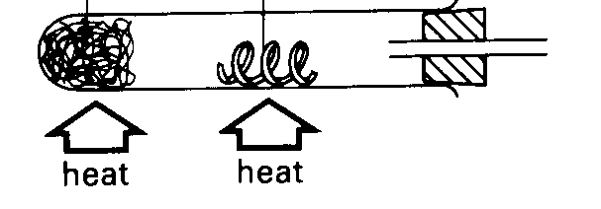
soaked in water

magnesium + water(steam) magnesium oxide + hydrogen

The hydrogen produced can be burnt off at the end of the jet.

Reactivity with dilute acids
The trend in reactivity seen with water is repeated for reaction with dilute acids, such a hydrochloric acid. However reaction with acid is even more violent than with water. In practice only the reaction of magnesium with hydrochloric acid should be carried out. Pupils can do this as a class experiment, adding a 2 cm strip of Magnesium ribbon to a test tube half full of dilute hydrochloric acid. Once again they can test for the hydrogen evolved by trapping the hydrogen evolved with their thumb before applying a lit splint which will 'pop'.

Task 2

What reaction occurs when magnesium is added to hydrochloric acid? Explain what is happening when a lit splint makes a popping noise when put at the mouth of a test tube containing hydrogen.

The magnesium ribbon reacts energetically with the hydrochloric acid and soon appears to dissolve. Leaving a clear solution. This is magnesium chloride solution.
You will find that some pupils will produce a loud 'pop' when they apply their lit splint to the hydrogen. This is because their tube contains a mixture of air and hydrogen…an explosive mixture. On the other hand a test tube containing pure hydrogen makes a much quieter 'pop' as pure hydrogen burns rather than explodes when the splint is applied.

N.B. Pupils will normally be aware that magnesium ribbon burns with a 'bright white light'. As such it can be an attractive materials to some pupils to spirit away from the lab. Always monitor carefully the issue and use of magnesium ribbon. For example, get the lab technician to prepare the required number of 2 cm strips of ribbon prior to the lesson.

Transition Metals
These are the metals that occupy the part of the Periodic Table lying between groups II and III. As you can see, there are a large number of these metals such that the majority of chemical elements are, in fact, Transition Metals.

They are much less reactive than the Group I and Group II metals. While the Transition Metals vary in many ways, there are three key features of importance:

- Transition metals and their compounds are often use to catalyse (speed up) chemical reactions. For example, The Contact Process for the industrial scale production of sulphuric acid utilises a Vanadium compound (V₂O₅) to catalyse the main reaction in the process.
- Transition metals often form compounds which display a range of different colours. For example:
Copper(II) sulphate (blue)
Iron (II) cloride (pale green)
Iron (III) chloride (orange/brown)

The compounds formed by other metals, such as the Group I and Group II metals are almost invariably white when solid and, when dissolved in water form colourless solutions.
- Transition Metals often form more than one set of compounds. For example, iron forms Iron (II) compounds, which are pale green in colour, and Iron (III) compounds which are orange/brown in colour. Copper (I) compounds are red, while copper (II) compounds are usually blue.
For example:

Compund | Chemical formula | Colour
Copper(II) chloride | CuCl₂ | blue/green
Copper(I) oxide | Cu₂O | red
Iron (II) sulphate | FeSO₄ | pale green
Iron (III) sulphate | Fe₂(SO₄)₃ | Orange/brown

Non-transition metals normally form just one set of compounds.

Transition metals can form ions with different charges. Thus:
Copper (I) compunds contain Cu⁺ ions
Copper (II) compounds contain Cu²⁺ ions
Iron (II) compounds contain Fe²⁺ ions
Iron (III) compounds contain Fe³⁺ ions

On the other hand sodium forms only Na⁺ ions; calcium forms only Ca²⁺ ions.

Semi-metals (or metalloids)
The stepped zig-zag line found on most Periodic Table charts separates metallic elements from non-metals. Let us review the major differences between metals and non-metals:
Metal | Non-metal
shiny | Dull (if a solid)
bendable | Brittle (if a solid)
good conductor of heat/electricity | poor conductor of heat/electricity

However, there are some elements which are not clearly identifiable as either metal or non-metal using such criteria. These are elements (such as gallium, germanium, silicon). Silicon, for example, is shiny, hard and grey (like many metals) but occurs on the non-metal side of the zig-zag line. Germanium, on the other hand, is a relatively poor conductor of heat and electricity occurs on the 'metal side' of the zig-zag divide. (Both silicon and germanium are semi-conductors).

The halogens
These are the elements of Group VII of the Periodic Table:

Element Formula State at Room Colour
Temperature

Fluorine F₂ gas pale yellow

Chlorine Cl₂ gas pale yellow/green

Bromine Br₂ liquid red

Iodine I₂ solid black

Fluorine is a highly reactive gas and requires special equipment and handling techniques. It is never encountered in the school laboratory. Chlorine is encountered in schools and must be treated with great caution. Not only is it very reactive, but it is also highly toxic. Do not carry out experiments with chlorine in the open lab; always work in a fume cupboard. Chlorine can be prepared by dripping concentrated hydrochloric acid on to crystals of potassium permanganate using an arrangement such as:
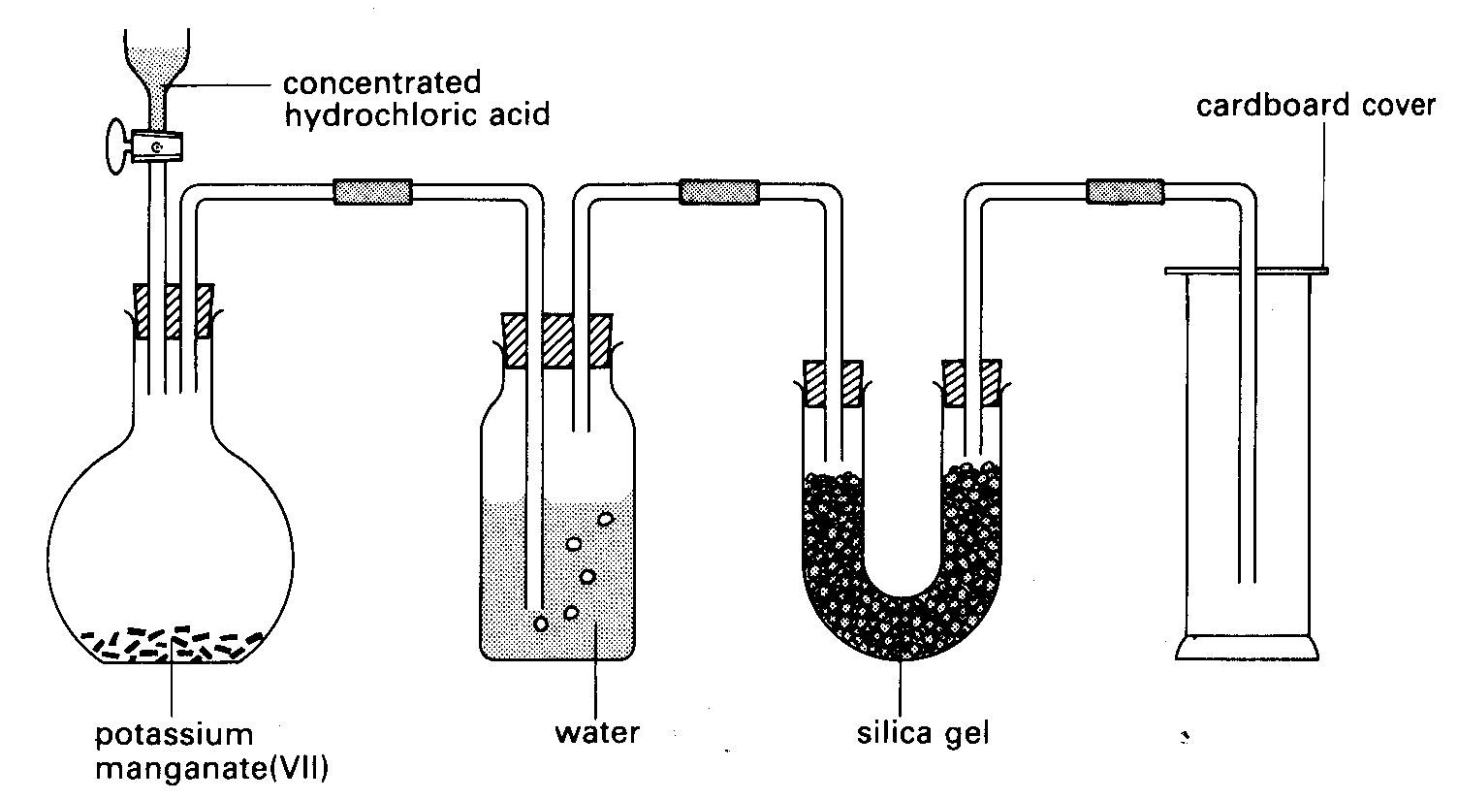
Fig. 3

The water will remove any hydrogen chloride gas, while the silica gel dries the chlorine.

A spectacular demonstration can be carried out to show the violence of the reaction between reactive metals and the reactive non-metal chlorine. A small piece of sodium is taken from under its protective layer of oil with tweezers and dried with filter paper. It is placed on the end of a deflagrating spoon and then heated in a bunsen flame until it melts. It is then plunged into a gas jar of chlorine. There is a violent reaction resulting in the formation of a white solid, sodium chloride. (if traces of oil remain on the sodium you will also get a black carbon residue). The reaction of sodium can be compared with that of lithium (less reactive) and potassium (more reactive).

This can be a useful way of bringing home to pupils that a safe and useful chemical, salt (sodium chloride) can be made from the reaction of two hazardous and highly reactive elements.

Chorine is slightly soluble in water to form 'chlorine water'. In this form it can be used by pupils in class work. Get pupils to use a dropper to drop a few drops of chlorine water onto a strip of universal indicator paper. They will find that the paper turns red/pink and then colourless. This is because some of the chlorine has reacted with the water to form hydrochloric acid (HCl) and some chloric (I) acid (HClO). This latter acid is also a bleach.

H₂O_{(l)} + Cl_{2(g)} HCl_{(aq)} + HClO_{(aq)}

In a similar way, bromine is slightly soluble in water to form bromine water. Pure bromine, although less reactive than chlorine, requires great care when used. Pure bromine is very volatile it is often used to demonstrate the process of gaseous diffusion. Bromine water is a common laboratory reagent.

Iodine, while less reactive still than bromine, should be used with caution. It should be kept out of contact with the skin. While it is virtually insoluble in water it will dissolve in potassium iodide solution to form a deep purple liquid. In this form it can be used in class work.

- Displacement of halogens
Halogens, being so reactive, 'prefer' to be in compounds rather than in the elemental form. By putting halogens in competition with each other an order for their reactivity can be established. Get pupils to add chlorine water (colourless) to potassium bromide solution (colourless) in a test tube. They will see a yellow/orange colour appear as bromine is displaced from the potassium bromide. Repeat adding chlorine water to potassium iodide solution (colourless). A dark brown coloration appears as iodine is displaced.

The experiment can be repeated using:

Bromine water + Potassium iodide solution iodine + potassium bromide solution

A more reactive halogen will displace a less reactive halogen from one of its compounds.

Task 3
- Predict what ( if anything) would be observed if bromine water were added to potassium chloride solution
- Complete the following word equations:
potassium bromide + chlorine bromine + ______________

potassium iodide + chlorine ________ + __________ _________

- Write full equations using chemical formulae for the above two reactions.

The Inert Gases
Helium, neon, argon, krypton and xenon are all colourless, very unreactive gases. Sometimes these elements are called the noble or rare gases. They all exist in minute quantities in the air. As they are so unreactive they were discovered relatively recently. Indeed, in the case of helium, its presence in the sun was detected before its presence of Earth from analysis of the sun's spectrum. The uses of these gases are based almost entirely on their inertness. For example, helium can be used to provide the buoyancy of air ships or balloons. It is less dense than air but is much safer to use than the explosive hydrogen.

N.B. In Table 1 you will see all the inert gases listed under 'Group 0' of the Periodic Table. Sometimes you will find helium separated from the other inert gases.

The Periodic Table and Atomic Structure
It should be remembered that when Mendeleev produced the structure for the modern Periodic Table nothing with known about the structure of atoms relating to sub-atomic particles. The Periodic Table was devised on the basis of patterns established from observable chemical reactions.

We now know the theory that explains these patterns of reactivity. It is based on the number and arrangement of electrons in atoms. This can be summarised as follows:

- Group I metals have one outer electron that can be removed from an atom relatively easily to form a positive ion with a single positive charge:

Element | Atomic Number | Electron arrangment | Ion formed by loss of outer electron
Lithium | 3 | 2.1 | Li⁺
Sodium | 11 | 2.8.1 | Na⁺
Potassium | 19 | 2.8.8.1 | K⁺
The high reactivity of the Alkali metals results from the relative ease with which the outermost electron can be removed when the metal undergoes a chemical reaction. It requires least energy to remove an electron from a K atom to form K⁺, rather more in the case of Na, and more still in the case of Li. This theory, then explains the differences in reactivity oberved in the alkali metals, such as in their reaction with water.
- Group II metals are also reactive. In this case each element has two outer electrons. These require relatively small amounts of energy to remove them (but generally rather more energy needed when removing the outermost single electrons of the alkali metals).
Element | Atomic Number | Arrangement of electrons | Ion formed by loss of outer electrons
Beryllium | 4 | 2.2 | Be²⁺
Magnesium | 12 | 2.8.2 | Mg²⁺
Calcium | 20 | 2.8.8.2 | Ca²⁺
It requires more energy to remove outer electrons from Be than Mg. It requires more energy to remove outer electrons from Mg than Ca. Hence:

Beryllium magnesium calcium

least reactive most reactive

- The halogens all have seven outermost electrons. They become more stable if they can gain an additional electrons so that they can have a full outermost shell of electrons. Fluorine achieves this most readily, and iodine least readily. Thus fluorine is the most reactive halogen and iodine the least reactive halogen.
Element | Atomic Number | Arrangement of electrons | Ion formed by gain of extra electron
Fluorine | 9 | 2.7 | F⁻
Chorine | 17 | 2.8.7 | Cl⁻
Bromine | 35 | 2.8.18.7 | Br⁻
Iodine | 53 | 2.8.18.18.7 | I⁻
- Inert gases has a full outer shell of electrons. This is a very stable arrangement. It is extremely difficult for an inert gas to either lose or gain additional electrons. Hence these gases do not react.
Element | Atomic Number | Arrangement of electrons
Helium | 2 | 2
Neon | 10 | 2.8
Argon | 18 | 2.8.8
Krypton | 36 | 2.8.18.8
Xenon | 54 | 2.8.18.18.8
- Elements towards the middle of the Periodic Table (such as transition metals or metalloids) are generally less reactive than those on the right hand side, and the more reactive non-metals in groups VI and VII to their right. It is normally relatively difficult for them to form compounds. They cannot form ions easily as it requires too much energy. Instead they form compounds through sharing their outermost electrons (covalent bonding).

- The Reactivity Series of Metals
A concept central to chemistry is the difference is reactivity of elements. We have already noted these trends when discussing patterns of reactivity relating to the Periodic Table. There are a number of activitiers that can be carried out that can form the basis for establishing the order of reactivity of common metals.

The usual way to start is by looking at common metals and their reactions. A number of experiments can be carried out:

Corrosion of Metals
Assign each group of pupils a metal. Get them to prepare four test tubes for the metal (ensure the pieces of metal have been polished with emery paper):

Figure 4
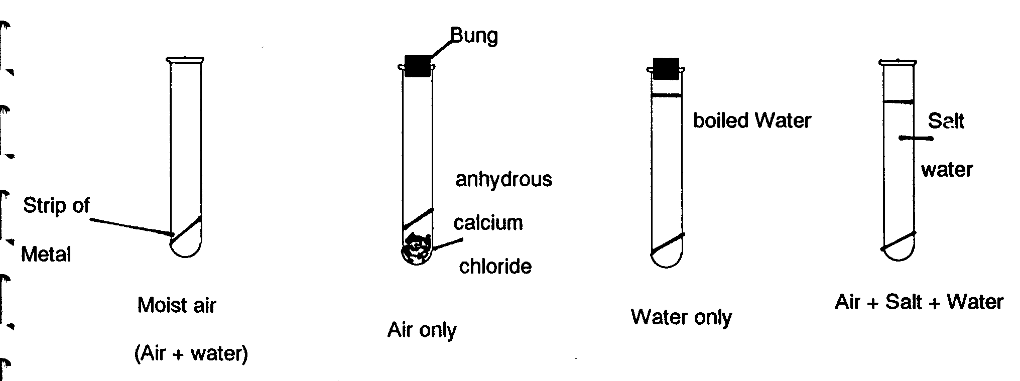
Leave the tubes for one week. After the week pupils examine the pieces of metal in all the test tubes. They assess the degree of corrosion on a scale of 0 (no corrosion) to 10 (completely corroded) and fill in a Table of Results:

Conditions | Al | Fe | Mg | Pb | Cu | Sn | Zn
Water and Air
Air only
Water only
Salt water

Besides looking at the conditions under which metals corrode most, an estimate can be made of the relative reactivity of these metals by adding up the numbers in the vertical columns and comparing them.

Reaction of Metals with Water
Add small uncorroded pieces of K, Na, Li, Ca and Mg to water as a demonstration. Don’t be egged on into using larger pieces of metal. Remember to clean off the oil layer from K Na and Li or nothing will happen when you put them in the water!

Reactions of Metals with Acid
Get pupils to add small pieces of magnesium, aluminium, iron, lead, copper, tin and zinc to dilute HCl in a test tube. Compare the amount of fizzing that occurs in each tube. Devise an order of reactivity.

(N.B. Aluminium is quite a reactive metal but has an oxide coating. Remove the oxide coating with some emery paper immediately prior to adding the aluminium to the dilute acid)

You are now in a position to bring together all the results from the experiments to create a Reactivity (Activity, Electrochemical) Series for the metals. In the three experiments described the differences in reactivity are clearly visible in terms of the magnitude of the observable effects. A further step is to apply knowledge of the reactivity series in making predictions about reactivity.

Displacement of metals
This can be achieved by introducing the idea of competition between metals in displacement reactions where the more reactive metal is able to displace the less reactive one from its compounds. Thus pieces of a metal can, for example, be added to solutions of salts.
Thus: Iron + Copper Sulphate → Copper + Iron Sulphate
Iron + Zinc Sulphate → no reaction

Iron is able to displace copper from copper sulphate solution as iron is a more reactive metal than copper whereas iron is unable to displace zinc from zinc sulphate; zinc being the more reactive of the two metals.

For example, pupils can be given access to the following metals and some solutions such as:

magnesium ribbon magnesium sulphate solution
iron filings iron (II) chloride
copper foil copper sulphate
aluminium foil aluminium chloride
lead foil lead nitrate
tin foil tin chloride
zinc foil zinc nitrate

Pupils can be asked to predict whether reactions would occur before actually testing their hypothesis.

Task 4

- Devise a suitable list of equipment you would need to book from the Lab. Technician in order to carry out the above experiment on Displacement Reactions as a class activity. Assume a class of 26, working in pairs. Remember to be specific about your requirements: the technician is following your instructions.

- Devise a suitable results table for the range of chemicals you have chosen for the experiment.

The concept of competition between metals can be a difficult one for pupils to grasp.
Some teachers use role play activity to get the idea across. For example:

Get pupils to think about what whether magnesium can displace zinc from zinc oxide. Cut out three large cards labelled 'Mg' 'O' and 'Zn'. Get three (sensible) volunteers to come out to the front of the class and to hold one of the large cards each. Get 'Zn' and 'O' to stand next to each other, holding hands. 'Mg' come along and 'wrestles' with 'Zn', eventually walking away holding hands with 'O', leaving 'Zn' alone. It is as well to get the pupils to practise this exercise prior to the lesson!

Fig.5

Mg
Zn
O

The Reactivity Series provides an important basis for discussing the extraction of metals. Metals that are reactive tend to form very stable compounds (ores) from which it is generally difficult to extract the metal. On the other hand, unreactive metals, such as gold and silver are found as native metals.

Fig. 6 The Reactivity Series and extraction of metals

Most reactive Potassium Difficult to extract from ore
Sodium (electrolysis of molten ore)
Calcium
Magnesium
Aluminium
Zinc Extracted by reduction of ore
Iron
Lead
Copper
Mercury
Silver Found in native state
Least reactive Gold

Note: this table contains most of the better known metallic elements. Of course it can be extended to include additional metals

Historically this ha meant that unreactive metals have been known and used for thousands of years, whereas the more reactive metals that require sophisticated technology for their extraction were discovered much more recently.

An enjoyable exercise is to plot a graph of year of discovery of various metals against their position in the Reactivity Series. The implications of the shape of the graph can be discussed in groups or a with the whole class.

As a memorable finale the Thermite Reaction can be demonstrated. Ensure everyone is wearing goggles and that a Safety Screen is in place between the apparatus and the pupils. Mix dry aluminium powder thoroughly with an equal quantity of dry iron III oxide in a crucible. Stand this in a tin filled with sand. Insert a length of clean magnesium ribbon into the mixture to act as a fuse. Light the fuse with a wooden splint or taper attached to a length of wood. Stand well back! The reaction is violent and usually involves the destruction of the crucible.
2Al + Fe₂O₃ → 2Fe + Al₂O₃
The experiment can be repeated using magnesium powder and copper II oxide as the reactants.

Some teachers prefer to carry out this experiments outdoors in the playground to minimise the risk of damage to laboratory fittings.

You may well be nervous about demonstrating this reaction (indeed, in carrying out demonstrations in general). This is quite normal when you start teaching. Many demonstrations don’t work when you simply follow instructions from a book. Always try to find time to practice a demonstration before carrying it our in front of a class. In addition don’t hesitate to ask an experienced colleague for advice. He/she will probably know the idiosyncrasies of that particular demonstration.

Even taking these steps will not guarantee a successful demonstration. It is usually better to share in the class’s humour when a demonstration fails to work rather than to act embarrassed.

Task 5

A research group at Brunel University discovered two new metallic elements, Cleminsonium and Williamsium. They found that Cleminsonium displaced Williamsium from a solution of Williamsium nitrate and metallic iron from a solution of Iron (II) sulphate. However there was no reaction between Cleminsonium and zinc sulphate solution. Williamsium can be extracted from its ore Williamsite by smelting with charcoal. Williamsium was found to displace grey metallic lead from lead nitrate solution. The researchers tried a thermite reaction between iron filings and williamsium oxide. There was a violent reaction.

Write word equations for any reactions the researchers carried out.

Suggest the position of the two new elements in the Reactivity Series of Metals.

4. Acids and Bases
Pupils are often introduced to simple notions of acidity in Year 7. Usually this starts by looking at the effects of a range of chemicals on an indicator and thus developing an operational definition of acids as being substances that change the colour of many naturally occurring dyes, whilst bases can restore the colour of dyes after they have been changed by an acid. Correspondingly indicators can be defined as dyes whose colours respond to the action of acids and bases. It is usual to include among the chemicals to be tested some with which pupils are likely to be familiar. For example:

Ammonia solution alkaline
Vinegar acid
Lemon juice acid
Milk of magnesia alkaline
Baking powder alkaline

Other simple properties of acids/bases such as taste and effect on metals (for acids) can be introduced at this stage of the pupils understanding.

Fig. 6

Pupils enjoy making their own indicators. Boiling red cabbage or beetroot in water produces indicators which work quite well and which the pupils can relate to easily.
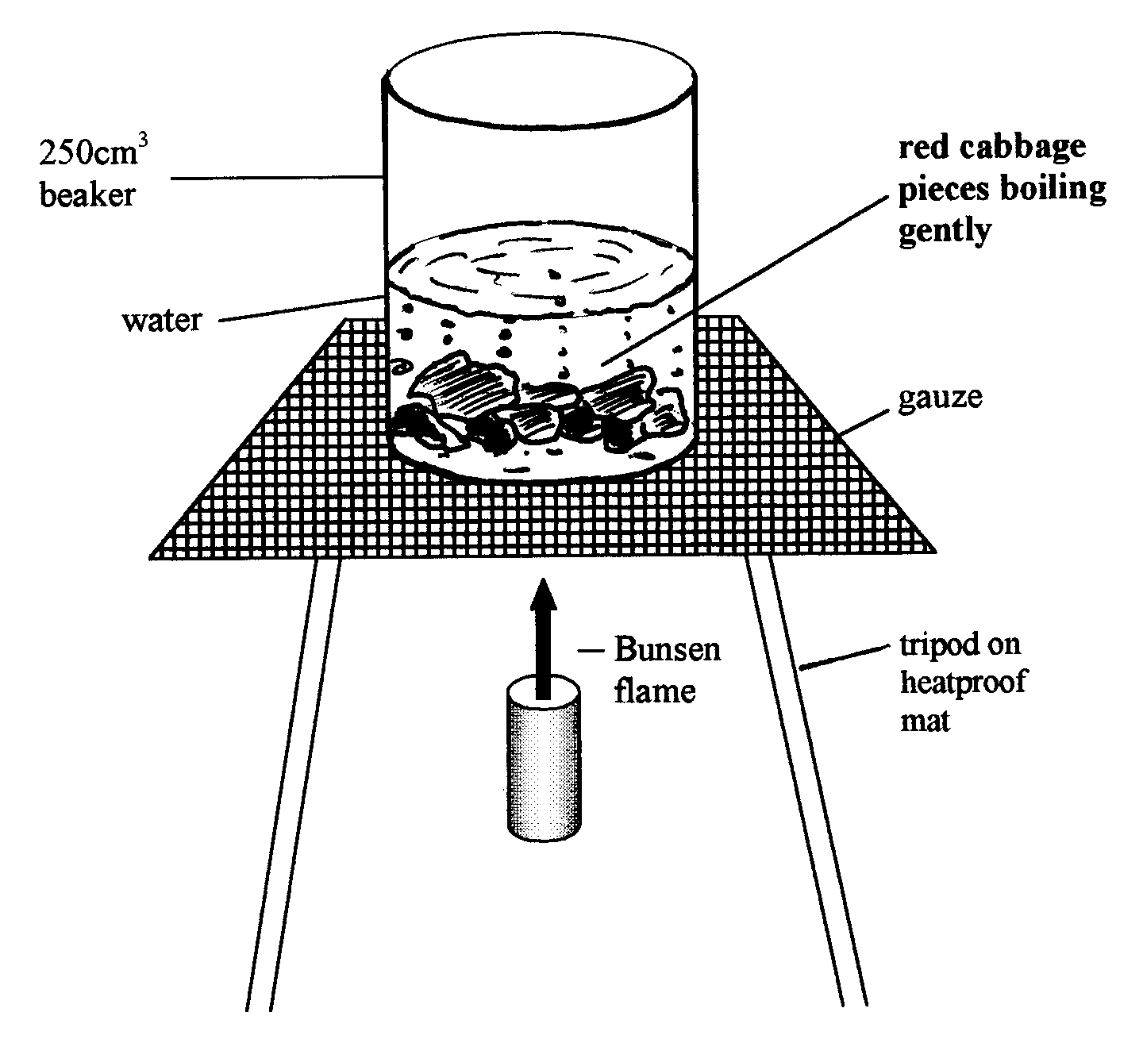

Universal Indicator which is made up of mixture of dyes provides and introduction to strong/weak acids and bases and hence to the pH scale. To all intents and purposes the pH scale ranges from 0 (strong acid) through 7 (neutral) to 14 (strong alkali).

Universal indicator is a green liquid. It shows a continuous range of colour changes which show how acidic or how alkaline a liquid might be. Most often it is used in the form of universal indicator paper (pH paper) by pupils. You should be wary of the fact that often the universal indicator found in schools is not 'full range'. That is to say it will show colour changes indicating only a limited range of pH values (often 1-11).

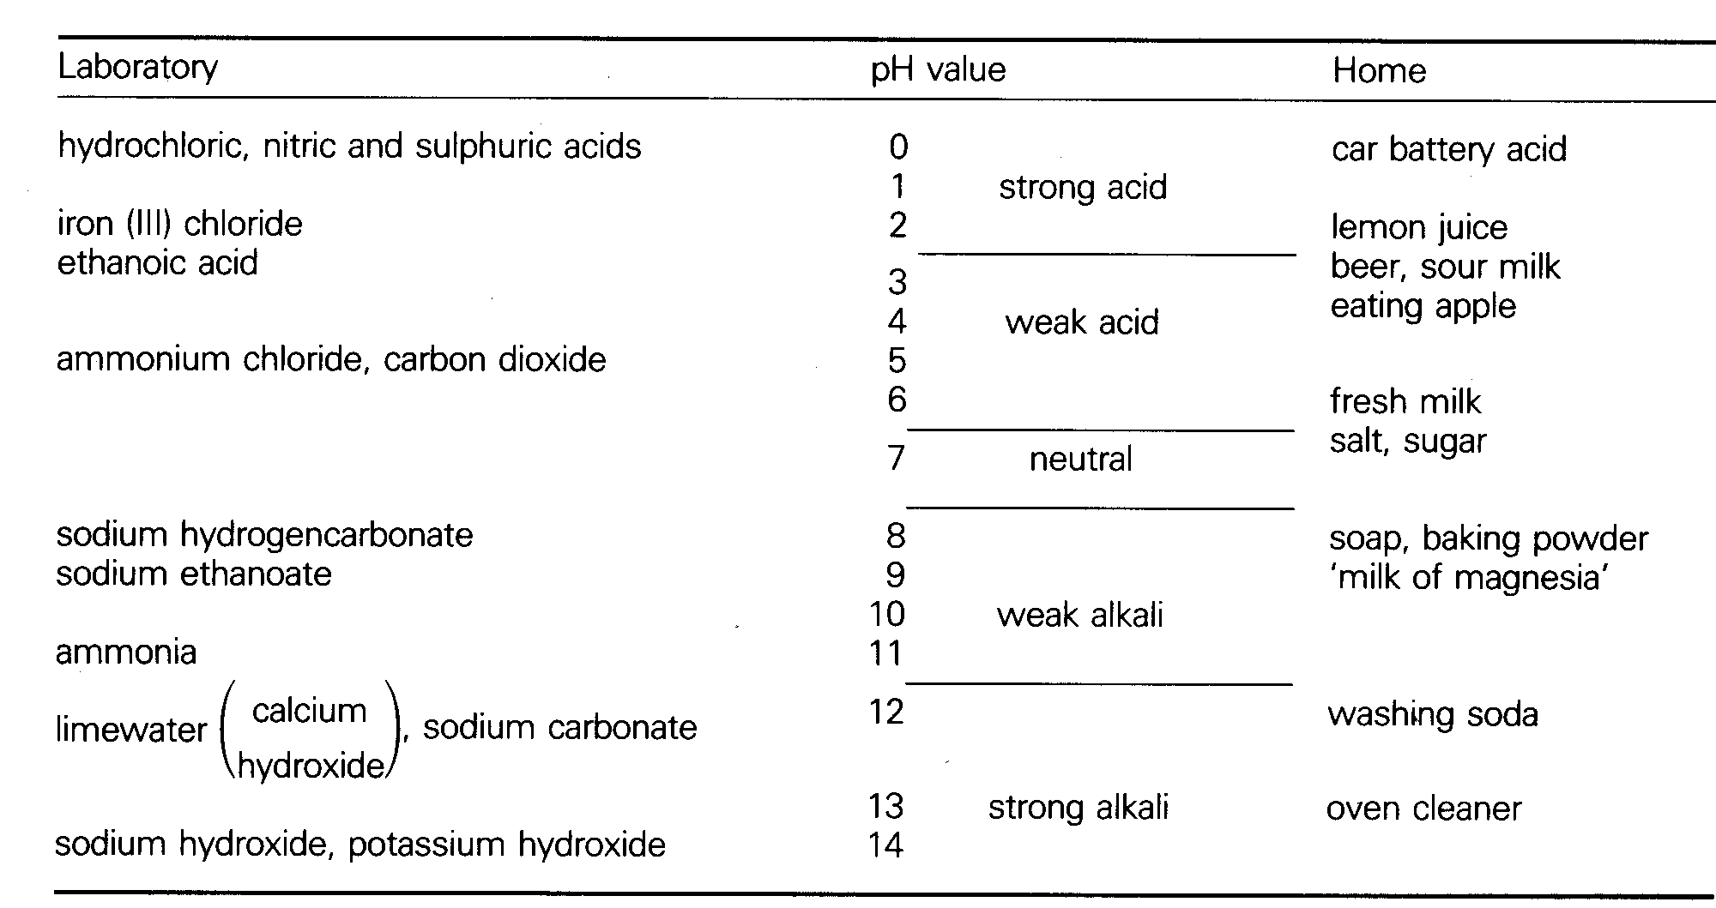
Neutralisation can be described in a simple way as being a process by which an acid cancels out an alkali/base or vice versa to produce a neutral solution of pH7.

There is little further work that can be suitably done on acidity until the pupils are made aware of the concept of ions. At this point the Arrhenius definition of acids and bases can make sense:

ie acids are substances that dissociate in water to produce hydrogen ions.

alkalis are substances that dissociate in water to produce hydroxide ions.

bases are substances which react with hydrogen ions to form water.

There is always confusion between the terms base and alkali (a soluble base).
Thus: all alkalis are bases, but not all bases are alkalis (as they may be insoluble in water).

Fig. 7

bases

alkalis

Relative strengths of acids and alkalis can be explained in terms of the degree of dissociation of acids and bases in water to form H⁺ or OH^{-.}

Thus the mineral acids (sulphuric, nitric, hydrochloric) are all strong as they dissociate in water completely to form ions:
e.g. hydrochloric acid: HCl → H⁺ + Cl⁻

On the other hand acetic (ethanoic acid) is weak as it contains largely of molecules in solution and dissociates very little: most of the particles in solution are CH₃COOH molecules, with relatively few CH₃COO⁻ and H⁺ ions.
CH₃COOH  CH₃COO⁻ + H⁺

A strong base will dissociate completely in solution to produce OH⁻ ions. With weak alkalis there will be fewer OH⁻ ions.

The necessity of water to be present for substances to show acidic properties can be demonstrated in a number of ways:

- Rub a few crystals of tartaric (2,3-dihydroxybutandioc) acid with a length of Universal Indicator paper. There is no colour change to indicate acidity.

- Add a length of magnesium ribbon to a little glacial ethanoic acid in a watch glass. No bubbles of hydrogen are observed. Now add a few drops of distilled water. Hydrogen is evolved.

This can be perplexing. Seemingly the acid is becoming more dilute, yet stronger! Two issues arise:

First, the role of the oxonium ion. H⁺ ions do not exist freely: they are hydrolysed (react with H₂O to form oxonium ions. Thus the ion that is found in acids is H₃O⁺ rather than H⁺.

H⁺ + H₂O → H₃O⁺

Secondly is the confusion that can be caused by two concepts that are associated but not directly related to each other: concentration and strength. Thus a 2M solution of ethanoic acid is more concentrated than a 1M solution of Hydrochloric acid yet is not as strong an acid. This can be illustrated using diagrams:

Figure 8
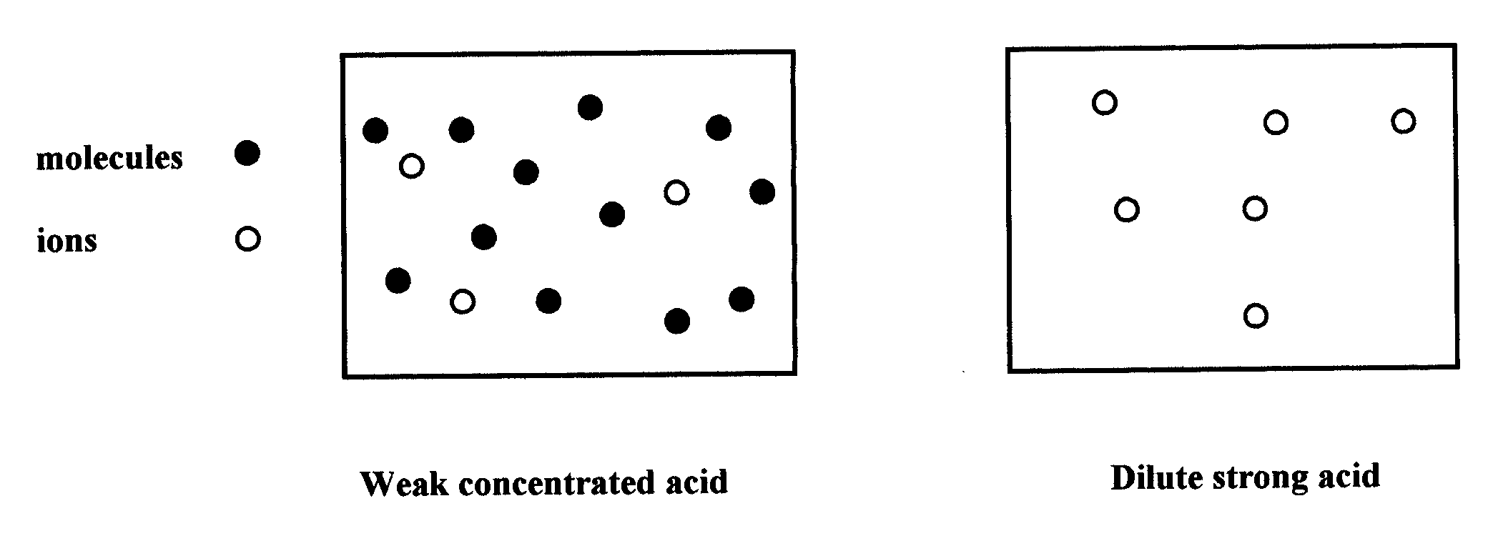
There are more particles in the weak acid, making it more concentrated. However, there are more H⁺ (strictly speaking, H₃O⁺) in the dilute acid, so it is a stronger acid than the concentrated acid.

The pH value of a substance is derived from the amount of H⁺ ions present.

5. Chemical reactions
We will now consider some types of chemical reaction and how they might be illustrated.

Combustion
Heating materials in air can have three effects: no change occurring, a temporary change (e.g. melting and then re-solidifying) or a permanent change. In simple terms, a permanent change in appearance is when a chemical reaction occurs

Permanent changes may (e.g. lit paper) or may not (e.g. copper changing to copper powder) be seen as “burning”.

It is worth pointing out here another inherent difficulty in studying science. This is the vocabulary, which teachers often use in lessons being different from the foreign to a pupil’s everyday use of language. “Combustion” is not a word used in everyday parlance of pupils so be careful when using it. Point out that it means the same as burning.

The concept of oxidation is not an easy one to grasp and develops over time. There is no foolproof way of teaching pupils how to extend their ideas on burning to a wider concept of oxidation. What can be done is to introduce the pupil to a range of experiences that will aid the pupil in this progression. Examples include:

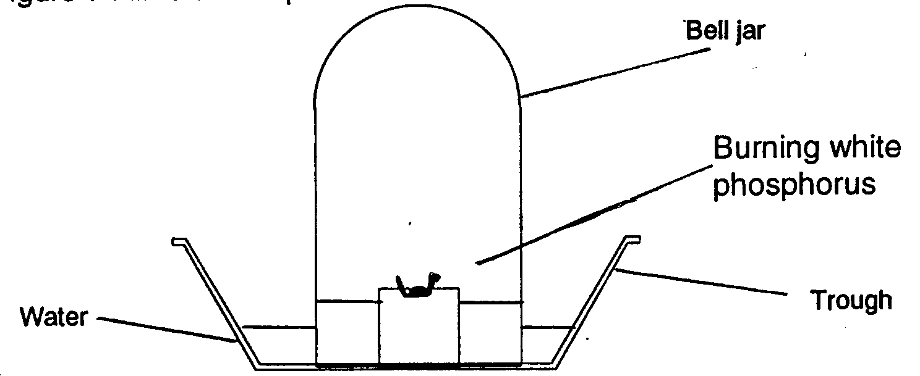
- Figure 9. Air is used up when substances burn in it.

White phosphorus is supported in a crucible resting on a pipe-clay triangle and tripod. A hot metal rod is applied through an opening at the top of the bell jar to ignite the phosphorus. As it burns fumes are formed in the bell. The water level in the bell jar rises to replace oxygen 'used up' in the reaction.

N.B. White phosphorus requires great care when used in the laboratory. Ensure you refer to the appropriate HAZCARD.

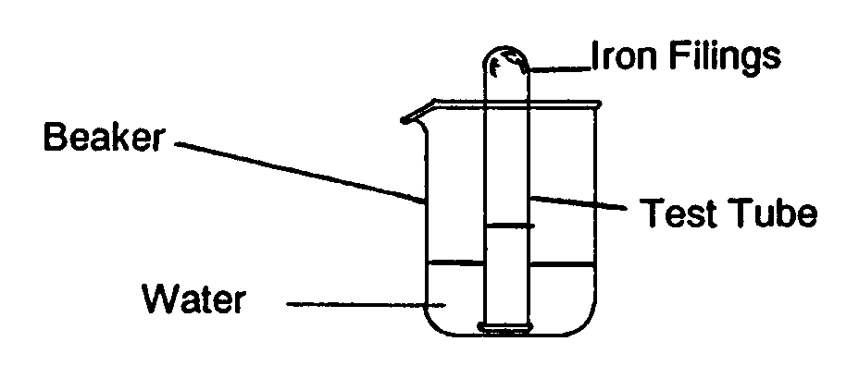
- Figure 10. Air is used up when rusting occurs.
A test tube is washed out with water. Iron filings are added. These adhere to the wet test tube. The test tube is inverted over water and left for a few days. As the iron rusts the water level in the test tube rises. Water is replacing the oxygen 'used up' in the rusting reaction.

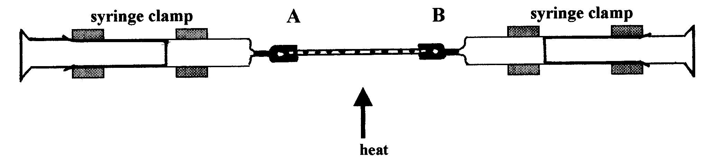
3. Figure 11

Passing air over heated Copper. Air is passed over heated copper using gas syringes. The volume of air in the syringes decreases by 20% as the oxygen reacts with the copper to form black copper II oxide.

While (1) is clearly an example of burning, (2) and (3) are not, yet all involve using up part of the air. Pupils are may well know that oxygen is the “active” part of the air and are able to associate these changes quite easily with the notion of oxidation. Extending the use of the term “oxidation” to its wider use in chemistry in a more difficult matter and should be left until a later stage.

Thermal Decomposition
Intuitively combustion involves breaking down into simpler substances. The fact that this is not an accurate picture can be difficult for pupils to grasp. Thermal decomposition, on the other hand, is intuitively “right” insofar as heat is used to break down a more complex substance into simpler ones. Once again remember you are dealing with scientific language that the pupil may well be unfamiliar with. Both “thermal” and “decomposition” are not often in a pupil’s everyday vocabulary.

Heating copper carbonate is a good, visible, example of thermal decomposition. One green chemical can be seen to break down into two chemicals: a black solid (copper II oxide) and a colourless gas (carbon dioxide).
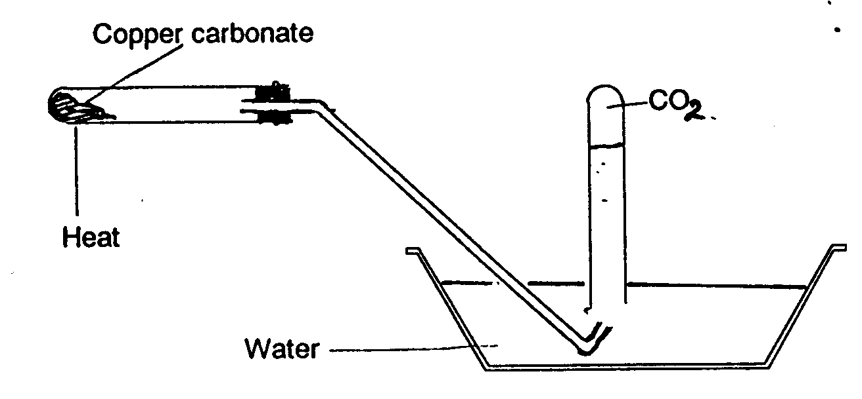
Figure 12

Oxidation/Reduction
The notion of oxidation is introduced by the idea that oxidation occurs when a substance gains oxygen. Reduction can be introduced in terms of it being the reverse of oxidation: i.e. loss of oxygen. For example:

- when a piece of magnesium ribbon burns in air to leave a white ash of magnesium oxide, the magnesium gains oxygen from the air; it is oxidised. Oxygen is an oxidising agent as it brings about the oxidation of magnesium to magnesium oxide.
- If dry hydrogen is passed over heated copper (II) oxide a colour change is observed as the black copper oxide is reduced (loss of oxygen) to brown metallic copper.

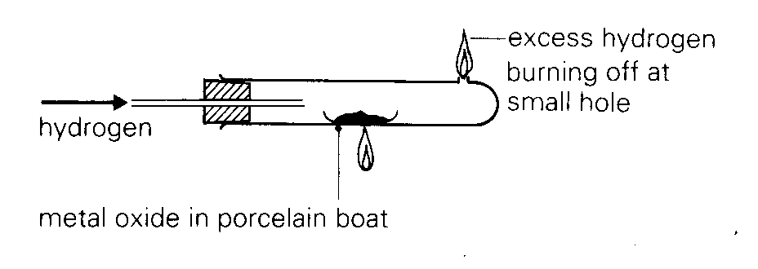
Fig.13

The hydrogen is a reducing agent as it removes oxygen from the copper oxide.

A more sophisticated and more inclusive concept of oxidation and reduction needs to be developed at key stage 4. A new definition of oxidation and reduction is needed. Thus:

- Oxidation occurs when an atom or ion loses electrons.
- Reduction occurs when an atom or ion gains electrons

A link can be made between oxygen gain/loss and electron loss/gain:

oxidation
(loss of e⁻)

e.g. 2Mg + O₂ ----------> 2Mg⁺⁺O⁻ ⁻

reduction (gain of e⁻)

Thus magnesium atoms 'gain oxygen' to form magnesium oxide. They also lose electrons in forming the Mg²⁺ ions in magnesium oxide.

In fact oxidation and reduction (in terms of loss/gain of electrons) always occur together. If an atom or ion loses electrons, these electrons must be gained by another atom or ion. Such reactions are often called redox reactions.

Salt Formation
With a simple descriptive understanding of acids and bases, salt formation can be explained as resulting from neutralisation of an acid by a base. Emphasise that each acid has a corresponding set of salts. Thus sulphuric acid produces sulphates, hydrochloric acid produces chlorides, nitric acid produces nitrates etc.

An experiment that neatly illustrates a salt being formed is making copper sulphate crystals from copper II oxide and dilute sulphuric acid.

Fig.14
dilute sulphuric acid

The key here is in adding the black copper II oxide a little at a time to simmering dilute sulphuric acid. Filter off excess copper II oxide when no more will dissolve. Add the filtrate to an evaporating basin and boil off half the water. Then leave to crystallise.

Task 6

I would like you to devise a Worksheet for pupils doing the above experiment. Ensure the wording is clear with vocabulary as simple as possible. Ensure the layout allows sufficient space for pupils to write in their observations. Include any diagrams you think would be appropriate.

How could you produce a second, differentiated worksheet for four pupils in the class with poor literacy skills?

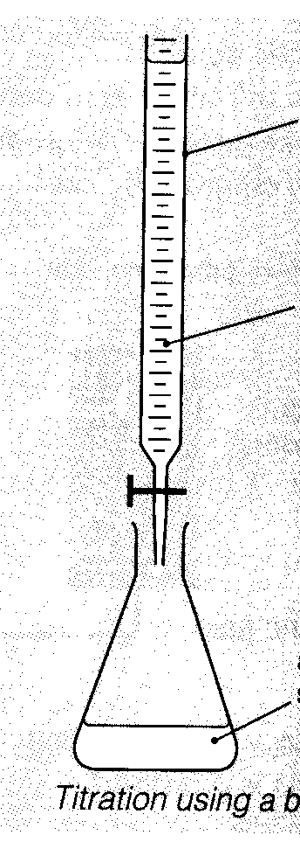
Another good experiment which reinforces the idea of neutralisation reactions producing salts is to produce sodium chloride from the reaction between dilute sodium hydroxide solution and dilute hydrochloric acid:

Fig. 15
burette

dilute hydrochloric acid

dilute sodium hydroxide solution

Add the acid to a burette. Pipette 25 cm³ of the sodium hydroxide solution to a conical flask with a few drops of a suitable indicator (e.g. phenolphthalein). Add acid to the conical flask until a colour change occurs (pink to colourless). Note the volume of acid required. Repeat to get a more accurate value of the volume of acid needed to neutralise 25 cm³ of sodium hydroxide solution WITHOUT the indicator. Evaporate to obtain the sodium chloride. With care this can be done as a class experiment to introduce pupils to basic titrimetric techniques. It will take them a long time, as the manipulative skills needed are quite extensive.

There are other methods of producing salts:

- ACID + METAL → SALT + HYDROGEN

e.g. Zinc + hydrochloric acid → zinc chloride + hydrogen
or : Zn_{(s)} + 2HCl_{(aq)} → ZnCl_{2(aq)} + H_{2(g)}

- SOLUBLE SALT + SOLUBLE SALT → SOLUBLE SALT + INSOLUBLE SALT
('double decomposition' or precipitation reaction)

e.g. if colourless barium chloride solution is added to blue copper sulphate solution the mixture becomes cloudy as a white precipitate of barium sulphate (insoluble ) is produced:

Copper Sulphate + barium chloride → copper chloride + barium sulphate
or: CuSO_{4(aq)} + BaCl_{2(aq)} → CuCl_{2(aq)} + BaSO_{4(s)}
(ppt.)

- ACID + METAL CARBONATE → SALT + WATER + CARBON DIOXIDE

e.g. if dilute sulphuric acid is added to green copper carbonate powder violent fizzing occurs as carbon dioxide gas is given off. A blue solution of copper sulphate remains.
thus: CuCO_{3(s)} + H₂SO_{4(aq)} → CuSO_{4(aq)} + H₂O_{(l)} + CO_{2(g)}

A salt can be considered to be a chemical formed by the replacement of the hydrogen in an acid by a metal:

Acid | Formula of acid | Examples of salts | Formulae of salts
hydrochloric | HCl | Sodium chloride  Lead chloride | NaCl  PbCl₂
nitric | HNO₃ | Potassium nitrate  Copper nitrate | KNO₃  Cu(NO₃)₂
sulphuric | H₂SO₄ | Barium sulphate  Iron (II) sulphate | BaSO₄  FeSO₄

In addition: salts derived from carbonic acid are carbonates; salts derived from citric acid are citrates; salts derived from nitrous acids are nitrites etc. Each acid has a corresponding set of salts.

Netutralisation
We have already considered neutralisation as a means of salt formation.

Figure 11

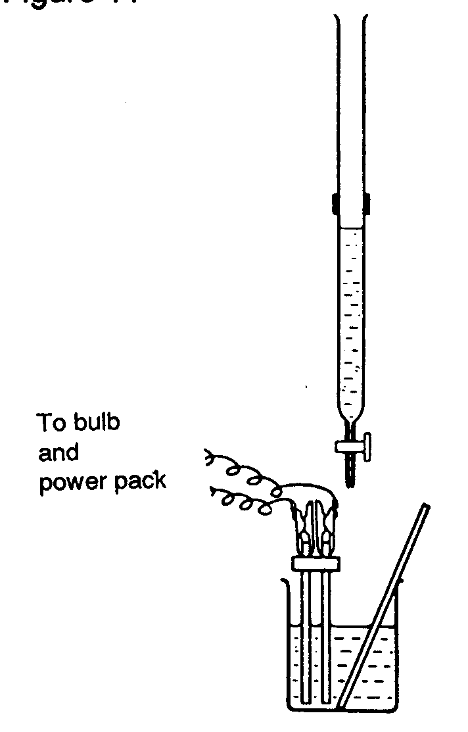
An excellent demonstration linking the concepts of acidity, basicity, indicators and ions is by adding dilute sulphuric acid from a burette to a mixture of dilute barium hydroxide (POISON) and phenolphthalein indicator using the arrangement shown in the diagram. The bulb dims, goes out altogether and then gradually brightens again as the colour of the mixture in the conical flask loses its pink colour and goes white (insoluble barium sulphate).

Task 7

Suppose you have just carried out the above demonstration and it is apparent that many pupils fail to understand what is going on.

Write down a transcription of how you would explain the observations to the class. Remember you are writing down what you would say. It might help if you practised the explanation by actually trying it out on a relative or friend.

6. Rates of reaction
Some chemical reactions are very slow, for example the rusting of an iron nail or the fermentation of sugar to produce ethanol (alcohol). Other reactions are very fast. For example, the reaction of potassium with water or, faster still, the explosion that occurs when a mixture of hydrogen and air is ignited.

The rate or speed of a chemical reaction can be increased in a number of ways:
- Raising the temperature of the reactant chemicals
- Increasing the concentration of the reactant chemicals (if liquids)
- Increasing the pressure of the reactant chemicals (if gases)
- Using a catalyst (a chemical that speeds up a reaction that remains in its original form and composition at the end of the reaction)
- Increasing the surface area of a solid taking part in a chemical reaction

If you refer to the National Curriculum you will find that the PoS for KS4 outlines the concepts that students should be taught relating to reaction rates.

It is really only if the quantitative aspects of such work are pursued that problems become marked. Such quantitative treatments can provide scope for differentiation within lessons so that the most able pupils can be stretched.

There are a number of experiments used to illustrate the factors affecting reaction rates. Let us look at each factor in turn.

Temperature
The reaction between sodium thiosulphate solution and dilute hydrochloric acid produces colloidal sulphur. The time taken for the reaction mixture to become opaque is indicative of the reaction rate.

10cm³ of sodium thiosulphate solution (40g dm⁻³) is added to a 100cm³ conical flask. 40 cm³ distilled water is added and the flask placed upon a piece of white paper marked with a cross. The temperature of the solution is taken (say 20⁰C). 5 cm⁻³ 2M HCl is added and a stopclock started immediately. The mixture starts to cloud over and the time taken for the cross to disappear from view is measured.

The experiment is repeated several times with thiosulphate/water that has been heated up to a range of temperatures, say 30⁰, 40⁰, 50⁰, 60⁰, 70⁰C)

Pupils will have little difficulty appreciating that raising the temperature increases the reaction rate by decreasing the time for the cross to disappear from view. Results can be displayed on a graph of time taken for the cross to disappear against initial temperature. As an extension, the more able pupils could be asked to plot 1/time against temperature (1/time being a measure of the rate of the reaction).

Concentration
This is a similar experiment. This time proportions of thiosulphate to water are varied. I would suggest:
50 cm³ thiosulphate/ 0 cm³ water
40 cm³ thiosulphate/ 10 cm³ water
30 cm³ thiosulphate/ 20 cm³ water
20 cm³ thiosulphate/ 30 cm³ water
10 cm³ thiosulphate/ 40 cm³ water

Once again the contents are put in a conical flask, placed on a cross, and 5 cm³ 2M HCl is added.

Most pupils will gain a feel for how concentration changes affect reaction rates BUT this experiment is conceptually more difficult that the previous one. Try to think why this should be.

Pupils can plot concentration of thiosulphate against time. Concentration, in simple terms, can be taken as the volume of thiosulphate in each reaction mixture. As an extension, the more able could work out actual concentrations of thiosulphate in each reaction mixture and plot these values against 1/time.

Note: There is an alternative way of following reaction rates in these two experiments. This is by employing a light sensor.
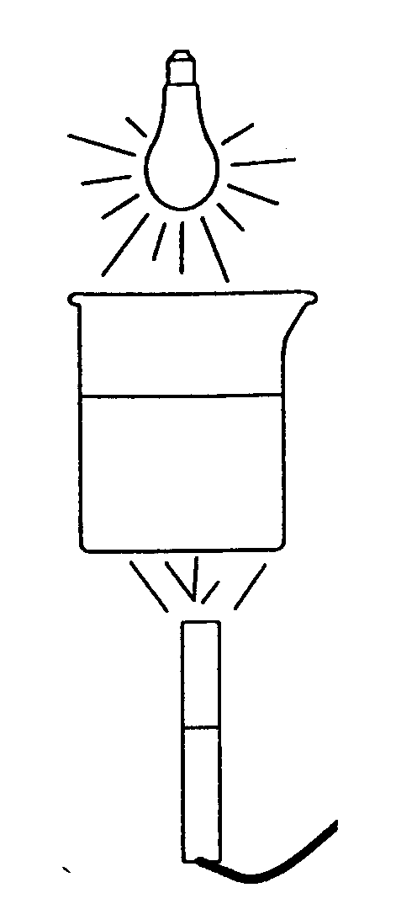
Fig.16

The light sensor can be set up underneath a beaker containing the sodium thiosulphate solution. The beaker is shielded from changes in the background light level. The sensor is connected to a computer. There is software on the market (eg Datadisc from Philip Harris) that can display changes in the light intensity with time.

The advantage of using IT in this case is that this is a case where changes occur fairly fast and using, say, a colorimeter, pupils would not be able to take readings quickly enough.

Particle size
This is linked to surface area. A simple, relevant approach could be to talk about the rusting of a nail. If the nail were to be sawn in two, would there be any difference in the amount of rust produced ? Pupils will realise that the creation of extra surface area will allow more rust to form. The argument can then be extended to talking about finer and finer divisions of the nail.
As a demonstration the same mass of marble chips of different sizes can be added to dilute hydrochloric acid. The amount of fizzing can be observed in each case to give a qualitative measure of the effect of changing particle size/surface area.

Task 8

Please look at the Lesson Plan shown in Appendix A. It is taken from a Year 9 scheme of work. This particular scheme of work is very prescriptive. This can have advantages and disadvantages. The author observed a student teacher (non-chemist) teach this particular lesson.

Please discuss:

(a) Any problems you could foresee that a non-chemist might encounter in teaching this work. I have left the student annotated notes on the lesson plan.

(b) The advantages of having a prescriptive scheme of work such as this.

(c) The disadvantages of having a prescriptive scheme of work.

There are several ways in which the marble chips experiment can be changed so that students get more of a feel for the quantitative aspects of this experiment.

For example the reaction can be followed by observing the weight change of the carbon dioxide evolved. This can be achieved by putting 40 cm³ 2M HCl in a conical flask sitting on a top-pan balance and adding 20g marble chips. A plug of cotton wool is placed in the neck of the flask to prevent loss of weight from acid spray. The whole apparatus is weighed and, at the moment at which the weight is determined, a stopclock is started. The balance reading is noted every minute. A graph can be drawn of loss of mass (ie the extent of the reaction) against time. The slope of the graph gives the rate of the reaction at the time represented by that point.

The experiment can be repeated with marble chips of different size.

Clearly the graphs obtained will relate not only to the change in particle area/surface area, but also to changes in rate associated with diminishing concentration of acid in each case.

Catalysts
A catalysed reaction that pupils are often asked to follow is the decomposition of hydrogen peroxide with the addition of manganese(IV) oxide. There are a number of experimental arrangements possible. For example:

Fig. 17
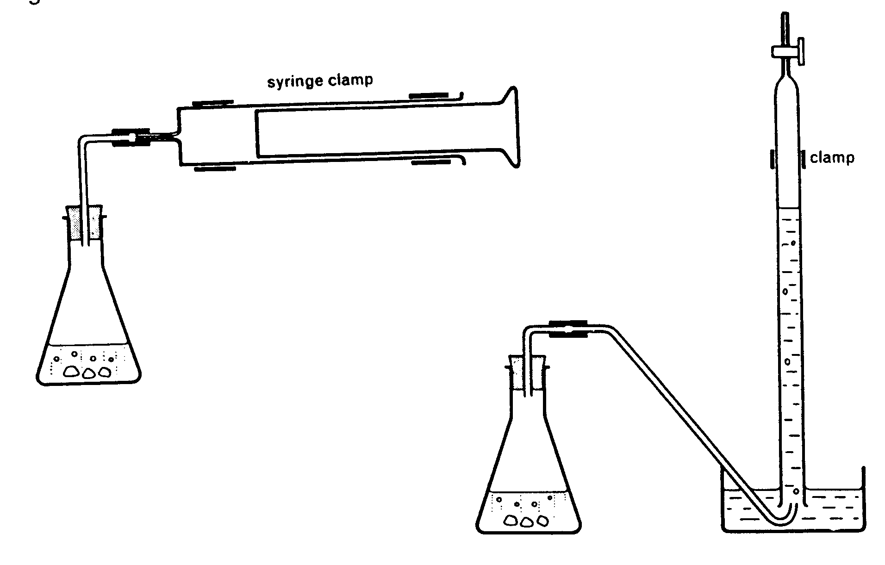
In the flask pupils add 2 cm³ of 20-volume hydrogen peroxide to 48 cm³ water. About one half spatula full of manganese(IV) oxide is then added and the bung immediately put in place. A stopclock is started and the volume of oxygen that collects is noted at regular intervals. A graph can be plotted showing the volume of oxygen produced against time. The slope of this graph will, of course be a measure of reaction rate.
A second experiment that can be carried out is more illustrative of the role that catalysts actually take in a chemical reaction: in the formation of an intermediate compound.

This is a visually impressive experiment. In a beaker place a solution of sodium potassium tartrate (about 3g in 50 cm³ distilled water). This is then warmed to 70⁰ C. 20 cm³ 20-volume hydrogen peroxide is then added. At this stage there is little to observe.

Now a small amount of cobalt chloride is added so that the solution has a definite pink colour. After an induction period of a few seconds the pink colour fades and is replaced by a deeep green. At the same time gas is seen to evolve (in fact a mixture of carbon dioxide and oxygen). After a few seconds the reaction stops and the original pink colour returns.

Experimental conditions can be changed (eg concentration of reactants, temperature) and the effects on induction period and duration of the whole experiment can be investigated.

Investigating Reaction Rates
The experiments described have been largely illustrative. As such they are not really investigative in the sense described in Sc1 of the National Curriculum. Remember, to count as an Investigation the following questions should be answered affirmatively:
Does the activity allow pupils to:
- observe objects and events?
- make "I think...because" statments?
- ask their own questions?
- plan their own solutions to the problems?
- decide how to make a fair test?
- decide what to change and what to measure?
- choose appropriate apparatus and instruments?
- decide how to organise the apparatus to meet their needs?
- decide on the best way of recording and displaying?
- decide what their results mean?
- come to their own conclusions?
- evaluate what they have found out and what they have done?
- suggest new ideas and questions for further exploration?

Remember also that investigations should be integrated into the teaching of other ATs: Sc1 investigations should not be 'stand alone' activities. A very common investigation used in most schools for GCSE coursework involves investigating factors affecting reaction rate. Let us consider how such an investigation could be devised using concepts involving reaction rates.

We will assume that pupils will have covered ideas that changes in concentration of solutions, changes in temperature, differing surface areas and the use of catalysts may affect the rate of a chemical reaction. These ideas may indeed have been met in Years 8 and 9.

Task 9

What bullet points from the programme of study for Sc3 at KS4 relate to an investigation involving reaction rates?

In Year 10, perhaps linked to the study of one or more manufacturing processes, some of the ideas in the programme of study could be used to frame a suitable investigation. For example, pupils could investigate the thiosulphate/acid reaction but with limited guidance to the procedure to be used Pupils would be given the opportunity for some background research and should be given the opportunity to carry out an extended the investigation. Remember, investigations provide a means to differentiate by outcome.

A brief for the investigation could be:

INVESTIGATING A CHEMICAL REACTION

Introduction
In this experiment you will be using the reaction between sodium thiosulphate solution and hydrochloric acid. They react to form sulphur.

The sulphur forms a precipitate. The time the reaction takes can be found by checking the cloudiness of the mixture.

Preliminary experiment
Put about 50 cm³ of sodium thiosulphate solution into a conical flask.

Place the flask on a sheet of printed paper.

Add about 10 cm³ of dilute hydrochloric acid to the flask.

If you view the print vertically through the mixture in the flask, a point will be reached when you can no longer see the printing.

Rinse the flask thoroughly.

Investigation
You are provided with sodium thiosulphate solution (40 g dm⁻³) and hydrochloric acid (1M).
Plan and carry out an investigation of the reaction between sodium thiosulphate and hydrochloric acid to examine ways in which the rate of reaction may be affected.
Your report should include details of your ideas, your method, your readings, your conclusions and explanations. You might also wish to suggest improvements to your chosen procedures.
Task 10

Using some of the ideas I have mentioned I would like you to think how you would explain:

1. How you would prepare for such an investigation. For example, how much time would you allow; what instructions you would give to the laboratory technician.

2. How you would introduce the investigation to students.

3. What guidance you would expect to have to give to students (oral and/or written).

4. What outcomes you would expect from students.

5. How you would use Sc1 to assess students (refer to a GCSE syllabus).

Explaining differences in Reaction Rates
‘Collision theory’ is used to explain differences in reaction rates. In essence this involves assuming reactions occur when particles (atoms, ions, molecules) of reactant chemicals collide with each other. The more frequently that these collisions occur, the greater will be the speed of the reaction.

Thus concentrated solutions contain more particles of reactant per unit volume. Particles will be close together; thus increasing the frequency with which reactant particles collide with each other; thus increasing the reaction rate. You might get pupils to think about dodgem cars at a fair. If all the dodgem cars are in use collisions will be more frequent than when there are only half the dodgem cars in use.

High temperatures increase the speed at which the particles move around. If the particles of reactant are moving around more quickly, there will be more collisions per second, so the reaction rate is increased. If the dodgem cars at a fairground could travel more quickly the frequency of collision between dodgem cars would increase.

A second strand to collision theory is that not all collisions result in a reaction taking place. In any substance the particles will have a range of different energies. Only high energy particles are able to undertake chemical change in a chemical reaction. Heating reactants not only increases the frequency of collisions between particles, it also increases the proportion of particles with sufficient energy able to react on collision.

- Chemical Energetics
All chemical reactions involve exchange of energy with the surroundings. The great majority of chemical reactions are exothermic. That is to say, heat is produced. This is often quite obvious, such as when a substance burns. In other reactions it may be less obvious, such as when a reaction occurs on mixing two liquids, where the temperature rise may be difficult to detect.

A few chemical reactions are endothermic. There is cooling and heat is taken in from the surroundings in order to restore the temperature to that of the surroundings.

Exothermic Reactions
EXOTHERMIC reactions GIVE OUT HEAT to the surroundings.

The reaction of magnesium with acid is exothermic. If you hold a test tube containing acid in your hand and then add a piece of magnesium the tube will soon feel warm because the reaction is giving out heat to your hand.

Figure 18
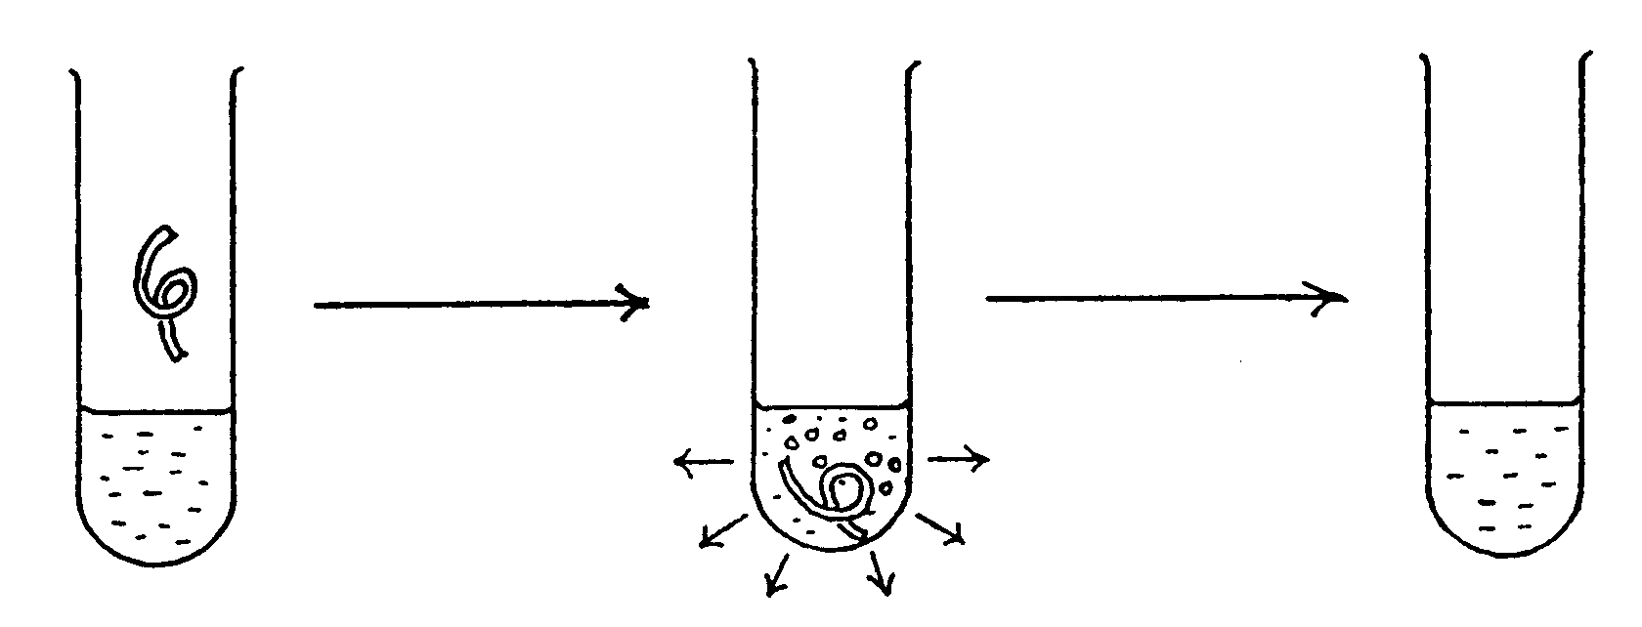
System before  reaction at  room temperature  Heat content = H₁ | System reacting  and giving out  heat to the  surroundings. It  feels hot | System after  reaction back  at room  temperature  Heat content = H₂

Notice that after the reaction has stopped and the products have returned to room temperature the heat content of the tube must be less than it was at the start since heat has given out to the surroundings.

So H₂ must be less than H₁.

The change (capital Greek Δ for difference) in the heat content H for any system is given the symbol ΔH.

Since in the exothermic process H₂ is less than H₁, ΔH must be negative.

FOR AN EXOTHERMIC CHANGE, ΔH IS NEGATIVE.

Burning ethanol (alcohol) is an exothermic process. The data book shows that the heat of combustion of ethanol is 1330 KJ/mol.

This can be represented, in shorthand form, as follows;

Ethanol + oxygen → carbon dioxide + water (Heat evolved)
C₂H₅OH(l) + O₂(g) → 2CO₂(g) + 3H₂O(l), ΔH = -1330 kJ/mol.

This means that when 1 mole of ethanol is burned according to the equation the reaction is exothermic and 1330 kJ of heat energy are given out.

The information can be represented on an energy level diagram:

Energy

C₂H₅OH(l) + O₂(g)
ΔH = -1330 kJ/mol.

___________2CO₂(g) + 3H₂O(l)

An energy level diagram shows that the reactants (ethanol and oxygen) have more energy than the products. The difference in energy between reactants and products is given out as heat.

Endothermic Reactions
ENDOTHERMIC reactions take in heat from the surroundings.

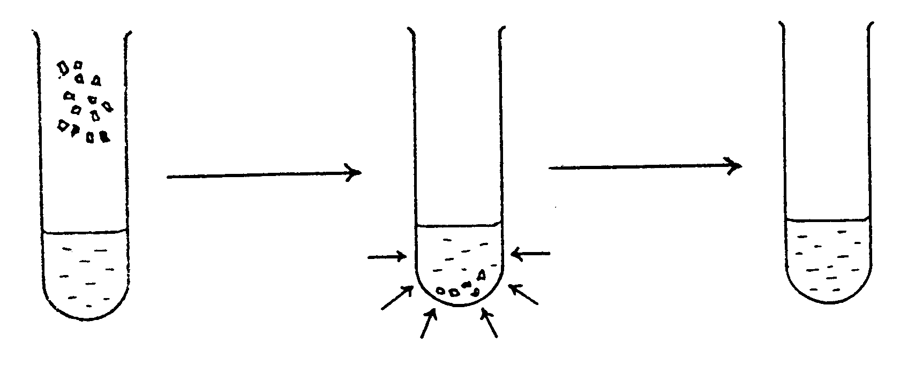
The dissolution of ammonium nitrate in water is endothermic. If you hold a test tube containing water in your hand and then add some crystals of ammonium nitrate the tube will soon feel cold because the system is taking heat from your hand (the surroundings).
Figure 19

System before  reaction at  room temperature  Heat content = H₁ | System reacting  and taking in  heat from the  surroundings. It  feels cold | System after  reaction back  at room  temperature  Heat content = H₂

Notice that after the reaction has stopped and the products have returned to room temperature the heat content of the tube must be greater than it was at the start because the tube has taken in heat from the surroundings.

So H₂ must be greater than H₁ and ΔH must be positive.

FOR AN ENDOTHERMIC CHANGE, ΔH IS POSITIVE

Melting ice and naphthalene are endothermic processes. The vaporisation of water is also an endothermic process. Heat, from say a Bunsen burner or the element of an electric kettle, has to be supplied to water at 100⁰C to convert it to steam at 100⁰C.
H₂O_{(l)} → H₂O_{(g)}, ΔH = +41 kJ/mol.

This means that when 1 mole of water is evaporated at 100⁰C, 41kJ must be supplied.

This information can also be represented on an energy level diagram.

H₂ O(g)

ΔH = +41 kJ/mol.

H₂O (l)
-----------------------------------

Where does the energy come from?
A chemical reaction e.g. combustion, is a series of processes in which existing bonds are broken and new bonds are made. The atoms themselves are not destroyed, but are simply rearranged.

Energy has to be PUT IN to the system to BREAK bonds
Energy has to be TAKEN OUT of the system to MAKE bonds

Consider what happens when hydrogen burns in oxygen to form water:
2H₂(g) + O₂(g) → 2H₂O (l)

We can see the changes in the bonding of the atoms by looking at models of the reactants and products.

Figure 20
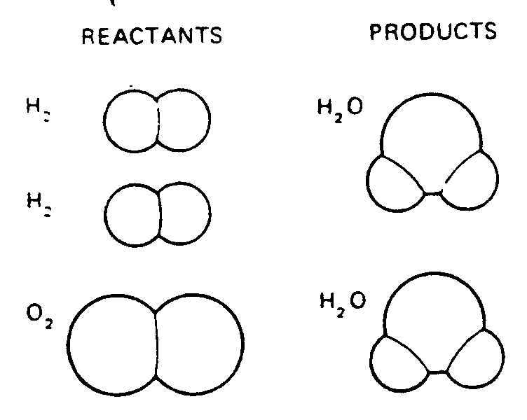
In order for these changes to occur, the bonds between the hydrogen atoms in the molecules must first be broken and those between the oxygen atoms must also be broken. These processes require energy so the atoms formed are at a higher energy than the original molecules.

Then new bonds form between hydrogen and oxygen atoms to give steam molecules. This process gives out energy. More energy is given out when the steam condenses to water.

Figure 21
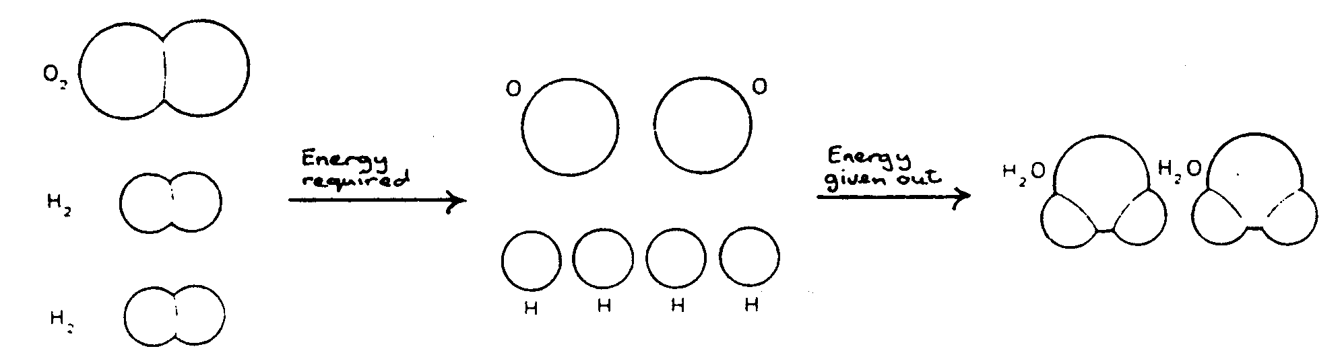
These energy changes are shown conveniently on a diagram.

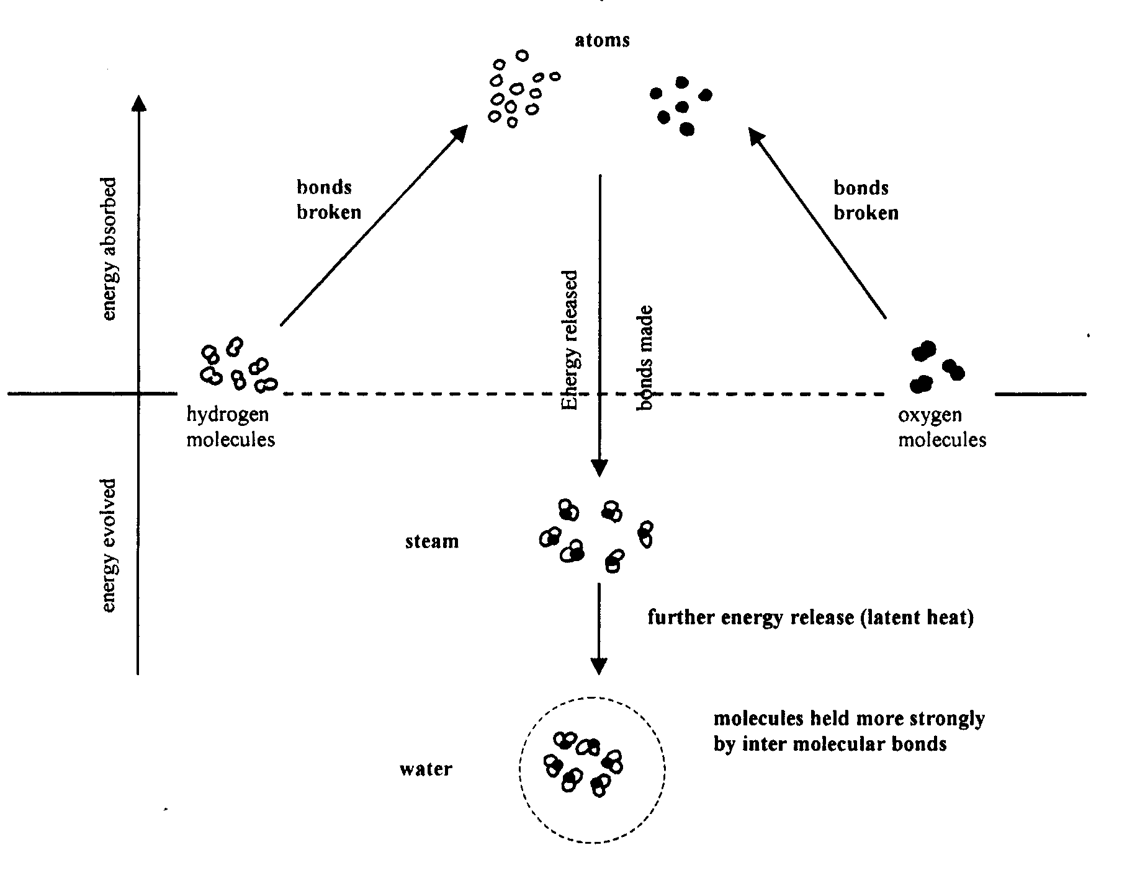
Figure 22
Overall the reaction gives out heat (it is EXOTHERMIC) because the new bonds formed are stronger THAN THE BONDS which had to be broken.

What makes chemical reactions take place?

We have seen that the great majority of chemical reactions are exothermic: energy is given out from the reaction mixture, causing a rise in temperature.

Sometimes it is helpful to draw an analogy:

Consider a ball on top of a hill: given a slight nudge it will roll down the hill. It will do this because it is energetically favourable for it to do so. At the bottom of the hill the ball will have less gravitational potential energy.

In an analogous way reactants often react to form products because it is energetically favourable to do so: this is an exothermic reaction:

energy Reactants

ΔH

Products

The ball needed a nudge in order to get it rolling down the hill. Most exothermic reactions require a ‘slight nudge’ too. This usually involves warming or heating.

For example: paper does not spontaneously burn in air. We need to supply a lit match (the slight nudge) in order to start the blaze.

In some cases it is impossible to instigate a chemical reaction ‘with a nudge’ even if it appears energetically favourable for the reaction to take place. For example, it is energetically favourable for graphite (a form of carbon) to change into diamond (another form of carbon). Manifestly this does not happen! One way of explaining this is by extending the above analogy:

energy

Graphite

diamond

There is an enormous energy hill or barrier to be overcome if we are to change graphite to diamond: it is not feasible. Similarly:

Given a nudge the ball will not roll down the hill!…there is a barrier in the way.

The ‘energy barrier’ that has to be overcome in order for reactants to change into products is called the activation energy. In some chemical reactions the activation energy is very small and the reaction occurs spontaneously. White phosphorus, for example, will smoulder in air, producing fumes of phosphorus oxides. In other reactions a moderate amount of energy is required to instigate a reaction: those reactions where reactants require heating in order to start changing into products, for example. Finally there are reactions that cannot take place because of the very high value of the activation energy that must be overcome.

