

School of Sport and Education

Pre- and In-course Study Materials for QTS

Physics

Electricity and Magnetism

Copyright © Andrew Cleminson, 2000
Andrew Cleminson, Nick Price, 2004

Contents

1. Introduction

2. National Curriculum and electricity and magnetism at key stages 1 to 4

3. Magnetism

3.1 Magnetic poles
3.2 Magnetic fields and lines of magnetic force
3.3 Making magnets
3.4 Electromagnets
3.5 Relays
3.6 The domain theory of magnetism
3.7 Demagnetising a magnet

4. Static Electricity

4.1 Simple experiments with static electricity
4.1 Lightning

5. Current Electricity

5.1 Circuits
5.2 Current
5.2 Resistance
5.4 Energy in circuits
5.5 Potential difference (pd) and voltage
  - Series and parallel circuits
  - Ohm’s law
  - The chemical effect of a current
  - The motor effect
  - Analogies, teaching challenges and circuit electricity tasks

6. Mains electricity

7. Generating electricity

1. Introduction

This unit is designed to upgrade your subject knowledge and understanding of electricity and magnetism so that you are confident when teaching these topics, at least to Key Stage 3 pupils. Electricity is often cited as the area of physics which is most difficult to deliver effectively by both specialist and non-specialist teachers alike.

Electricity and magnetism are fundamentally linked areas of physics. The main topics to be considered are:

- Magnets and magnetism.
- Electromagnets.
- Static electricity.
- Current electricity.

You will realise that your subject knowledge and understanding will increase by using this unit in conjunction with other means of subject enhancement such as:

- Study of textbooks and pupil revision guides.
- Study of on-line materials (e.g. BBC Bitesize)
- Working with your mentor and other colleagues in school.
- Campus based work, particularly taking the opportunity to try out and think through relevant practical work.
- Planning, teaching and assessing topics related to magnetism and electricity.

In addition you should evaluate your improvements in subject knowledge and understanding against the 'scores' of your subject knowledge audit.

2. National Curriculum and electricity and magnetism at key stages 1 to 4

You should, of course, be aware that pupils will have encountered a number of aspects of the study of electricity and magnetism while in primary school (i.e. key stages 1 & 2).

_____________________________________________________________________
Task 1
Examine the National Curriculum requirements for electricity and magnetism for key stages 1 and 2.

Look at model schemes of work for key stages 1 and 2. (The National Curriculum and model schemes of work can be accessed from www.nc.uk.net).

Now devise a 20 minute pre-test to give to a year 7 class prior to teaching them a unit on electricity and/or magnetism. The aim of this test is to assess their knowledge and understanding of electricity and magnetism.

_____________________________________________________________________

At key stage 3 the National Curriculum requires that pupils be taught about circuits (series and parallel), magnetic fields and permanent magnets, and electromagnets. For reference, extracts from the current key stage 4 National Curiculum for Double Award Science are given below:
Sc 4 Physical processes

Electricity, pupils should be taught:

Circuits
1.a that resistors are heated when charge flows through them
1.b the qualitative effect of changing resistance on the current in a circuit
1.c the quantitative relationship between resistance, voltage and current
1.d how current varies with voltage in a range of devices
1.e that voltage is energy transferred per unit charge
1.f the quantitative relationship between power, voltage and current

Mains electricity
1.g the difference between direct current (dc) and alternating current (ac)
1.h the functions of the live, neutral and earth wires in the domestic mains supply, and the use of insulation, earthing, fuses and circuit breakers to protect users of electrical equipment
1.i how electrical heating is used in a variety of ways in domestic contexts
1.j how measurements of energy transfer are used to calculate the costs of using common domestic appliances.

Electric charge
1.k how an insulating material can be charged by friction
1.l about forces of attraction between positive and negative charges, and forces of repulsion between like charges
1.m about common electrostatic phenomena, in terms of the movement of electrons
1.n the uses and potential dangers of electrostatic charges generated in everyday situations
1.o the quantitative relationship between steady current, charge and time
1.p about electric current as the flow of charge carried by free electrons in metals or ions during electrolysis.

3. Magnetism

Magnets are objects that attract certain metals (magnetic materials), and attract and repel other magnets. Magnets are themselves made from magnetic materials. The most common metals attracted by magnets are iron, steel (which contains iron), nickel and cobalt. Whilst you are very unlikely to come across a sample of cobalt in a school, you can get pupils to test other metals, including nickel. Whilst many low cost school magnets are made from steel, better magnets are made from ceramic materials, which may contain iron and nickel.

There are a number of problems with using magnets in school. For example:

- They are very attractive to year 7/8 pupils. You need to be vigilant when counting in and counting out magnets whenever you use them with a class.

- Magnets need to be stored carefully or else they will lose some of their magnetism. This is best done by keeping them in pairs so they attract each other with the ends kept in place by soft iron 'keepers'. The science department needs to be particularly careful with plotting compasses. Frequently you will find that their poles are reversed through misuse.
- A number of pupil experiments involve using iron filings to show magnetic fields. Iron filings stick to magnets! Wrapping cling-film around magnets is one way round this issue.

3.1 Magnetic poles

Magnetism is concentrated at the two ends of a bar magnet, these ends are known as the poles. You can show this by dipping a bar magnet into iron filings. Most of the iron filings cling to the two ends or 'poles' of the magnet

The next stage in a teaching sequence may involve showing what happens when a bar magnet is suspended freely in the air; pupils should be able to detect that it moves as it interacts with the Earth’s magnetic field:

Fig. 1

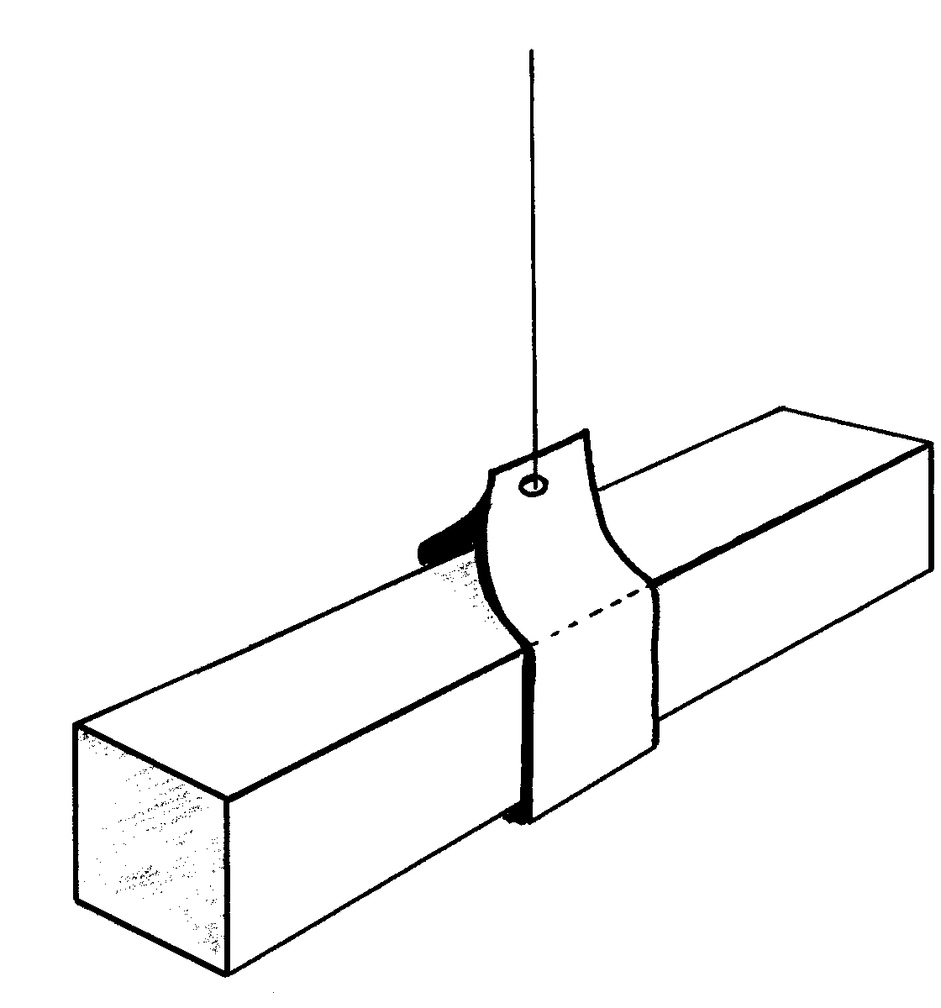
The magnet needs to be suspended in stirrup so that it can rotate freely in the horizontal plane. You should ensure that there are no large iron or steel objects nearby.

This can be a rather fiddly experiment for pupils to carry out so ensure that you have a demonstration set of apparatus at hand. The bar magnet will settle into the North-South direction. It is important to ascertain prior to the lesson which direction is North and which is south and that the pupils are aware of this. For example, you may establish that the front of the classroom/lab is north, while the back is south.

You can now introduce the terms 'North-seeking pole' and 'South seeking pole'

Pupils can mark the poles (for example with chalk) so as to identify each pole. Magnets bought from school suppliers often have the North-seeking pole marked with a notch.

You are now in a position to get pupils to test the effect of placing two magnets close to each other, with their poles adjacent to each other. Having identified North and South seeking poles on a pair of magnets it is easy to show that:

N with N | Repel
S with S | Repel
N with S | Attract

Leading to the basic rule:

Like poles repel, unlike poles attract

3.2 Magnetic fields and lines of magnetic force

Pupils quickly become aware of the fact that magnetic forces extend around a bar magnet and seem to diminish with distance away from the magnet. The space around a magnet in which the magnet extends its attractive force is called a magnetic field. The magnetic field is often represented using field lines which run between the poles of a magnet, and indeed between opposite poles of adjacent magnets. Carrying out whole class experiments to generate the field lines around a bar magnet is an exceedingly popular class practical, which is often not backed up by defining what the field lines actually show or mean. Field lines ‘describe’ a magnetic field as follows:

- Each line shows the direction of the force generated (a small piece of iron released on a field line will move along the line towards the area where the field is stronger).
- The spacing of lines shows the strength of the force (hence they are closer together at the poles).
- Arrows on field lines follow a convention, they point from N to S.

Two useful rules relating to field lines are:

- Field lines never cross.
- Field lines between magnets link opposite poles, never the same poles.

There are two main ways of demonstrating the shape and presence of a magnetic field:

By sprinkling iron filings:
You can place a bar magnet underneath a sheet of white paper and sprinkle the iron filings on top of the paper. Gently tap the paper. The iron flings align themselves with the magnetic field and the pattern of the force fields can be seen (although it is not all that convincing)

Alternatively you can place the bar magnet on top of an OHP and cover with a transparency sheet. Now sprinkle iron filings on top of the transparency sheet to demonstrate the magnetic field present. Be aware that OHPs have their own (electro)magnetic fields which can distort the field of a bar magnet or compass placed on them, resulting in very confused field patterns.

By using a plotting compass:
Again this method can be demonstrated effectively using an OHP. Place a bar magnet in the centre of the OHP transparency and draw around the magnet (this is in case you accidentally move the magnet during the experiment). Now mark a point at one end of the magnet. Place the plotting compass adjacent to this point: one end of the compass will point towards the mark you have made. Place a second mark to where the other end of the plotting compass point. Move the compass round now so that the other end points towards the mark. Once more mark off to where the other end of the compass points and so on. Continue until you reach the edge of the paper and then join up all the points.
Now start from a different point on the edge of the magnet to produce another 'line of force' and so on until a magnetic field pattern can be seen

Fig.2: Magnetic field of a bar magnet
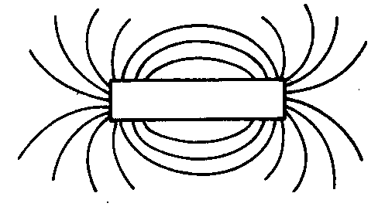
Of course this a very effective class experiment as well, with pupils or pairs of pupils drawing the magnetic field patterns on paper. You may well find a number of pupils who find this exercise more difficult than you anticipate. However, pupils are generally proud of the finished produce. Please note that, strictly speaking, lines of magnetic force should never cross: a quick test of the quality of a pupil's work!

Both of these methods can be used to show magnetic field patterns for magnets with various shapes (e.g. horseshoe magnets) or by showing the pattern obtained by having two or more magnets adjacent to each other.

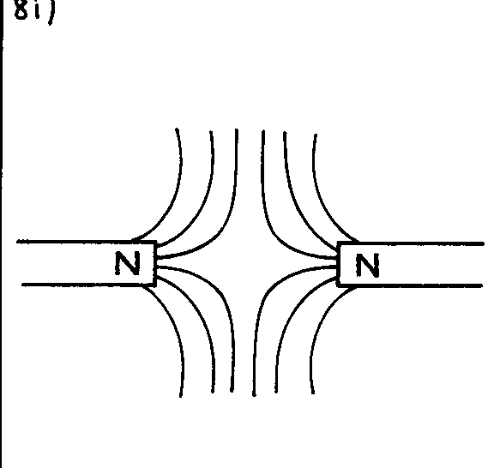Fig 3: Magnetic field between two poles repelling
It may not be apparent to pupils that a compass needle is itself a small magnet and that it points North-South for that reason. Having seen that a plotting compass aligns with lines of magnetic force it follows that the Earth itself has a magnetic field and that plotting compasses (and magnets in general) are simply aligning themselves with the lines of force of the Earth's magnetic field.

It is not easy convincing pupils of the Earth's magnetism: this is a difficult area. Let us look at the Earth's magnetic field:

Fig.4: The Earth's magnetic field
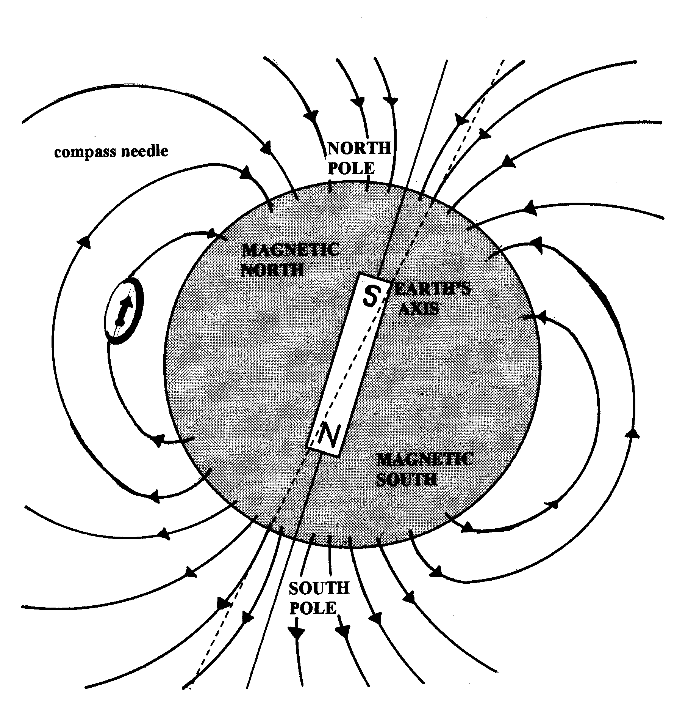
The plotting compass is pointing northwards: the North-seeking pole generally has an arrow.

Three (difficult) issues emerge:
- The North seeking pole of the plotting compass is being attracted by a South-seeking pole within the Earth in the Northern hemisphere (remember: unlike poles attract each other)
- The Earth's magnet does not align precisely with geographic North-South: a plotting compass points towards the magnetic North rather than the geographic North
- Of course, there isn't really a big bar magnet inside the Earth (the Earth's magnetism results from eddy currents within the molten core of the Earth). We are using a model: indeed you can make an effective model by moulding plasticine into a sphere around a bar magnet.

3.3 Making magnets

It is important to realise that steel is used for making permanent magnets as opposed to relatively pure (‘soft’) iron, as steel retains its magnetism. Soft iron loses its magnetism quickly and it is this property that leads to its use as the core material for electromagnets.

A length of steel can be magnetised by stroking it with a permanent magnet:

Fig:5

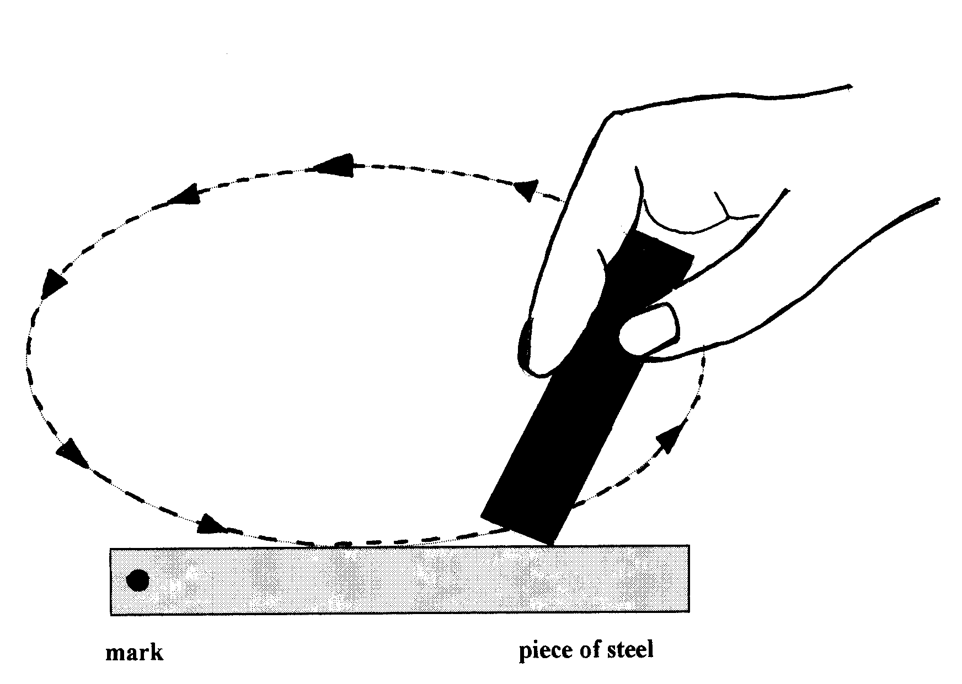
This is not a particularly good way of making a magnet. Strong permanent magnets are made by placing the steel inside a solenoid (coil) with dc electricity flowing through it. Most schools will have a solenoid that can be used for this purpose

3.4 Electromagnets

Any wire carrying a current has a magnetic field around it. The field pattern around a straight wire is circular. If a wire is wrapped into a coil, the field pattern is similar to that of a bar magnet.
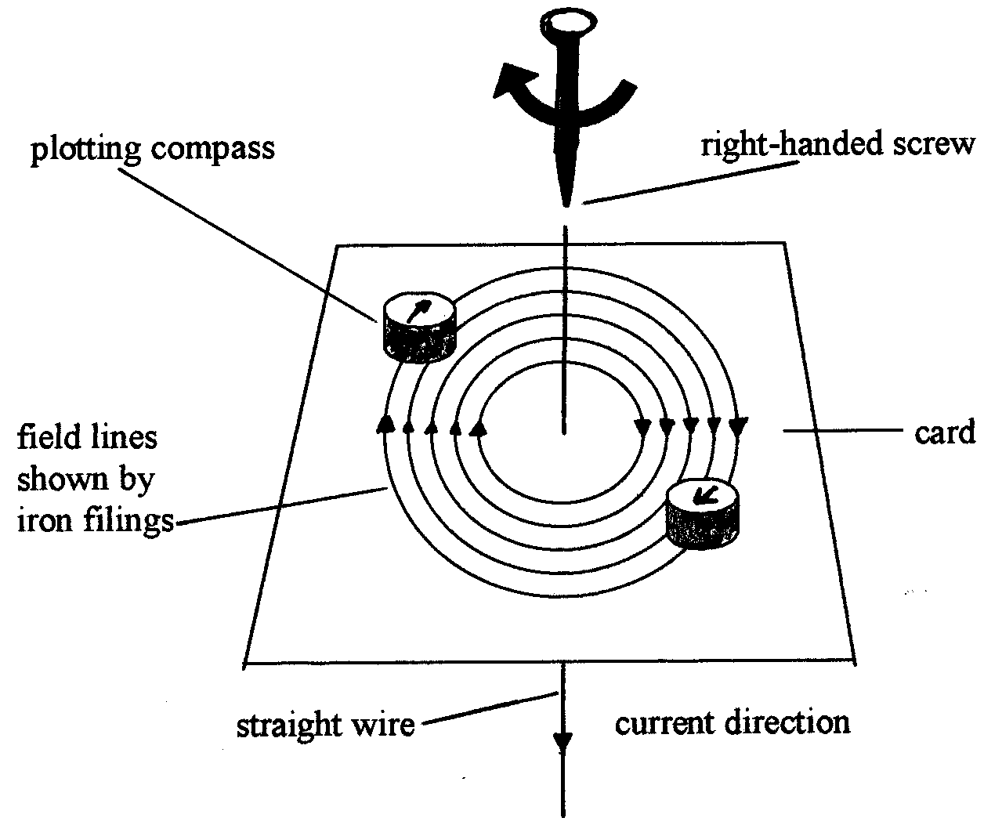
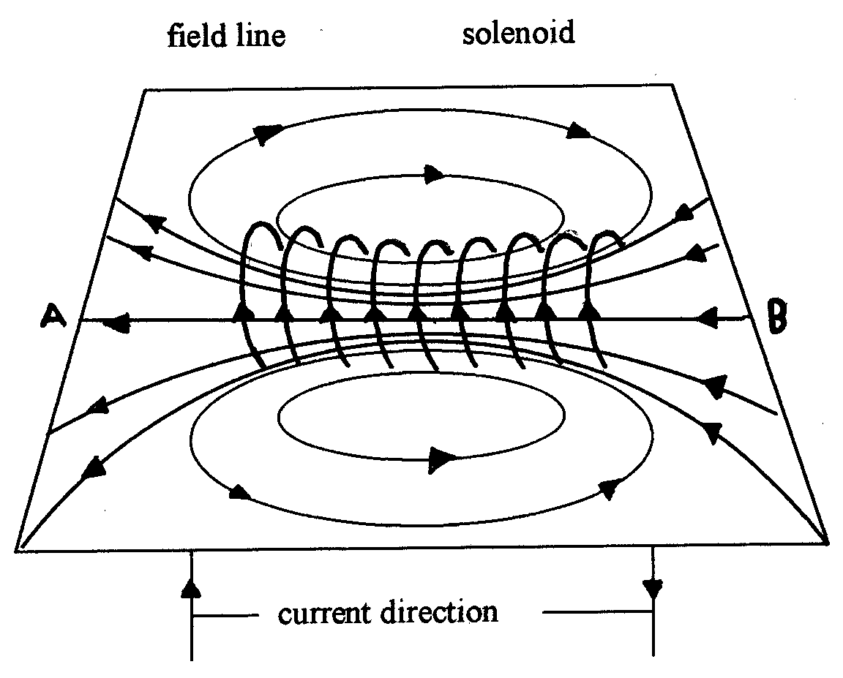

Fig 6 Magnetic fields due to a single current carrying wire and a solenoid
The basic rules relating to electromagnets are as follows:

- Greater current: stronger field
- More coils: stronger field
- Wrap coils around magnetic material (e.g. iron): stronger field
- Polarity is controlled by current direction and winding direction, reversing either swaps the poles around.

Whilst a steel core will enhance an electromagnet, the core will retain some magnetism when the current is turned off. This is a disadvantage for many applications of electromagnets, hence soft iron is used.

A simple class experiment is to get pupils to construct an electromagnet thus:

Fig.7
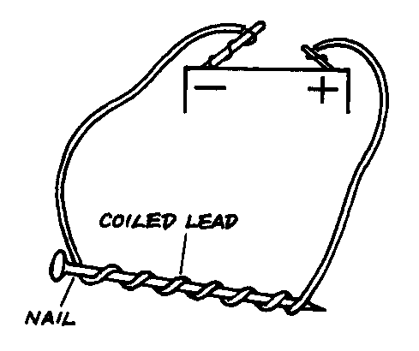
Try getting pupils to make the electromagnet stronger. What ideas do they have? How will they tell if they have a stronger electromagnet?

The experiment could be adapted to make an Sc1 investigation. What variables can pupils identify? What predictions do they make?

One word of warning: iron nails may not be pure iron. As a result they may retain some of their magnetism once the current has been switched off.

- increasing the current (in amps)

Fig.8
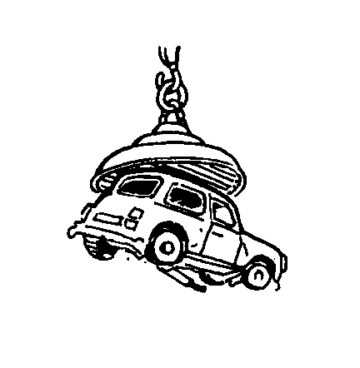
In scrap yards, heavy car bodies and engines need to be lifted and moved. Electromagnets on the end of cranes can pick up and put down components made of iron and steel. Electromagnets can also be used to separate iron or steel from other metals, e.g. aluminium.

3.5 Relays

An electromagnet can be used to operate a switch in a circuit. It can use a very small current from a battery to switch a larger current on and off. This is called a relay switch. For example, the starter motor of a car uses a relay.
Fig 9
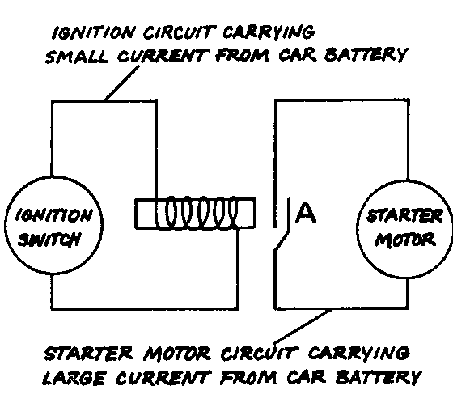

When electricity flows in the ignition circuit the electromagnet bends the metal contact, closing the gap at A and completing the starter motor circuit. The advantages of relays are:
- They allow the operator to use small, low current (i.e. safe) switches to turn on larger currents using relays remote from the operator.
- They can turn on several independent circuits simultaneously by using multiple contacts in the relay.

___________________________________________________________________
TASK 2
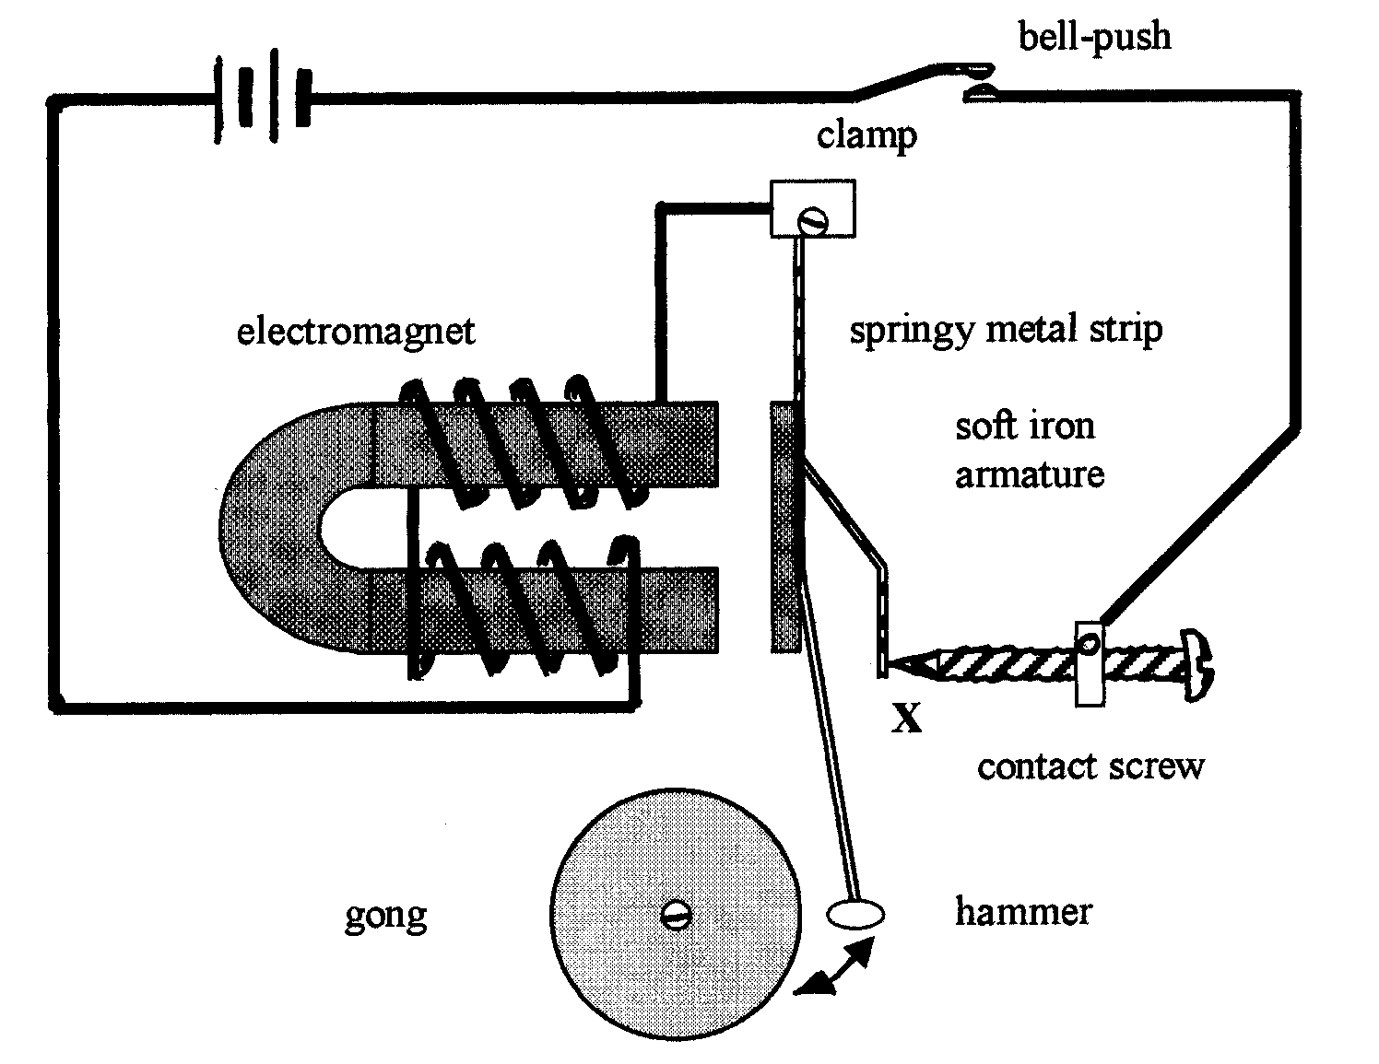
You are teaching a year 8 group about electromagnets. The scheme of work you are using includes the electric bell as an application of electromagnetism.

Prepare a transcript of how you would explain to a year 8 class how an electric bell works.

You can assume pupils have access to a textbook containing this diagram of an electric bell
_____________________________________________________________________

3.6 The domain theory of magnetism

This is a simplified way of explaining how iron and steel can be unmagnetised or magnetised.

You need to picture magnetic materials as being made up of very small 'mini-magnets'. Usually these mini-magnets all point in random directions, and their effects cancel each other out. When iron or steel are magnetised, the mini-magnets lie in the same direction. The effects cancel each other out in the middle of the magnet, but North and South poles are produced at the two ends. Breaking a magnet into two pieces can never produce a single North-seeking pole because new poles are produced at the break.

Fig.10
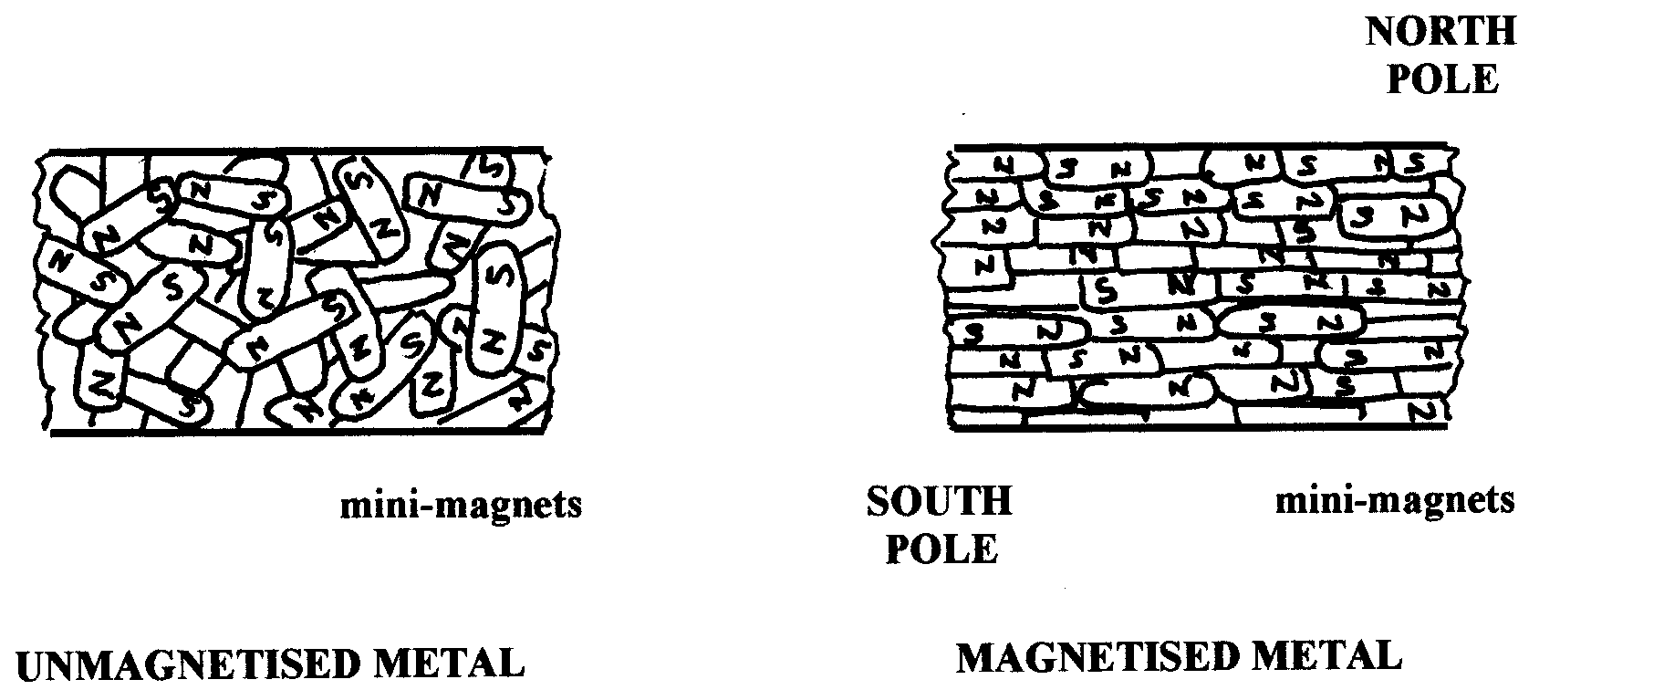

3.7 Demagnetising a magnet

The most effective way of changing magnetised steel in to unmagnetised steel is by putting the magnet into an AC solenoid, i.e. long coil of wire carrying an alternating current.

Mistreatment of a magnet by, for example, hammering it or heating it will also cause it to lose magnetism

In terms of the domain theory, can you explain how magnetism can be lost? In the case of the solenoid, the alternating current causes the poles of this electromagnet alternate very rapidly, disturbing the domains in the steel.

In order for magnets to retain their magnetism they should be kept in pairs so that they attract each other and with soft iron keepers at the ends of each pair of magnets.

4. Static Electricity

In order to understand static electricity it is first necessary to recognise that all materials have positive and negative charge. In the simplest explanation positive charge is due to the protons in an atom’s nucleus, and negative charge is due to electrons. If these charges balance, the object is electrically neutral. The basis for all static electricity can be summed up as:

If negative charge is moved onto, or off an object, for example by friction, then the object is left with either a net positive charge (electrons moved off) or net negative charge (electrons move on).

It is important to recognise that the materials involved can be insulators (e.g. plastics) or conductors, provided that in this case they are supported by insulators to prevent loss of charge.

Once the concept of generating static electricity by movement of negative charge due to friction has been grasped, the next step is to consider what static electricity can ‘do’ and where it is important in everyday life. The National Curriculum requires us to address these areas in detail.

There are many parallels between magnetism and static electricity:

- Magnetic poles are North seeking or South seeking
- Electric charge can be positive or negative

- Like poles repel, unlike poles attract
- Like charges repel, unlike charges attract

- There is a magnetic field between a North seeking pole and a South seeking pole
- There is an electric field between a positively charges object and a negatively charged object.

- Magnetic fields consists of magnetic lines of force
- Electric fields consist of electrical lines of force

At advanced level the similarities between magnetic and electrostatic fields are dealt with in detail as the concepts and mathematical analyses of the two systems are very similar.

4.1 Simple experiments with static electricity

Pupils are likely to be familiar with a number of electrostatic phenomena such as:

- Rubbing a balloon to make it stick to a wall.
- Rubbing a ball point pen on a jumper to make it pick up small pieces of paper.
- Getting a shock after walking on a nylon carpet.
- Lightening.

The first of these two examples rely on the attractive force between opposite charges, although students may be confused as to why a charged object (e.g. balloon) is attracted to a neutral ceiling. Can you supply an answer?

Once a material or object is charged it will retain its charge unless it is earthed, when charge can then go to earth as an electric current. This type of discharge is responsible for the second and third examples above, which might, strictly speaking be described as current electricity. The National Curriculum and many exam board syllabi attach particular importance to the fire risk caused by small sparks produced during this type of discharge.
Let us see how the presence of two types of charge can be demonstrated:
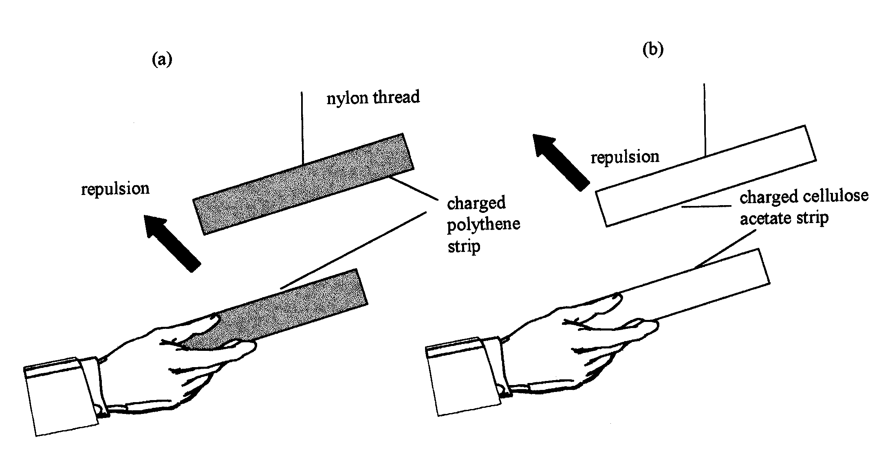
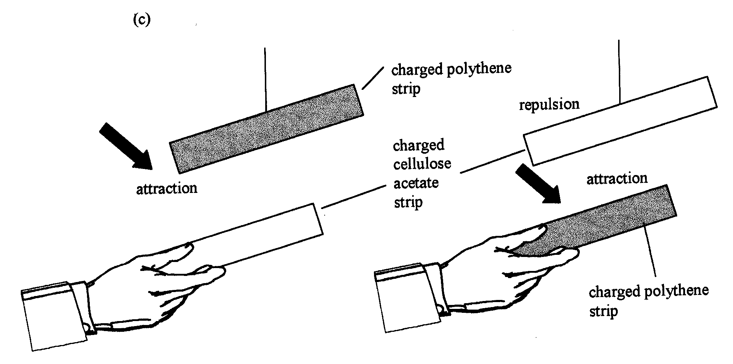
Fig. 11

Gold leaf electroscopes can demonstrate the presence of charge on an object. These rather old devices are present in large numbers in many schools, and whilst their use is now restricted by changes in the curriculum, they do provide an (available) method for carrying out whole class static electricity experiments. If a charged object is brought near the metal plate at the top of the electroscope the gold leaf will move upwards thus:

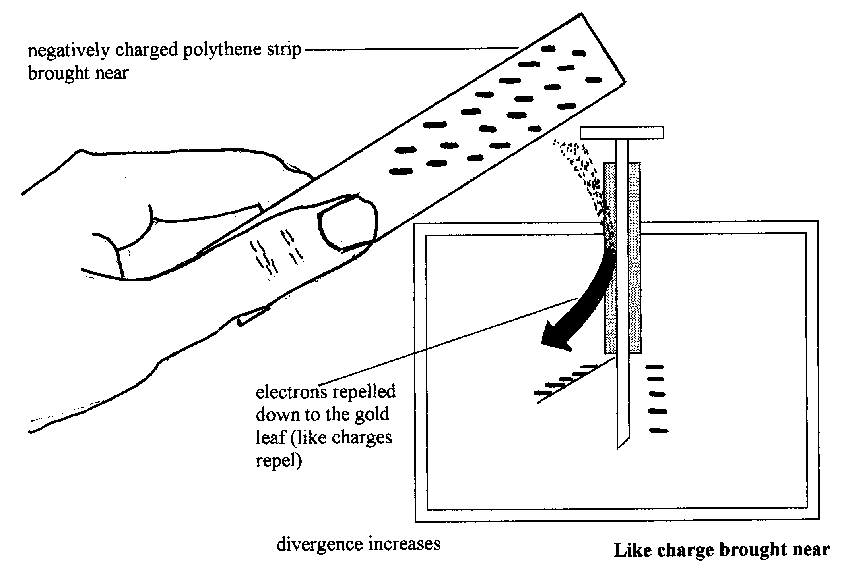
Fig.12 shows the effect of bringing a negatively charged object up towards the cap of a gold leaf electroscope.
_____________________________________________________________________TASK 3
Explain what happens and why when a positively charged object is brought near the cap of a gold leaf electroscope.
_____________________________________________________________________

Most schools will possess a Van de Graaff generator, which has the potential to excite a class and frustrate the teacher due to its often temperamental nature. The Van de Graaff generator can produce very high voltages of the order of 300,000 volts, but the current is very small, of the order of microamps. It is, therefore, safe to use this item of equipment with pupils. It is a very good example of stsic electricity being held on an insulated conductor, i.e. the metal dome.

Fig.13
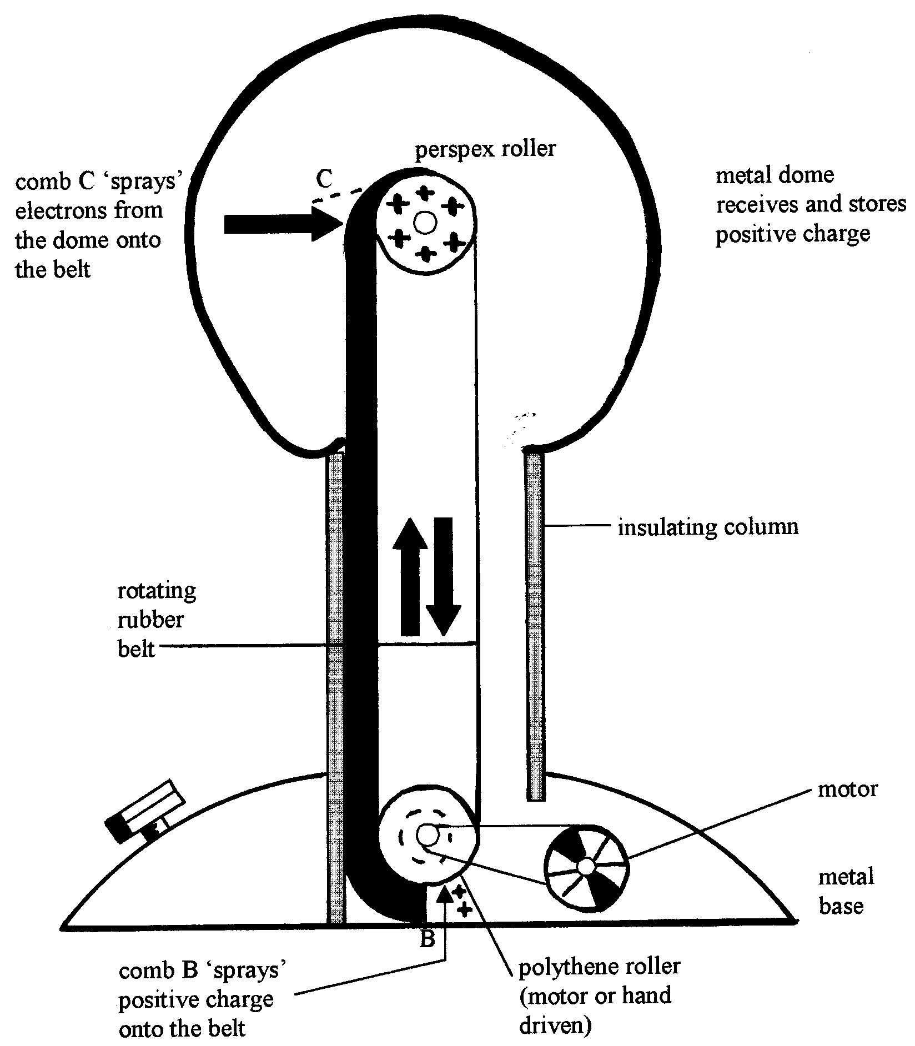

It is worth considering the way in which this machine generates such high potentials. A stream of charge is collected on the sphere and although the total amount is small the sphere soon reaches a high potential. This is because the capacitance of the sphere is small.

The most memorable of demonstrations involves someone placing a hand on top of the dome prior to starting the generator. If the person is insulated (e.g. standing on an inverted plastic bowl) they will become charged up. People with fine, dry hair may find that their hair stands on end! (why??). When they are discharged quickly by being earthed they will experience a small electric shock.

4.2 Lightning

The distribution of charge on charged objects is not uniform. Charge concentrates at points and angles. Let us now consider what may happen when a charged cloud goes over a high building:
Fig.14
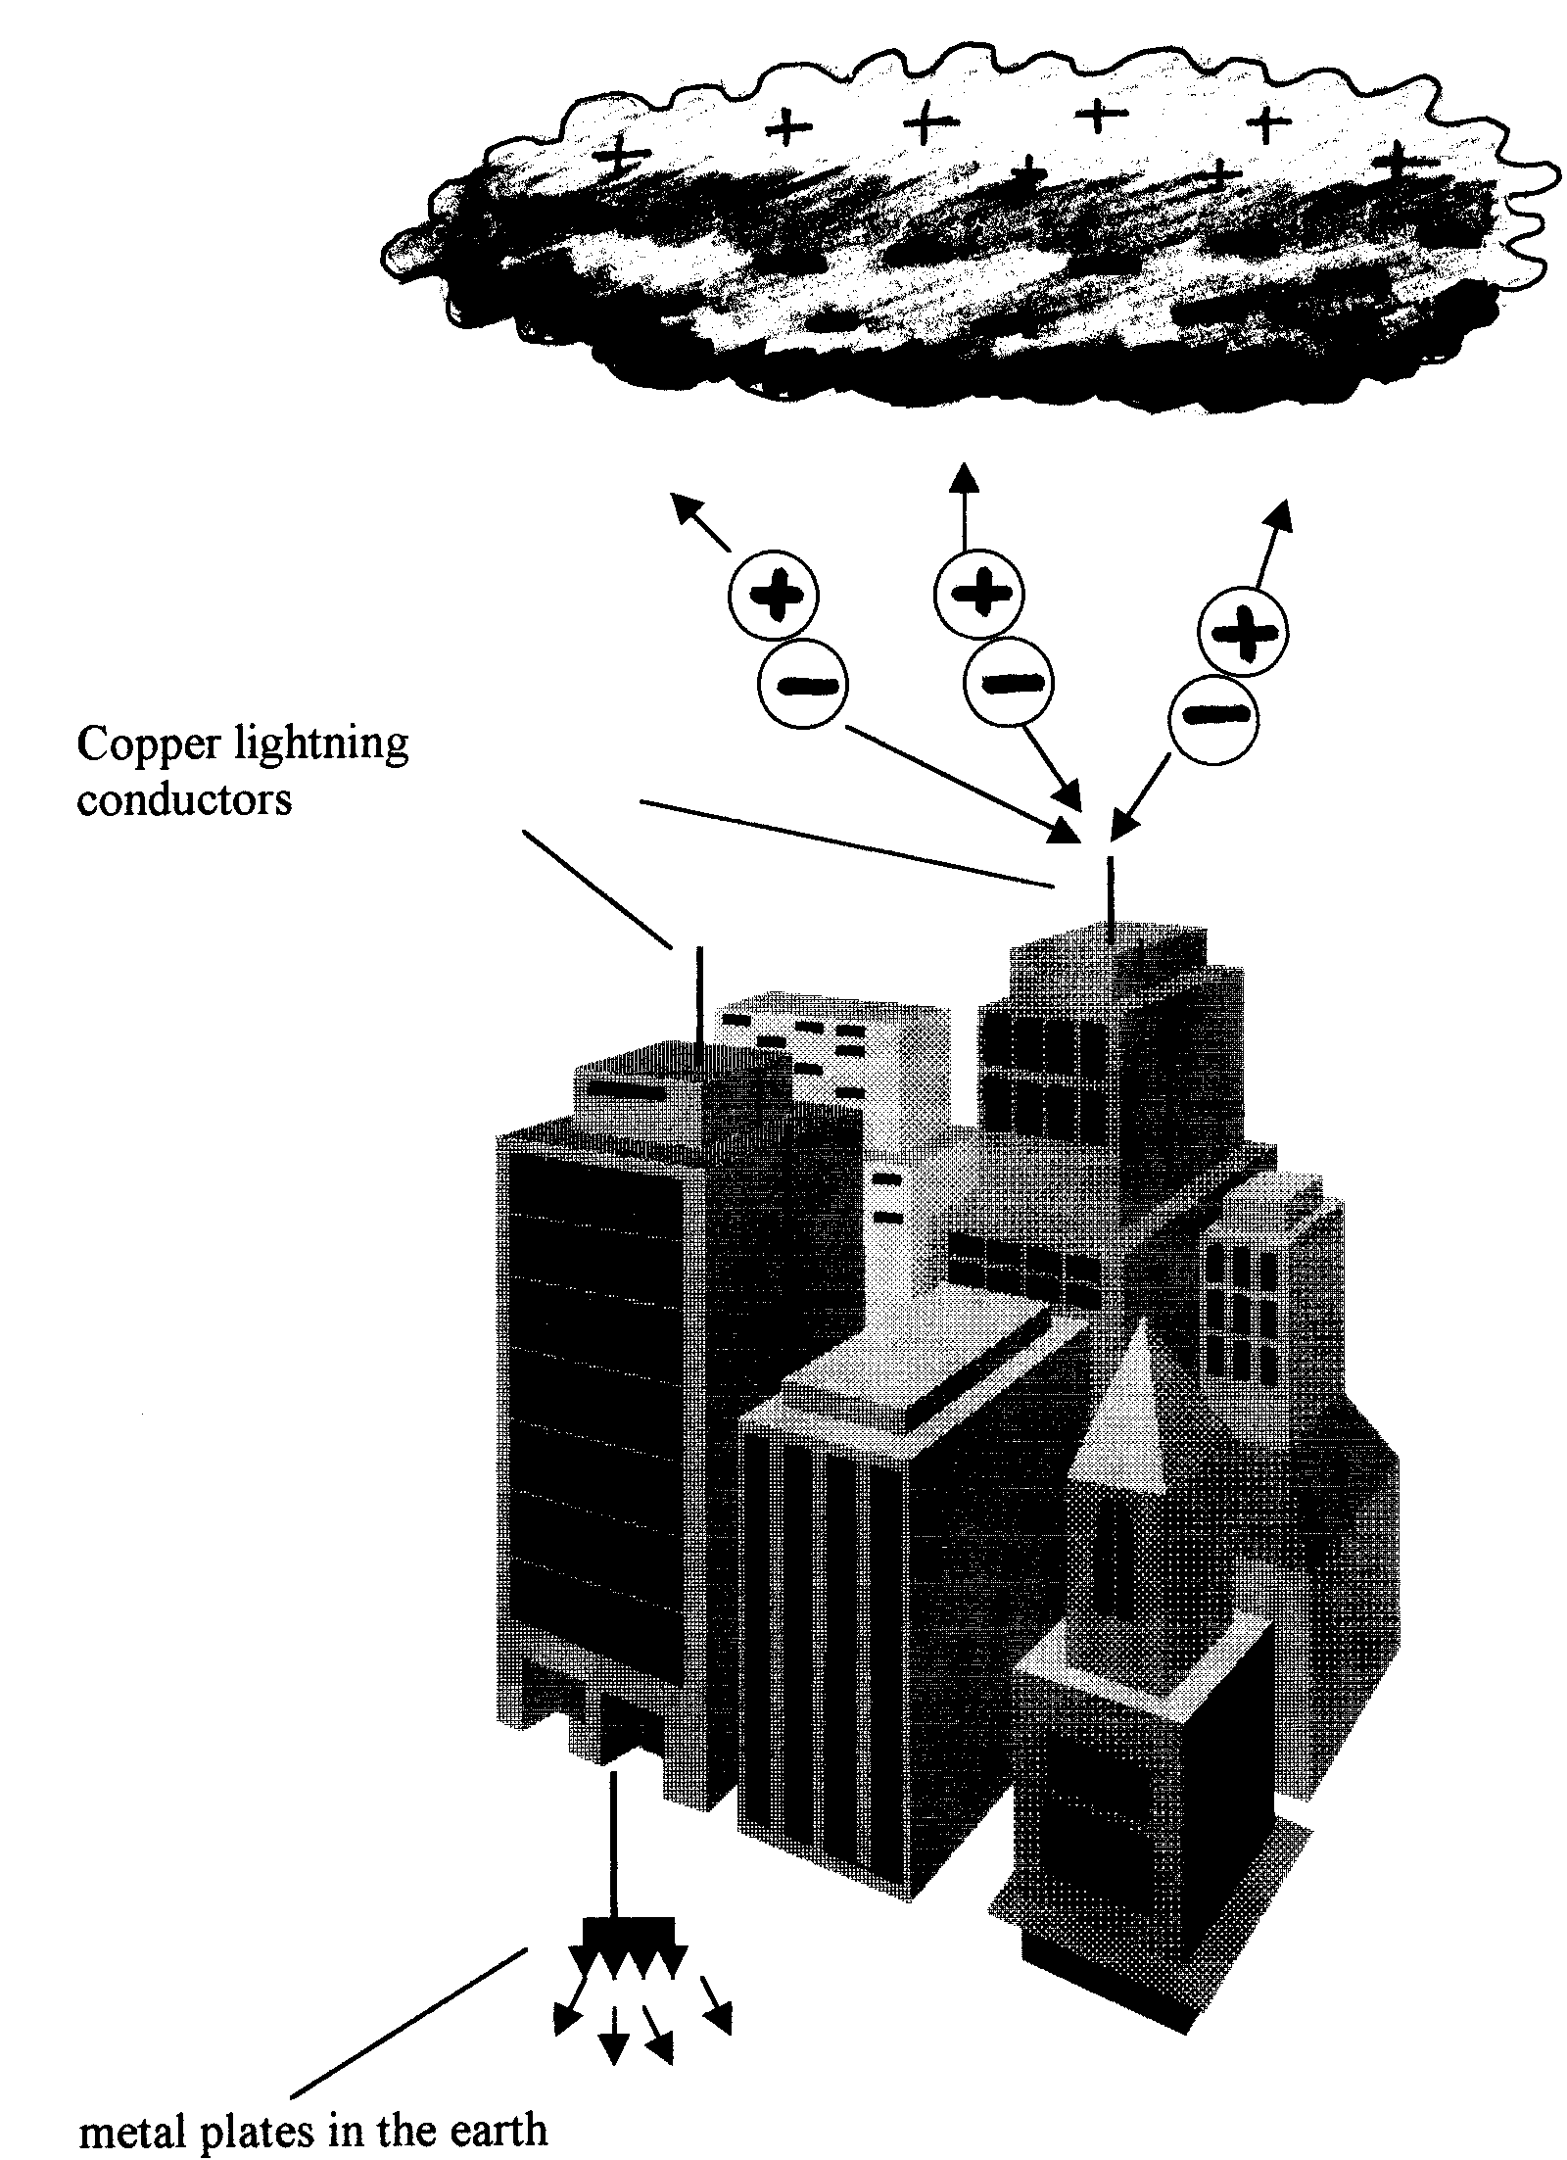
Thunderclouds can build up huge amounts of charge (created by friction between water droplets and air particles as they move around in the clouds). They have a high potential compared with the Earth. As charge continues to build up negative charges build up in the lower part of the cloud. These induce postive charge on the surface of the Earth. Eventually the charge becomes so concentrated (and the potential difference so great) that a spark (lightning) jumps between the cloud and the ground.

The spikes on a lightning conductor develop a very high positive charge (charge concentrates on sharp points) which removes electrons from nearby air molecules, so charging them positively and causing them to be repelled from the spike. This results in an 'electric wind' of positive air molecules streaming upwards to cancel some of the negative charge of the cloud. If a flash does occur it is less violent and the conductor give it an easy path to ground.

_____________________________________________________________________TASK 4
A year 8 pupil asks you 'It's dangerous to shelter during a thunderstorm isn't it?'.

How would you explain the dangers to them? What advice would you give them about what to do?
_____________________________________________________________________

5. Current Electricity

A full comprehension of current electricity requires an understanding of several different technical terms and physical concepts. This represents a challenge to the teacher; it is logical to break the subject down into discrete units, however a reasonable comprehension of current electricity requires understanding of a “critical mass” of the component units. It is often inescapable that the teacher and pupils alike, must invest time in “learning” the building blocks before the wider picture can be tackled.

The key units or elements of current electricity might be listed as:

- Circuits
- Current
- Resistance
- Energy in circuits
- Potential difference and voltage

Each of these elements will be discussed below as a starting point for our consideration of current electricity.

5.1 Circuits

A circuit might be described as: the complete collection of wires and electrical components that form a continuous loop around which the current flows. Note that we have already had to include another term (current) in this basic statement. Perhaps the critical teaching point is that there is a complete loop. If the purpose of the circuit is to illuminate a bulb, then the bulb needs two wires connecting it to the battery, or cell, to form a complete loop.

5.2 Current

Electric current is the ‘thing’ that flows around a circuit. In metal conductors the current is comprised of negatively charged electrons. The basic current facts are:

- Current is a flow of charged “carriers” (electrons in metals).
- Current is given the symbol “I” in equations.
- Current is measured in amperes, symbol A.
- Current is measured using an ammeter connected in series, “+ to +”.
- Current flows from + to -, but electrons flow from – to +.

In a metal there are positive ions in fixed positions, each ion has protons and neutrons in its nucleus surrounded by electrons “in orbit”. Apart from those electrons which are bound to the ions there are electrons free to move through the metal: these are the free electrons, which form a sea of shared negative electrons between the positive metal ions:
Fig.15
o o o o o
- - - - - -
o o o o
- - - - - -
o o o o o
'sea' of shared
positive metal ions
negative charge

It is these free electrons that move when a current flows. The free electrons in the wire are continuously moving around in a random way, rather like gas molecules. They are so light, however, that they can have high speeds, of the order of 100,000 ms⁻¹. When a current flows however, the electrons move around the circuit towards the positive terminal of the battery or cell (opposite charges attract..).. This motion is relatively slow, and is described as a drift, leading to the term drift velocity. Drift velocities are typically less than 1 mms⁻¹

Although the electrons are negative, the conventional direction of current flow is from positive to negative around the circuit, therefore the opposite direction to electrons. This is a legacy from history: conventional current flow was defined before the discovery of the electron in 1897. This does, however, present a problem for learners!

Each electron only caries a tiny amount of (negative) charge. Charge is measured in coulombs (symbol C) and 1 ampere is defined as a flow of charge of 1 coulomb per second past a point in the circuit.

Around the loop of a simple circuit, the current at all points is the same, as there is nowhere for the electrons to escape. Additionally, when the current begins to flow, it starts flowing at all points in the circuit simultaneously. These two (critical) concepts are often hard for pupils to grasp, and many models and analogies have been developed to assist teaching in this area.

5.3 Resistance

Resistance is a measure of how hard it is for a current to flow through a conductor. It is given the symbol “R” in equations and is measured in ohms, symbol Ω (upper case omega).

Resistance in a metal is due to the free electrons colliding with vibrations of the metal lattice or with impurity atoms. The lattice vibrations decrease as the temperature is reduced, but the impurity effect is unchanged. Some metals exhibit superconductivity, having zero resistance at very low temperatures near absolute zero.

Resistors are electrical components which have a fixed, known resistance and are used to control currents and voltages in circuits. Variable resistors allow you to adjust their resistance. Large variable resistors, often called potentiometers, areoften constructed from a coil of wire wrapped around a ceramic former with a sliding contact bearing on the coil.

For a simple piece of wire its resistance is determined by:

- Length: longer = higher resistance
- Cross sectional area: larger = lower resistance
- Material.

5.4 Energy in circuits

Energy transfer in a circuit is a key concept and perhaps the most important feature of circuit electricity. In a circuit carrying an electric current there is a continuous input of energy from a cell or battery. The electorns carry this energy and lose it as they pass through the circuit components and encounter the electrical resistance of each component. In summary:

- The cell or battery provides the electrons with energy.
- Electrons lose energy in the circuit’s components.
- High resistance components result in greater energy loss.

Perhaps the simplest example of energy transfer is alight bulb connected by two (low resistance) wires to a battery.

- The battery provides the electrons with energy
- The electrons lose minimal energy in the low resistance wires, producing a small heating effect.
- The electrons lose most energy in the thin, high resistance tungsten filament of the bulb.
- This energy loss heats the bulb, emitting heat and light.

An electric current can be viewed as an 'energy carrier'. The current transfers energy from the battery to the bulb. There it is emitted as light and heat energy. The current then returns to the bulb to gain more energy, which is again transferred to the bulb to be emitted.

The heating effect of a current flowing through a conductor is stressed in the National Curriculum and in many texts as the most commonly used application of electricity. Calculations relating to the heating effect rely on terms that have yet to be defined in these notes, however it is appropriate to quote the relevant relationships at this point:

Energy transfer per second = Current x pd

Or
Power = I (amps) x V (volts):
and
total energy transfer = current x pd x time = power x time
or
energy (J) = I x V x time (sec)

5.5 Potential difference (pd) and voltage

These two terms are often interchanged, but the do have different meanings, however confusingly at least one exam board does not distinguish between them.

Perhaps the easiest way to explain them is in terms of electrical pressure, with voltage defined as the electrical pressure “pushing” electrons out of a cell or battery, and potential difference (pd) as the electrical pressure felt by a component, e.g. a light bulb. The SI unit for voltage and pd is the volt (V), and both are measured by a voltmeter connected “+ to +”, in parallel with the component under consideration. In equations “V” is used for voltage and “pd” for potential difference.

The more precise explanation of pd is as follows: A Pd of 1 volt exisits between two points in a circuit when 1 coulomb of charge flowing between those points transfers 1 joule of energy. This leads to the following equation:

Potential difference (p.d.) = energy transferred (J)
charge moved (C )

in S.I. units 1 volt = 1 joule/coulomb

You will realise that, conceptually, voltage and pd are more difficult parameters than, say, current or resistance.

5.6 Series and parallel circuits

There are two basic arrangements for components in circuits, series and parallel. Pupils often find it hard to remember which is which, the following may help:

- Series: components one after another, like episodes in a TV series.
- Parallel: components side by side like parallel lines.

Fig 16 shows simple series and parallel circuits.

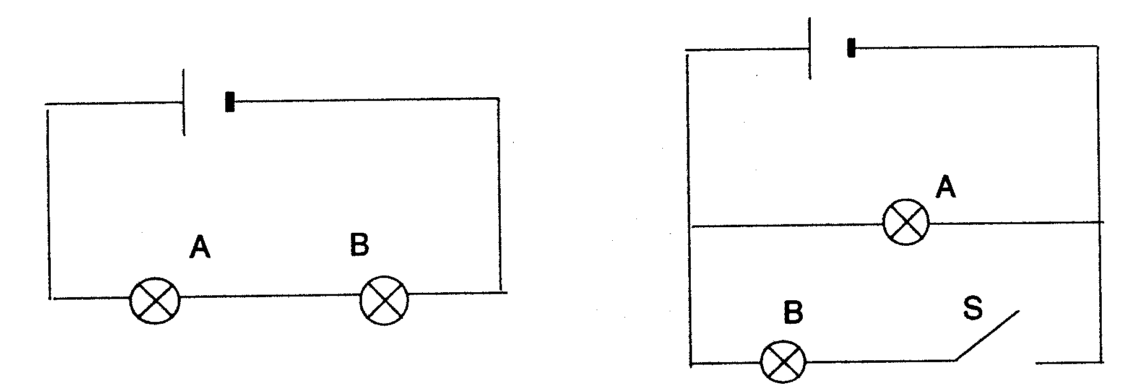

Series Parallel

Here is a summary of the basic learning points for series and parallel circuits.

Series
- Current is the same at all points in the circuit.
- Bulbs share the cell voltage (equally if they are identical, if a 12V cell is used each bulb will have a pd of 6V).
- Bulbs are equal brightness (provided they have the same resistance).
- Adding bulbs reduces the pd for each bulb and so reduces the brightness.
- If one bulb fails, the other goes out (the failed bulb acts as a switch)

Parallel

- Current is conserved at junctions, i.e. the current flowing into a junction is equal to the sum of the currents flowing out.
- Each bulb “feels” the full cell voltage in the example above.
- Adding more bulbs in parallel does not reduce bulb brightness (they all feel full cell voltage) but the total current delivered by the cell increases, and it goes “flat” faster.
- Individual bulbs can be controlled by individual switches, and the failure of one bulb does not control others.

It is very important to note that the rules on brightness only apply for identical bulbs having identical resistance. In practical sessions this is often difficult to achieve due to different “size” bulbs being available and the slight differences between supposedly identical bulbs. Bulbs are usually rated in terms of working voltage and operating current, marked in frustratingly small print on the metal case of the bulb. A useful tip is that many manufacturers colour code the small glass insulator separating the connections to the filament. It is vital that bulbs are selected carefully prior to any circuit demonstration.

Domestic lighting is always connected in parallel. Can you give the two main reasons for this? Many texts and schemes of work use the example of Christmas Tree lights, implying that they are wired in parallel so that if one fails the others remain lit. Many indoor light sets are in fact wired in series. This has two main advantages; the pd for each bulb is low (as they share the supply voltage), and failure of one bulb can lead to the other going out, leading to the traditional Christmas game of ‘find the blown bulb’.

5.7 Ohm’s Law

For any component in a circuit, pd (“Voltage”), current and resistance are linked. The relationship for many components is described by Ohm’s law, which leads to the well-known equation:

pd (volts) = I (amps) x R (ohms)

or V = IR

Strictly speaking the equation is only a product of Ohm’s law, and only applies to certain types of resistive components (so called Ohmic conductors) but at key stage 3 these details are not broached. In practice the equation describes the following relationship:

- The current through a component depends on its resistance and the pd across it.
- Increasing resistance reduces the current.
- Increasing pd increases the current.

At GCSE pupils may carry out an experiment to demonstrate Ohm’s law by varying the pd across a component and recording pairs of current and pd values, measured using an ammeter and voltmeter. Plotting a graph of pd against current should yield a straight line with gradient equal to resistance. On possible set up is shown below. Where, and how, should the voltmeter be connected?

Fig.17

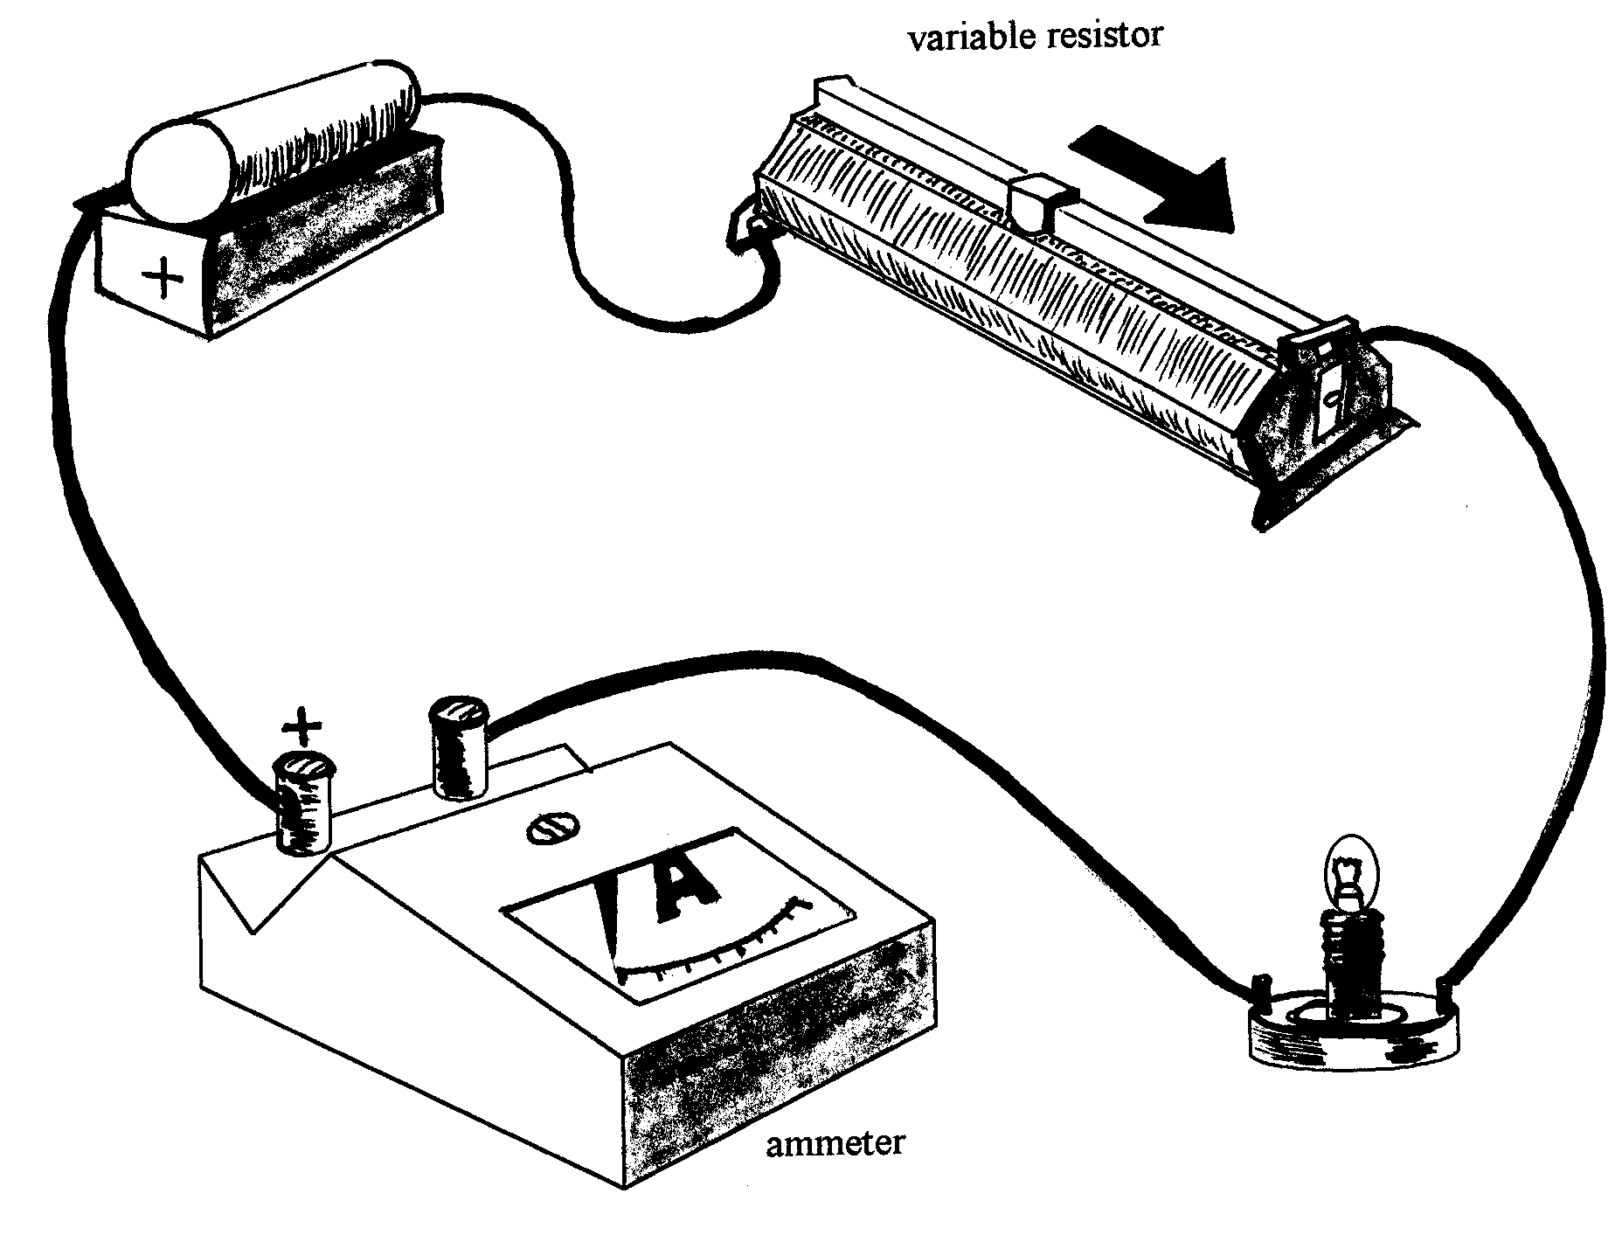

5.8 The chemical effect of a current

Electric currents may flow through any media that has mobile charged particles to act as current carriers. Solutions and molten materials containing ions can transmit currents, the ions being the charge carriers. The passage of currents through such liquids can result in electrolysis. In this process positive charge carriers move one way, and negative the other. If the circuit is produced by placing electrodes (connected to a power supply) in the liquid, then the ions will move to the relevant electrode obeying the “opposite charges attract” rule. At the electrodes the ions will be deposited, and this may be observed. A common key sage 4 experiment is to use a copper sulphate solution as the electrolyte. Copper ions move to the negative electrode, and are deposited as copper plating on the electrode.

5.9 The motor effect

Any current carrying conductor produces a magnetic field around it. This magnetic field will generate a repulsive (or attractive) force if there is a second magnetic field near by, and this force can lead to movement. This motor effect is used in electric motors, loudspeakers and moving coil electric meters.

The simplest way to demonstrate the effect is using a single wire connected to a dc supply and placed in the field of a strong permanent magnet.

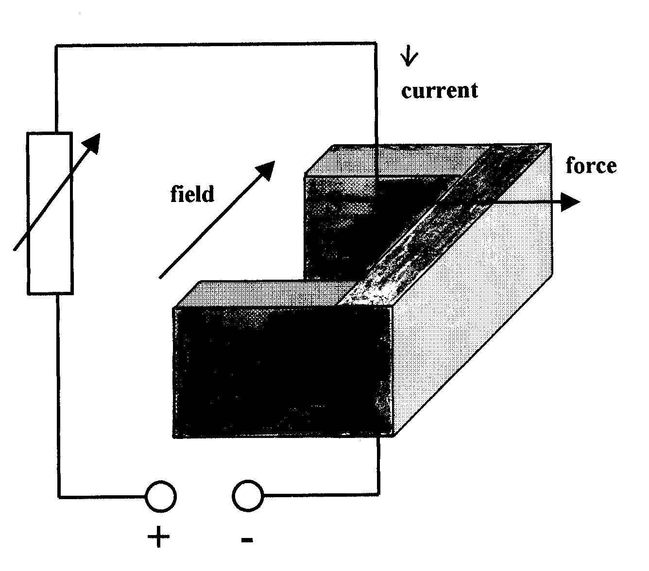
Fig.18 There will be a sideways force on the current carrying wire. The direction of this force (which can cause movement) can be predicted from Fleming's Left Hand Rule:
Forefinger is the direction of the Field
MIddlefinger gives the direction of current (I)
TheMb gives the direction of motion.

Consider how this rule causes the wire to rotate below:

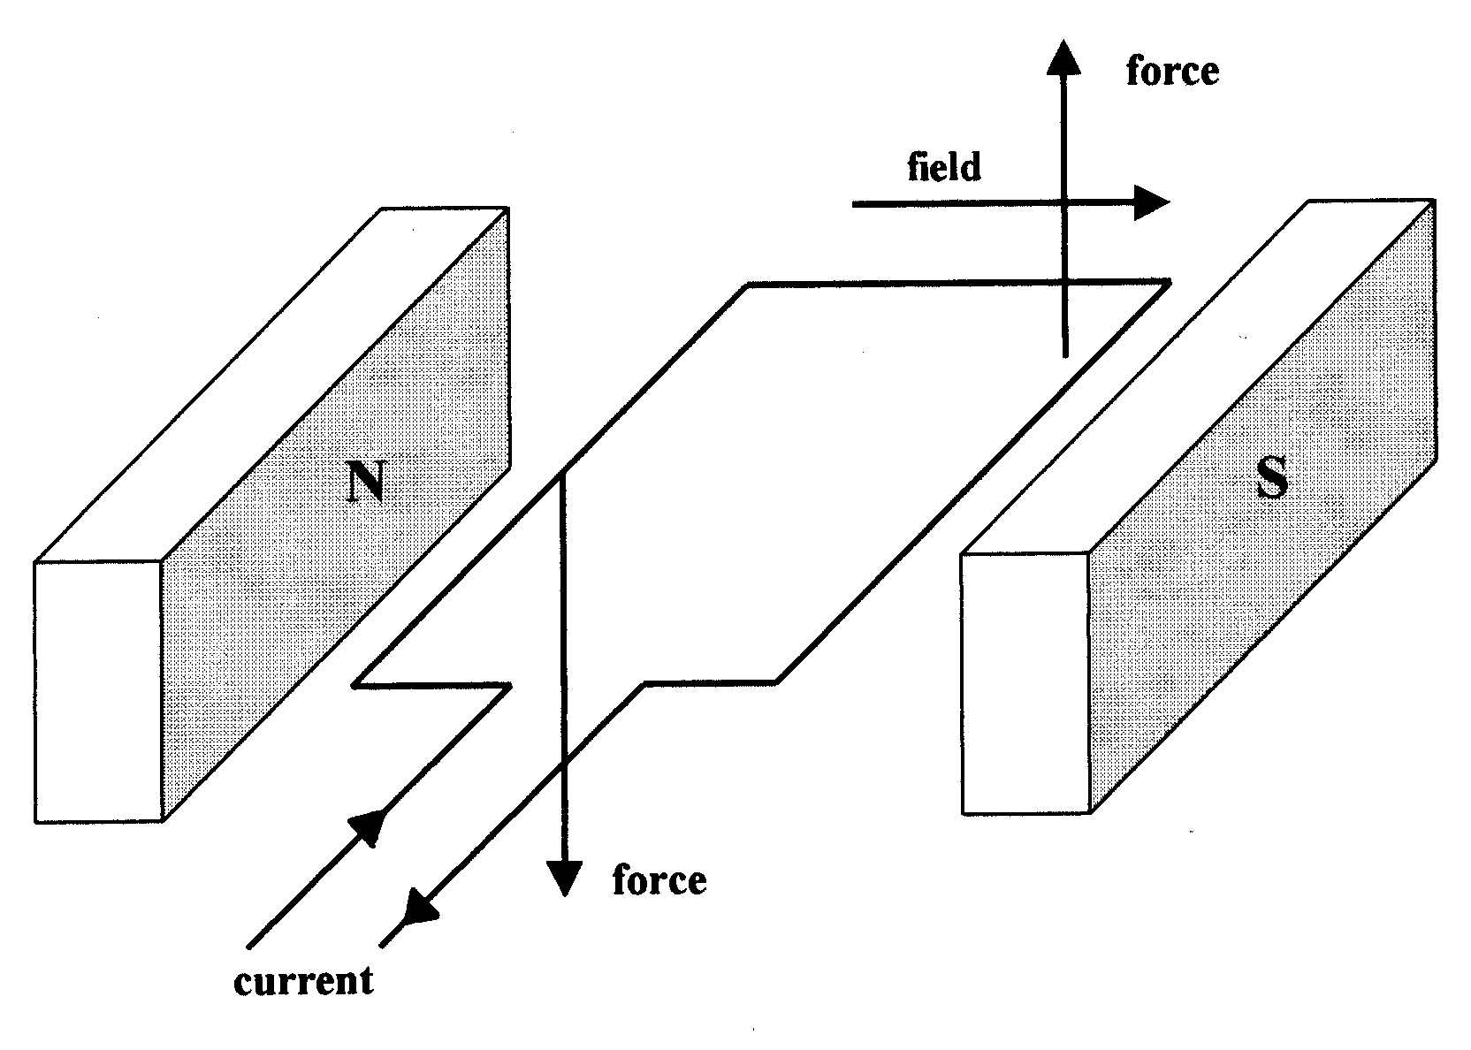
Fig.19 The wire can rotate until it is vertical

In order to produce continuous rotation a commutator is needed. This enables the direction of current flow in the coil to reverse once the coil reaches the vertical.
Thus, in an electric motor the direction of current flow in the coil changes every half rotation.

Electric motor kits are readily available from school suppliers. Making an electric motor requires dexterity. Ensure you practice before attempting this activity with a class!

The most common mistakes that pupils make are:

- Having insufficient turns in their coil.
- Having the magnetic poles repelling rather than attracting.

5.10 Analogies, teaching challenges and circuit electricity tasks

There are many models, analogies and devices to assist teaching of current electricity in circuits. Here is a relatively simple model used to demonstrate the concept of a current in a complete circuit.
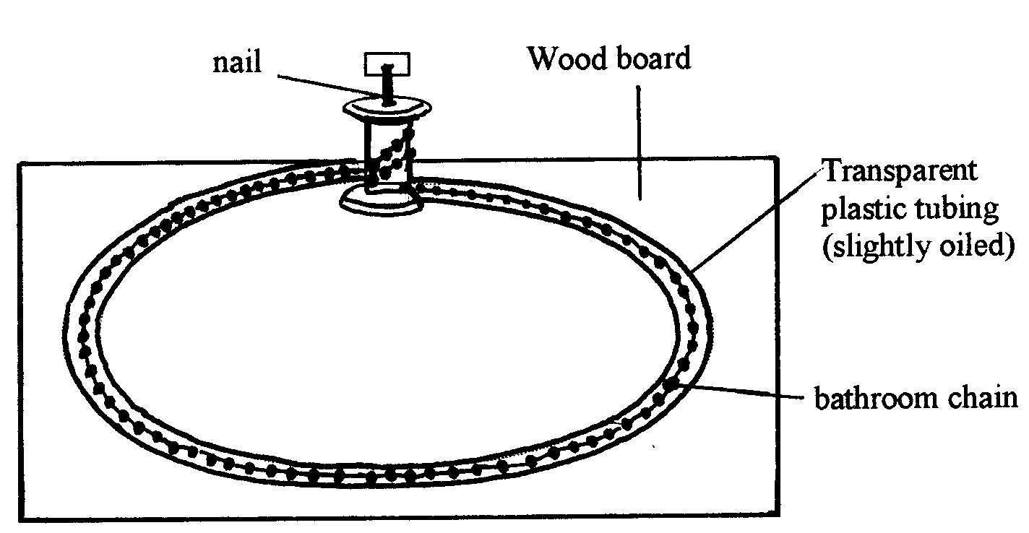
Fig.20
Think how you could use the apparatus illustrated to explain current flow to a year 7 group.

How helpful is this analogy? What key features of a current in a circuit does the model demonstrate? What doesn’t it demonstrate?

The most common analogy used to explain electric current is water flow around a water circuit. Some schools may have demonstration devices available for this analogy. In this analogy:

- Pipes are equivalent to conductors (wires).
- Water is equivalent to electrons.
- The pump is equivalent to a battery.
Fig. 21

Pump

Pump increases potential energy of the water
Water loses gravitational potential energy and returns to pump

Water flow as an analogy for electric current can be taken further by considering a water circuit as in Fig. 22 below. In this case the narrow pipes are equivalent to high resistance components, the manometer is equivalent to a voltmeter, and the tap equivalent to a switch.

Fig.22
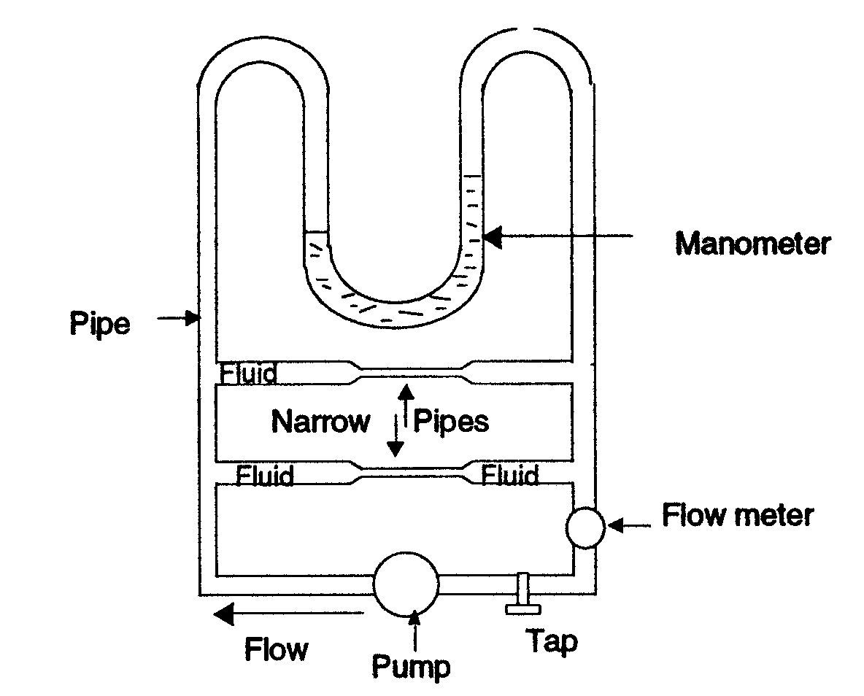

As with all analogies it is important not to lose sight of the key objective when deciding how far to go with the analogy. The aim is to convey the science, as opposed to developing sometimes increasingly abstract details of the analogy itself.
________________________________________________________________
TASK 5
Try for yourself to see how many good analogies you can write down for current electricity in a simple circuit. See how far you can go in describing each element of current electricity.
________________________________________________________________
There now follow some general tasks that draw on the material covered so far in this section on current electricity.
________________________________________________________________
TASK 6
A battery is connected up to a torch bulb as shown in the diagram below:
bulb

battery
wires

Now look at the diagrams below and select the best description for the electric current:
(a) (b)

There is no current in the wire attached to The electric current will be in a direction towards the
The bottom of the battery bulb in both wires

(c) (d)

The direction of the current is indicated by the The direction of the current is indicated by the
Arrows, but the current in the return wire is less arrows, with the current the same in each wire
__________________________________________________________________________________________

Each of the alternative answers provided is rational in terms of common beliefs regarding current, but only answer (d) is scientifically acceptable.

Answer (b) is fairly common among year 7 pupils. These children therefore view a cell or battery as something that pushes 'power' into the bulb through each terminal.
Answer © is also given very often. Indeed many adults give this answer. Most probably this is because they see current as being 'used up' as the bulb emits light and heat. This is not the case: current remains the same at all points in the circuit. The concepts of current and energy are being mixed up.
_____________________________________________________________________

TASK 7

When teaching a year 7 class what strategies would you use to try to convince pupils that electric current is not 'used up' by a bulb in a simple circuit?
_____________________________________________________________________

TASK 8
Imagine that a year 9 pupil aged about fourteen asks the questions below. Try to answer orally, perhaps asking a helper to read questions to you. The last few questions are more difficult and may require longer explanations. Your answer should contain an explanation rather than just a simple statement of fact.

- What is electricity?
- Why is electricity dangerous?
- Does the current start as soon as the switch is switched on?
- Why doesn't the bulb come on/go off straight away?
- Why do we say that current flows in a certain direction?
- Why not make this the same direction as the direction of electron travel?
- How do we know when there is a current flowing in a wire?
_____________________________________________________________________

TASK 9

If we consider a single bulb illuminated by a single cell to be glowing with 'normal ' brightness, predict the lamp brightness in the circuits below. What happens when the switches are closed?
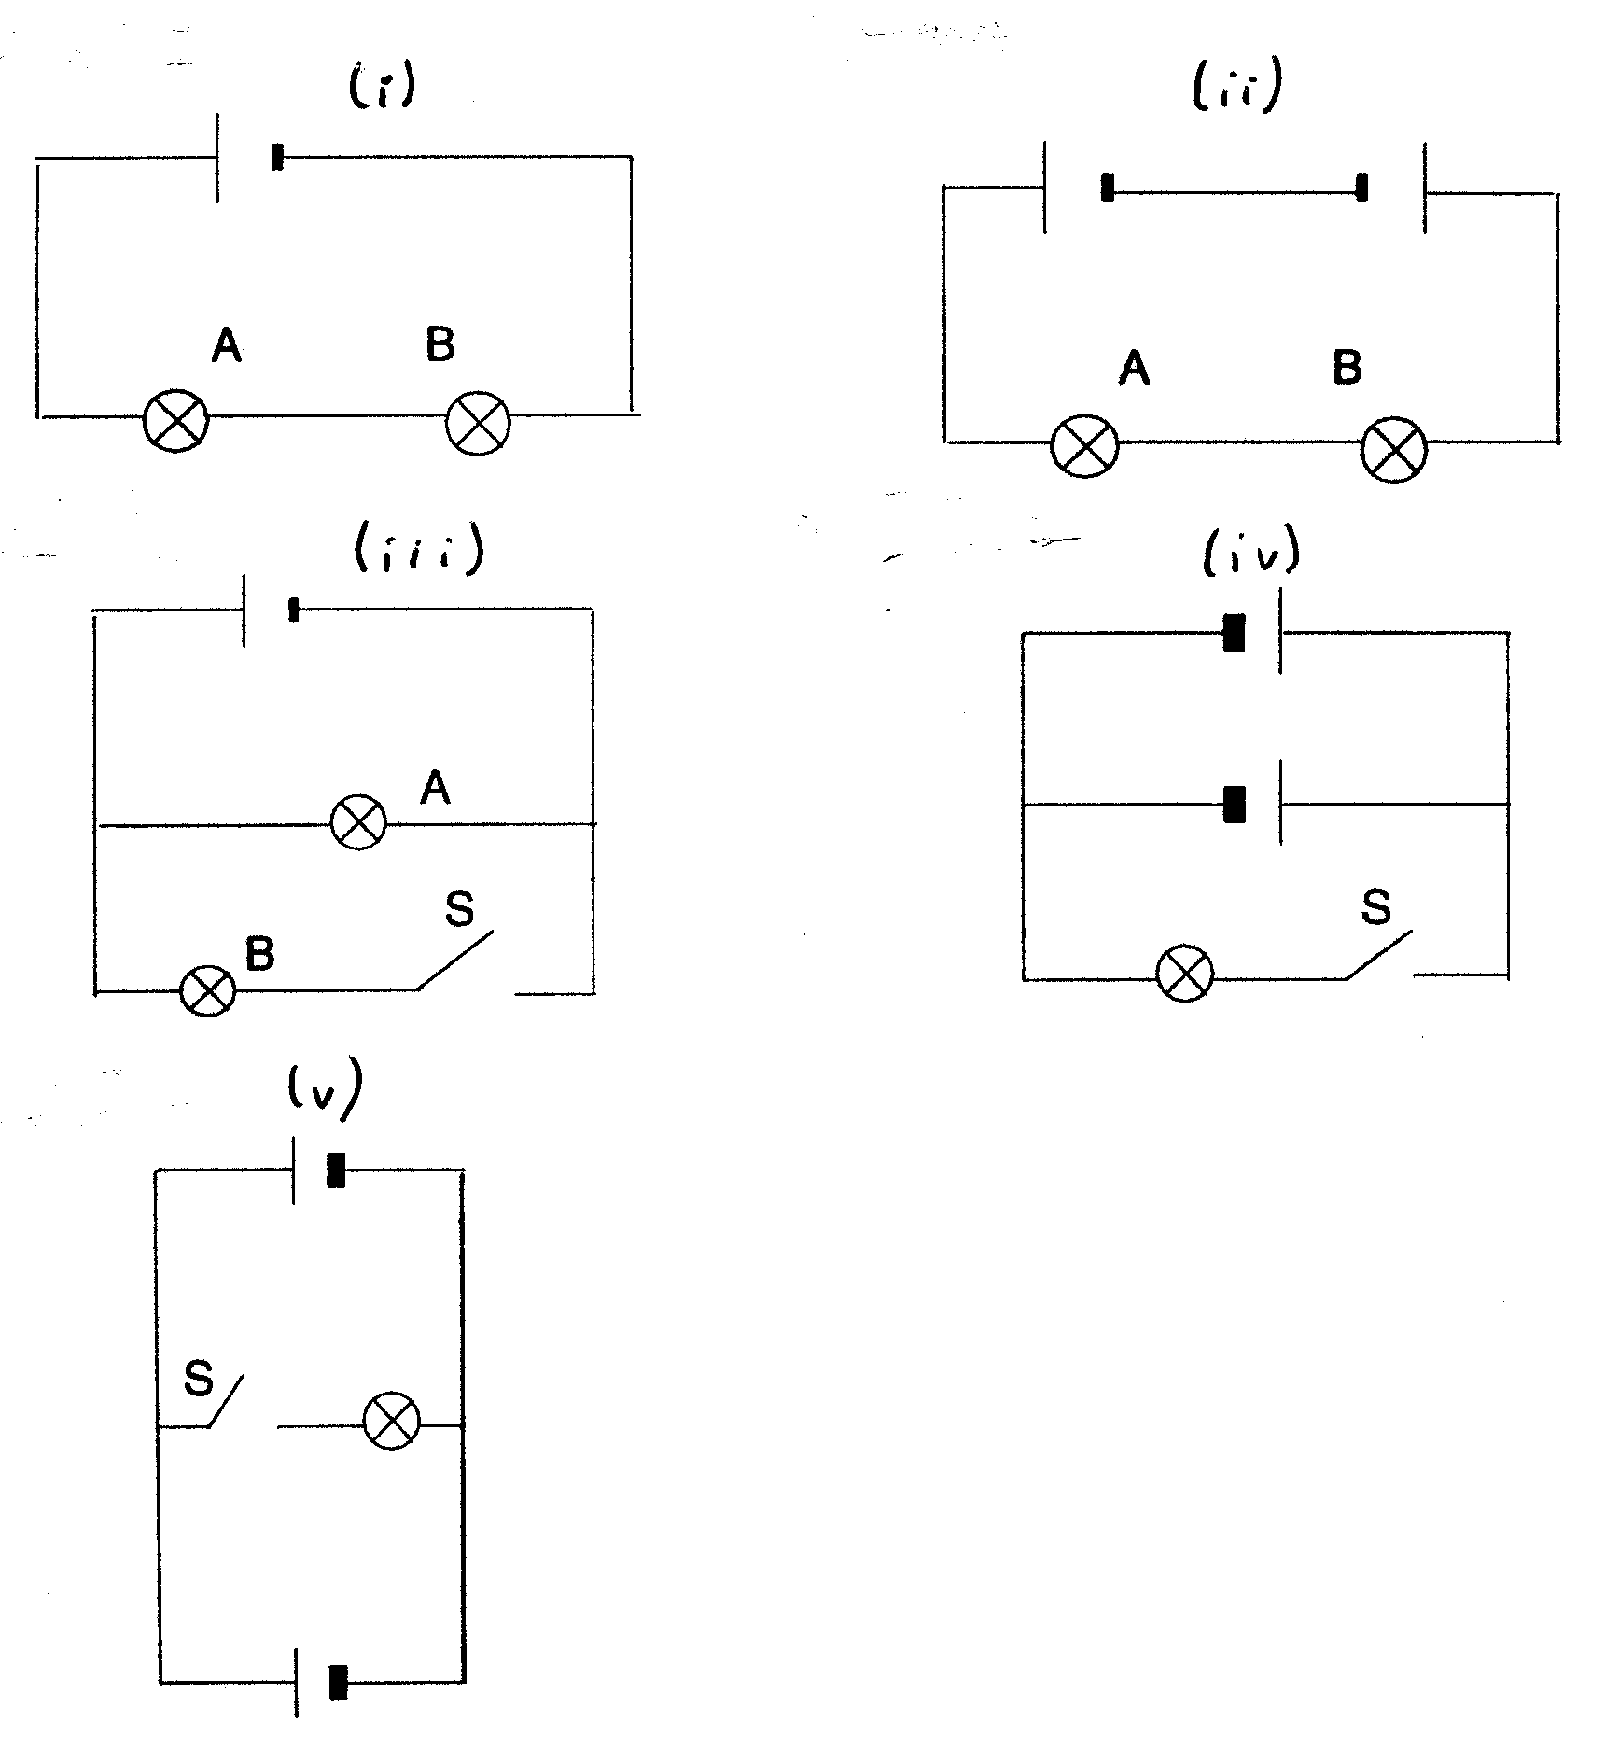

_____________________________________________________________________

TASK 10

Explain to a member of your family or a friend how a d.c. electric motor works.

Did they understand??
____________________________________________________________

6. Mains electricity

Mains electricity is alternating current (a.c.) as opposed to the direct current (d.c.) from a cell or battery. The polarity (i.e. + and – terminals) are effectively swapped, or alternated, 50 times a second (50Hz). It is easier to generate and change the voltage of an ac supply; ac is the norm for domestic supplies around the world, although the supply voltage and frequency vary from country to country.

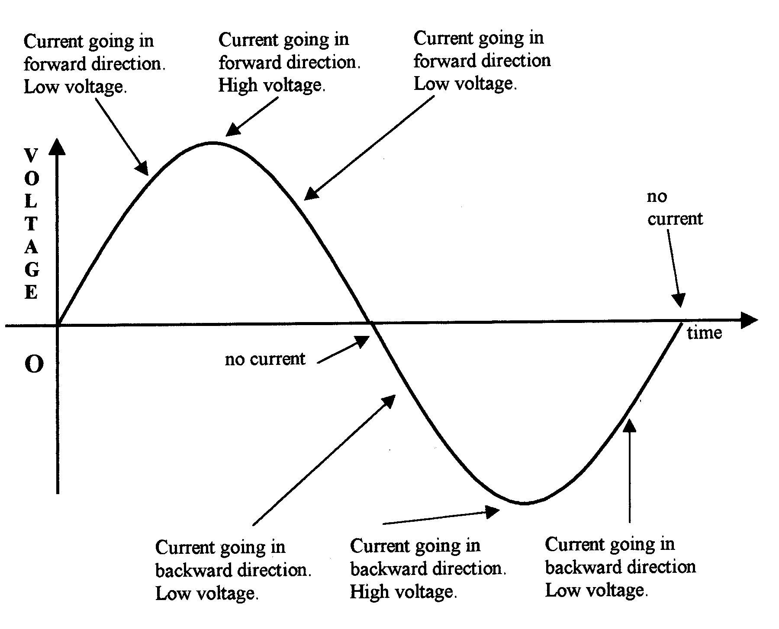
Fig.23 shows the variation of voltage with time of mains current.

Mains voltage is taken to be 230 volts. Fig.23 shows, however, that voltage is constantly changing. Thus 230 volts is an averaged value (technically it is the 'root mean square voltage'). For many calculations we use a value of 240 volts: this figure is easier to manipulate mathematically.

Many schemes of work include a practical lesson on wiring a three-pin plug. This practical skill has been rendered somewhat redundant by legislation that requires domestic appliances to be supplied with a plug fitted, however there is still the need to teach the cable colour code and electrical safety features. Ensure that the mains supply is turned off as you do this activity.

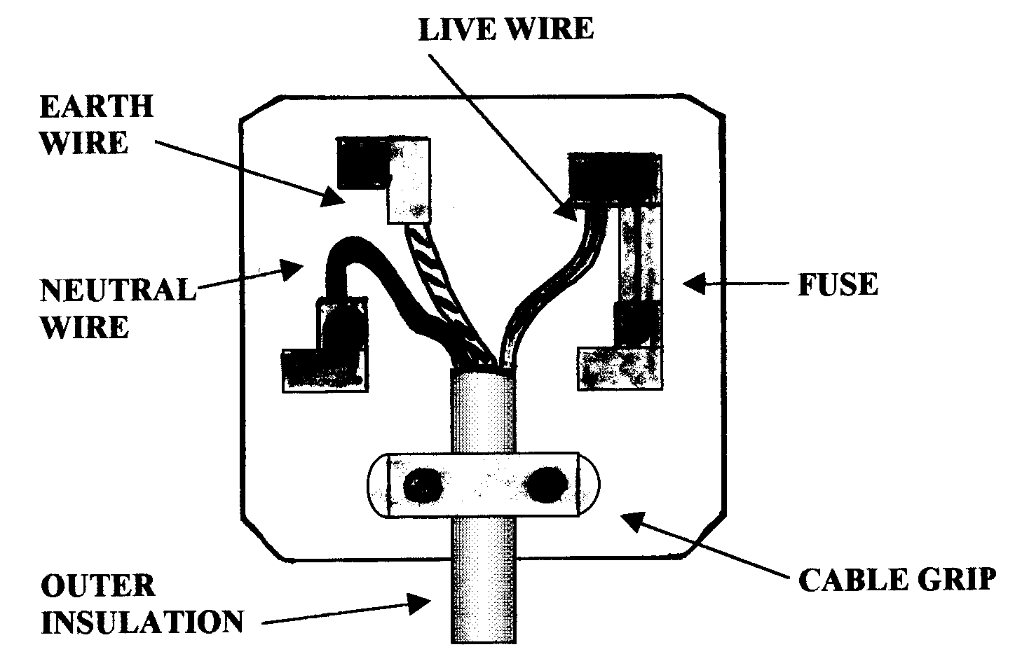
Fig.24 shows the wiring in a plug and the position of the fuse.

Remember: brown = live
blue = neutral
yellow/green = earth

Fig. 25
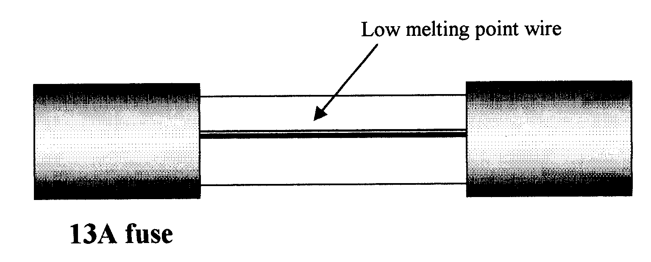
The fuse is a safety device. Inside the glass casing is a thin strip of fuse wire. This will melt and break the circuit if a particular current is exceeded. In plugs in your home you are most likely to come across 3 amp and 13 amp fuses. You would use a 3 amp fuse for a device taking a small current (such as a table lamp). If there is a short circuit and the current rises past 3 amps, the fuse wire melts and the circuit breaks (the fuse acting as a switch): the current can no longer flow. 13 amp fuses are used with appliances that need a larger current to operate, normally appliances whose main function is to provide heat

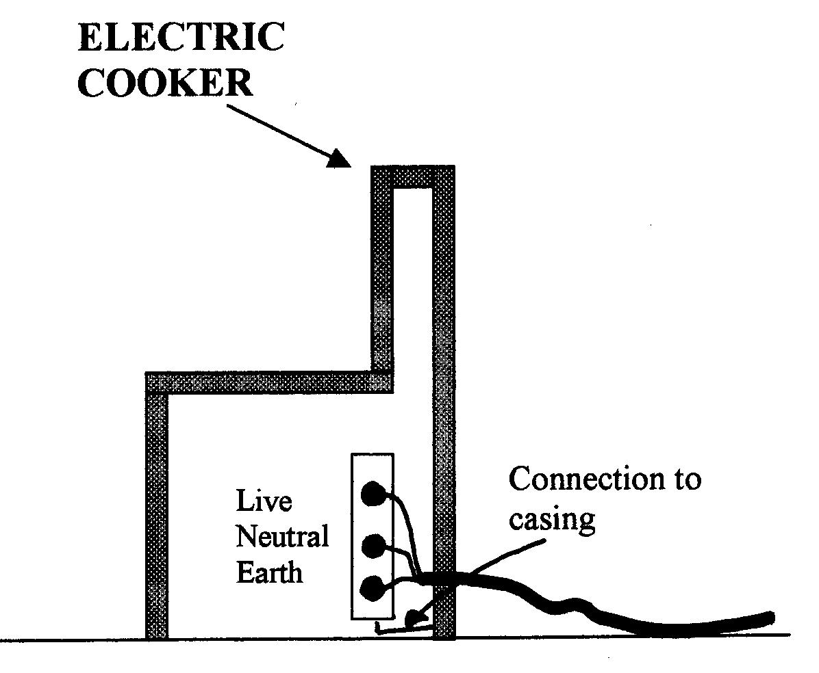
Fig.26

The earth wire also helps with safety by providing a safe route for the current to flow to Earth if the live wire touches the outer casing of an appliance.

The Earth terminal is connected to the metal casing, so the current goes through the Earth wire rather than through you. The earth wire route has very low resistance, so a big current flows which blows the fuse.

Domestic electricity in the UK is supplied at a voltage that is often quoted as 230-240V (but see the notes on ac above). Between the power station and the consumer the voltage is changed by transformers (which rely on ac to operate). The voltage is increased using a step up transformer near the power station and decreased using a step down transformer, or series of transformers near your house. The national grid is the network of cables connecting power stations to consumers. The high voltage is used for he long distance cables because the heating effect in the cables is less and hence the energy loss is less, if the higher voltage is used. The disadvantage is a greater risk of electric shock, necessitating tall pylons and other safety measures.
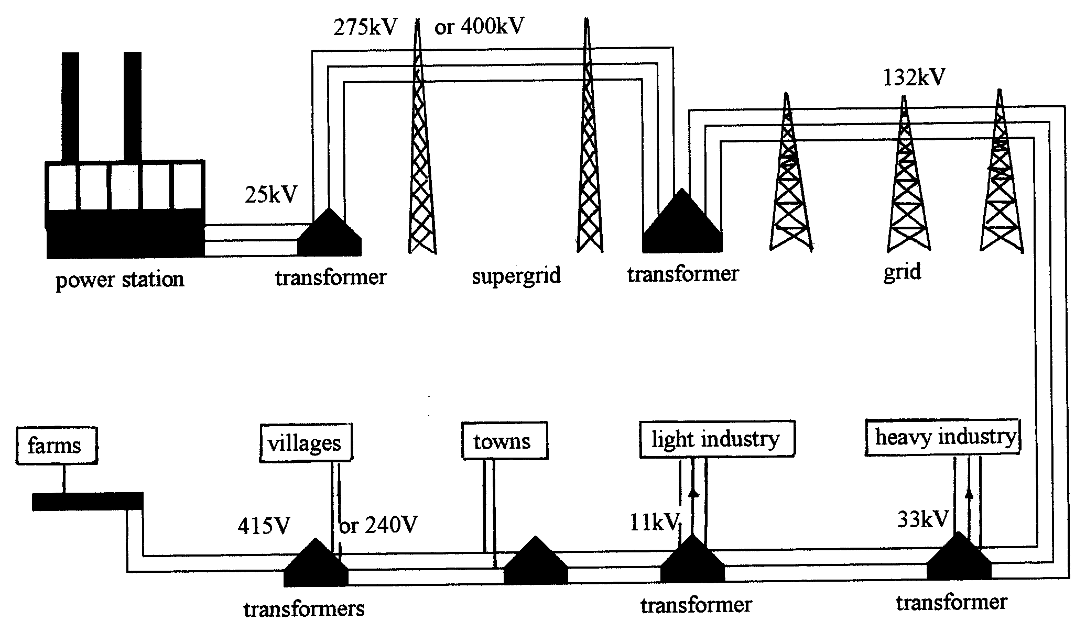
Fig.27

How consumers’ use of electricity is measured and charged for have been in schemes of work for many years. Developments in the measurement methods and billing structures have, however, outpaced schemes of work and many printed resources.

There are two types of meter, digital and analogue (dial), although the later are increasingly rare. Analogue meters can cause real difficulties for obvious reasons. Many teachers ask pupils to examine their meters at home (with parents' permission), although there are obvious safety concerns.

Broadly speaking electricity companies charge us for the amount of electricity we use; however there are he added possible complications of time dependent charging rates, dual fuel discounts and standing charges.

The unit used on an electricity bill is the kilowatt-hour (kWh). One kWh is the amount of electricity used by a 1 kW device in 1 hour. We are then charged for the number of units used in the charging period (such as each month), with the electricity company setting a tariff per unit used. More recently bills may be required to show in addition a conversion to joules or kilo joules. Two sequential readings are used to determine the number of kWh used between the two dates, this number is then multiplied by the cost per kWh.

Whilst digital meters are easy to read, for dial (analogue) meters it is important to work out which way each dial turns. The reading on a dial is the number that the needle has just passed. Examples are given below.

Fig.28
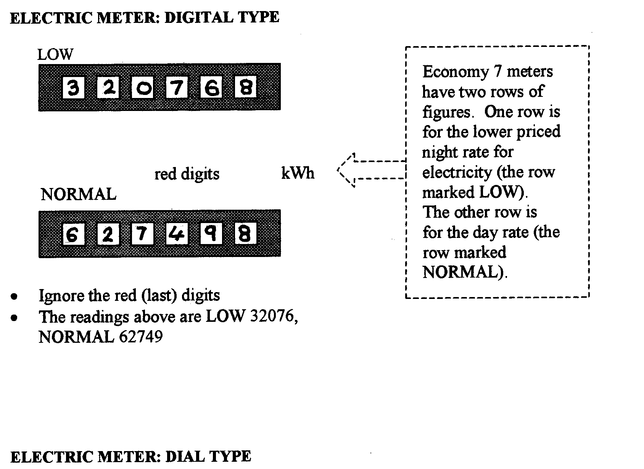
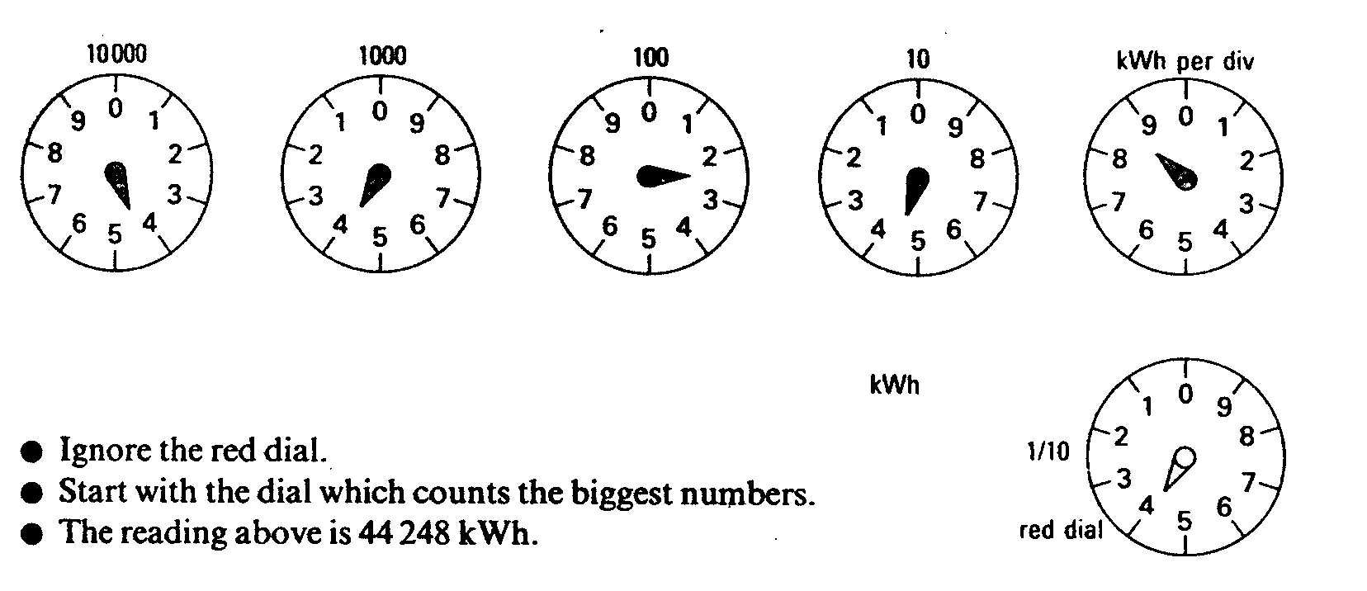

The power of an appliance is the amount of energy that is transferred per second. Power is measured in watts. The formula linking power, current and voltage is:

P = I xV

For example: an electric iron draws a current of 4A at 250V. What power is it?

P = 4 x 250
= 1000 watts = 1kW

Any appliance that produces significant amounts of heat (e.g. toaster, kettle, cooker, iron, immersion heater) will have a high power rating and cost more to run.

_____________________________________________________________________

TASK 11
- Sketch an analogue electricity meter reading for 37189 kWh.
- A 2.4 kW kettle is used six times a day for five minutes each time. If electricity costs 6.2p per unit, how much does it cost to use the kettle each week?
_____________________________________________________________________

7. Generating electricity

We have seen how a wire carrying a current in a magnetic field is subject to a force (the motor effect), with the direction of the force, and subsequent motion given by Fleming's Left Hand rule. In summary:

CURRENT + MAGNETIC FIELD ⇒ MOTION

Electricity is generated by electromagnetic induction. In simple terms moving a conductor within a magnetic field induces a pd across the ends of the conductor, and so a current flows if there is a complete circuit. Again in summary:

MAGNETIC FIELD + MOTION ⇒ CURRENT

The direction of current can be predicted from Fleming's Right Hand rule.
Fig.29

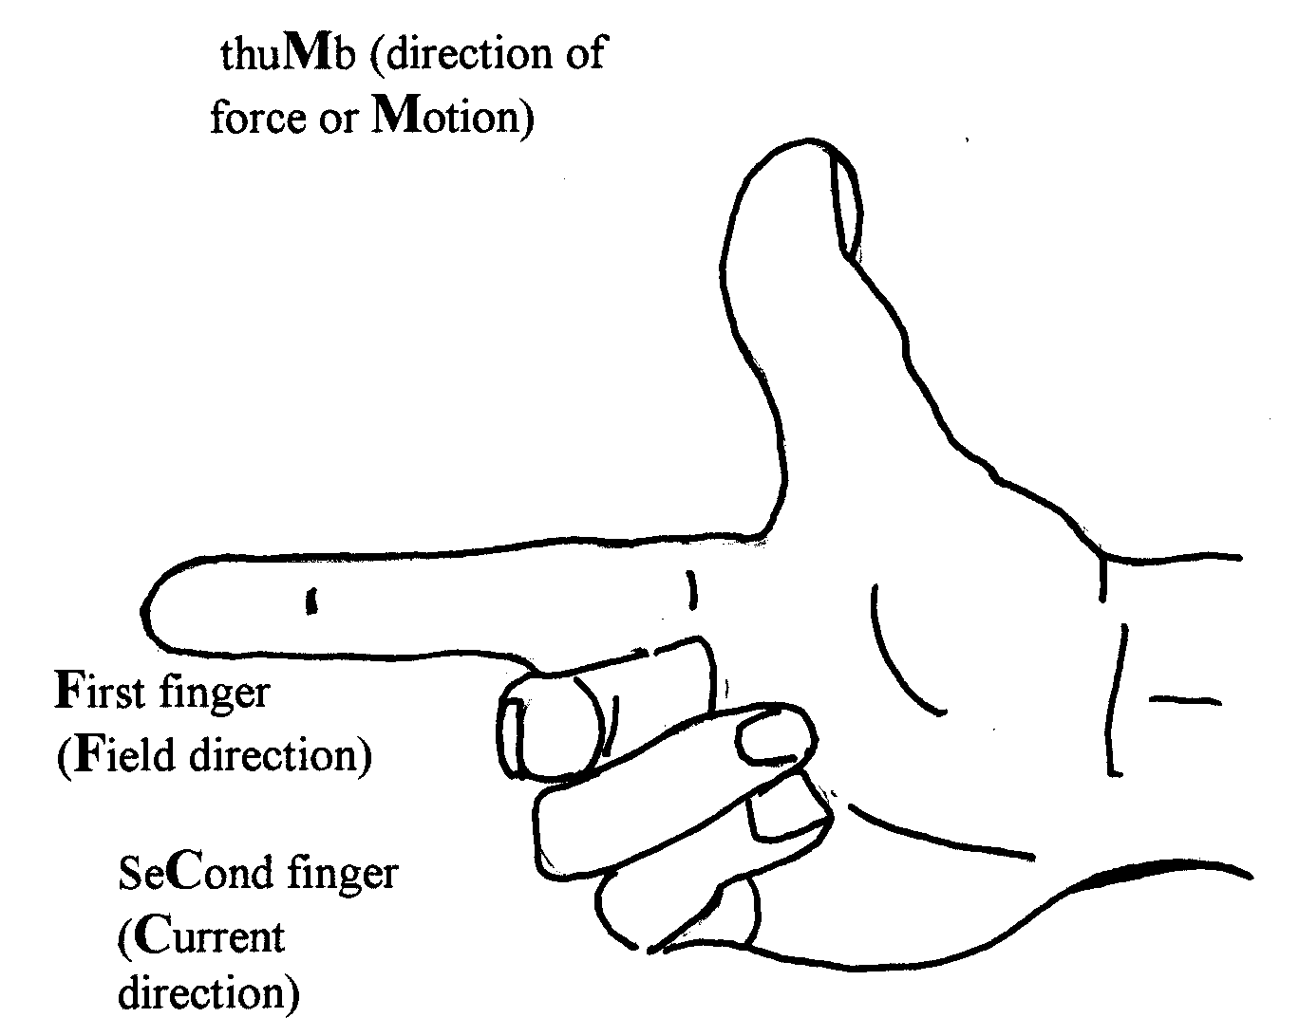
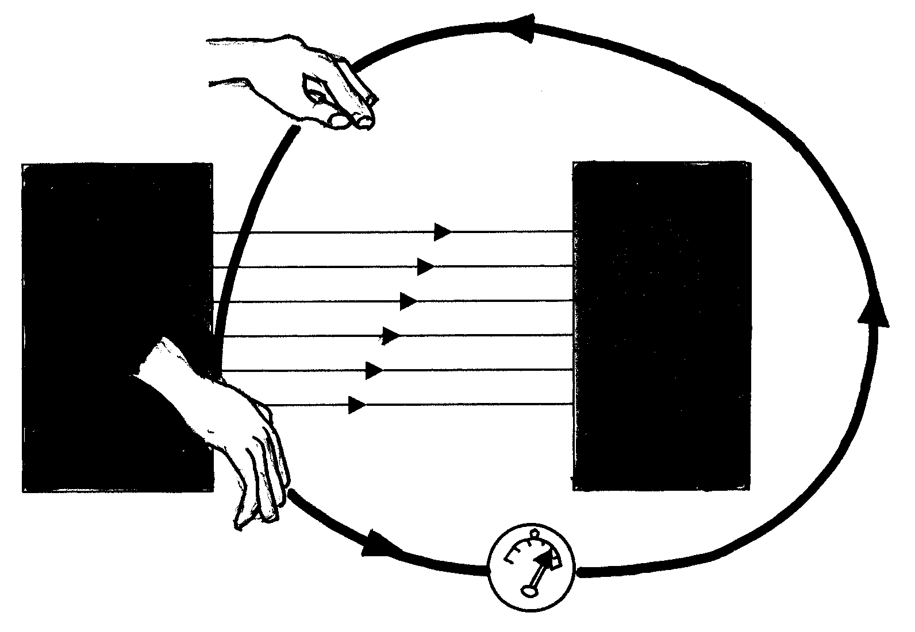
Any generator is basically a coil of wire, which is made to rotate in a magnetic field. This principle applies just as much to a generator in a power station as to a humble bicycle dynamo. As the coil rotates it cuts through the magnetic lines of force, and a current is induced in it.

Generators can produce either dc or ac current. The main difference is in the structure of the commutator in each case

Fig.30 Direct current generator

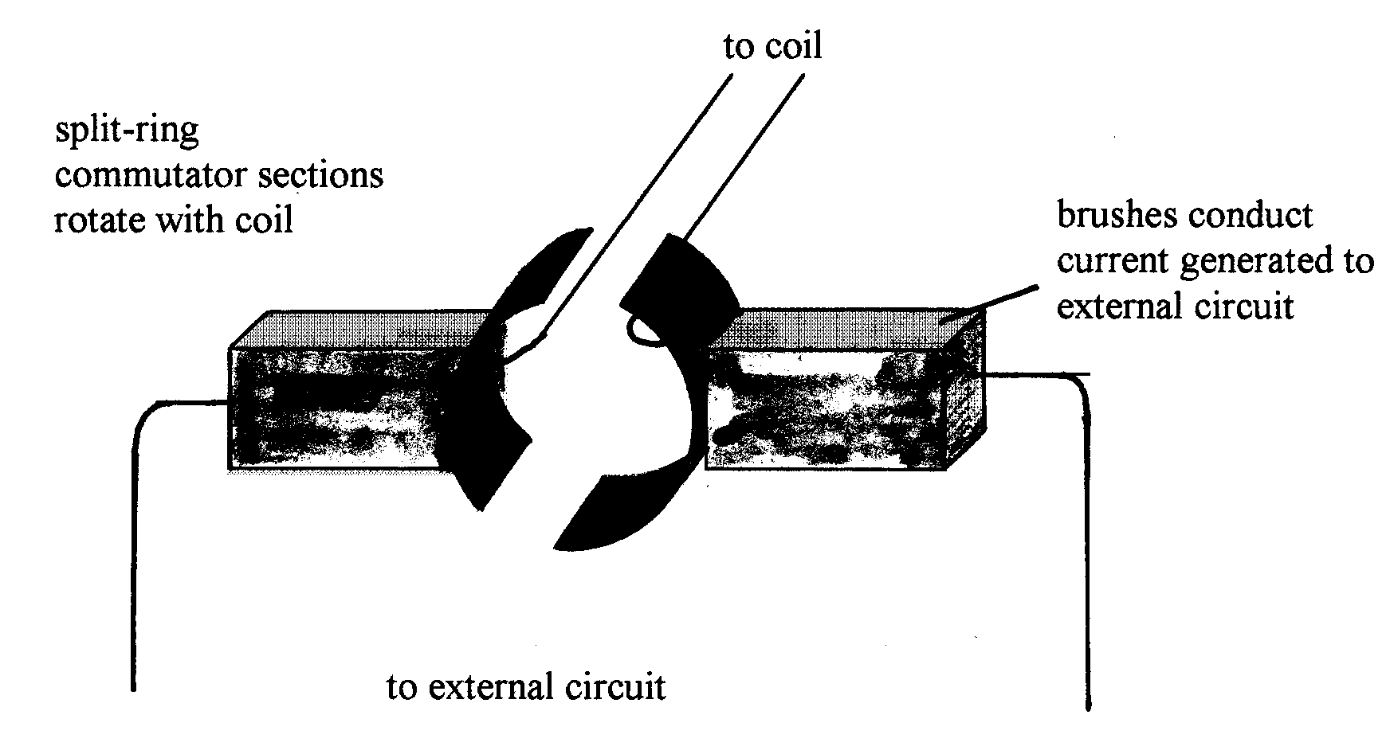
A direct current generator has a split ring commutator (really a ring split into two sections). Every half turn the sections pass from one brush to another. The output is always in the same direction.

An alternating current (ac) generator has two full rings (called slip rings). The brushes push against the rings as they turn. The output is a varying current which changes direction every half turn of the coil.

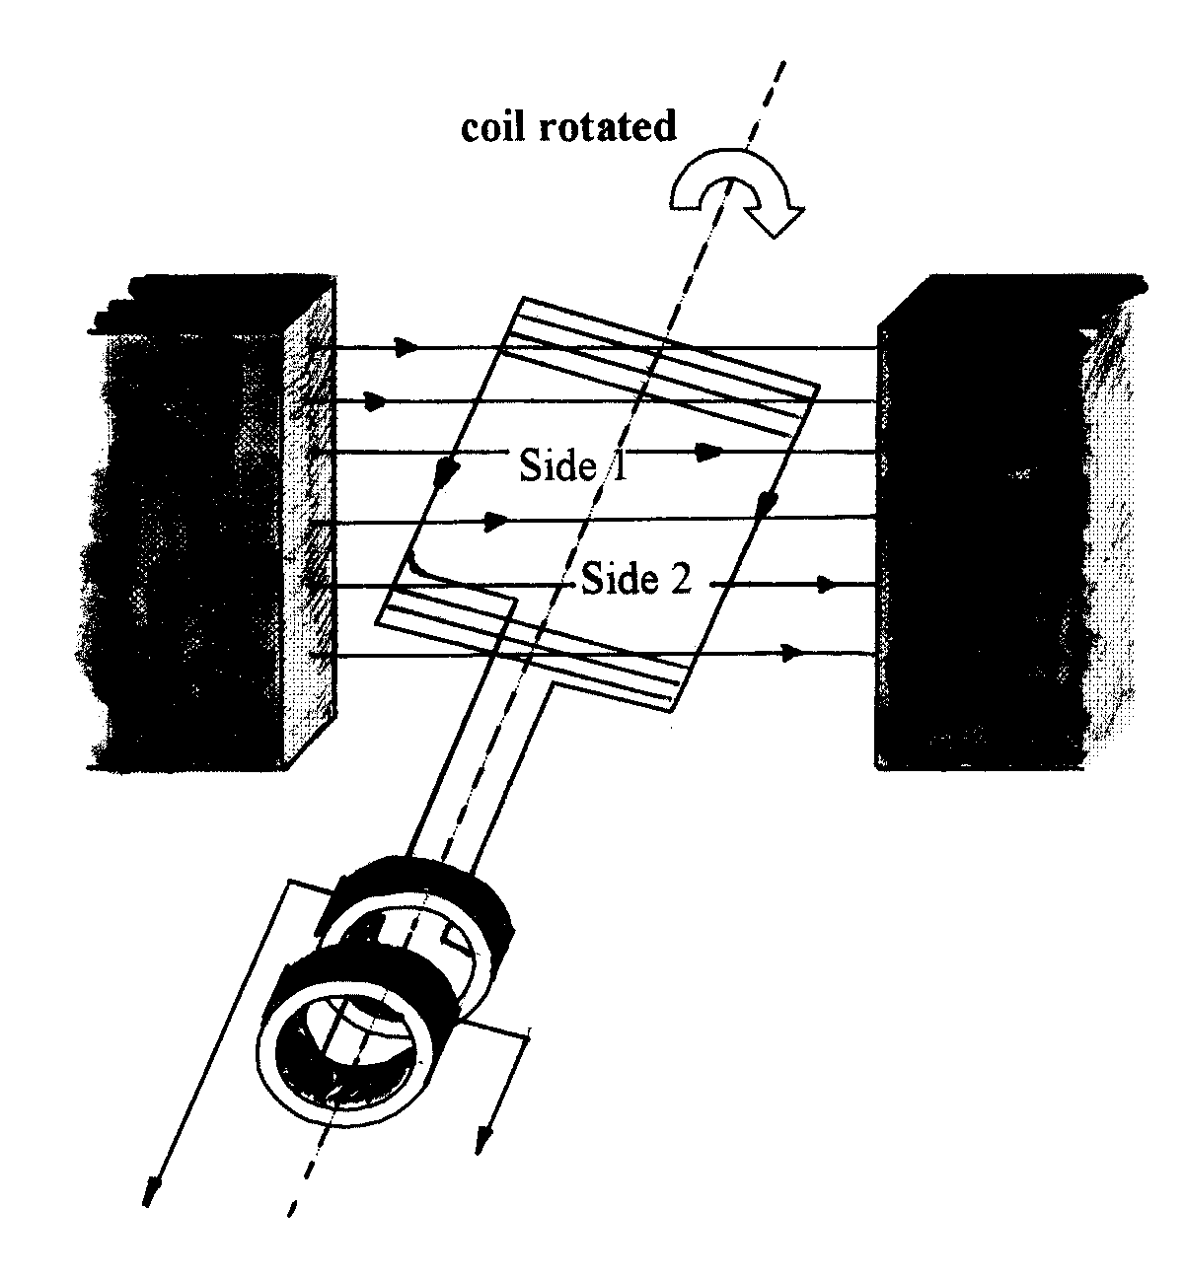
Fig.31

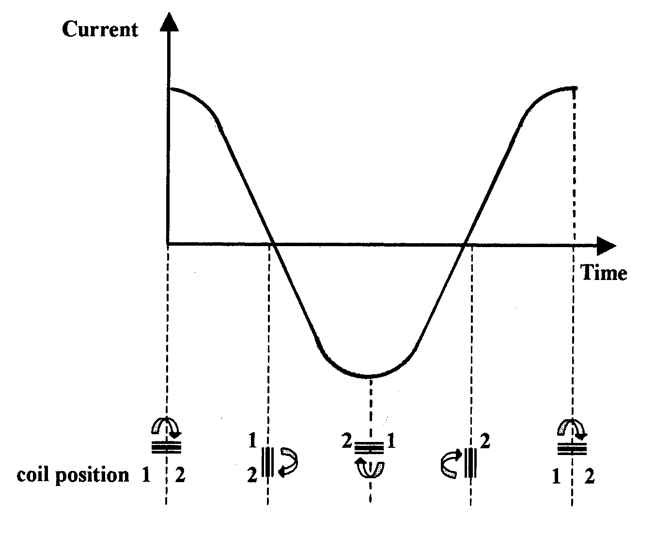

As the coil turns, side 1 moves up and side 2 moves down. A current is induced in the coil, which is fed to the external circuit via the rotating slip rings and the brushes.

As the coil moves into the vertical position it moves parallel to the magnetic field. The induced current is momentarily zero.

A quarter of a turn later the coil is horizontal again but with side 1 moving down and side 2 moving up.

_____________________________________________________________________
TASK 12
- A year 7 pupils asks you how a bicycle dynamo works. What would you say to her?
- A bright year 11 pupil in your class remains unclear about how electricity is generated in a power station. How would you explain this to him?
_____________________________________________________________________

